Development of Multimetric

Indices of Biotic Integrity for Assessing Macroinvertebrate and Fish Assemblages in Indiana Streams

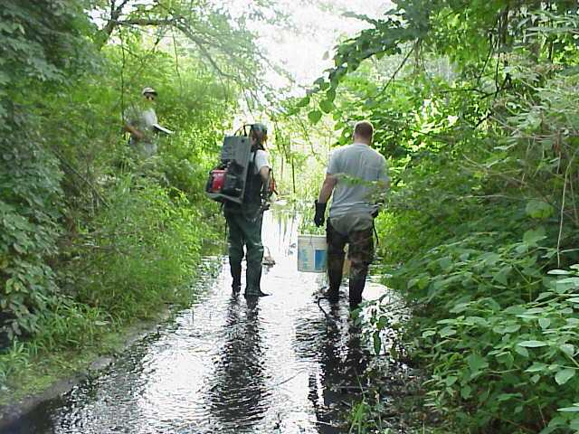

***Prepared for*:**

US EPA Region 5

Marietta Newell, Work Assignment Manager

Ed Hammer

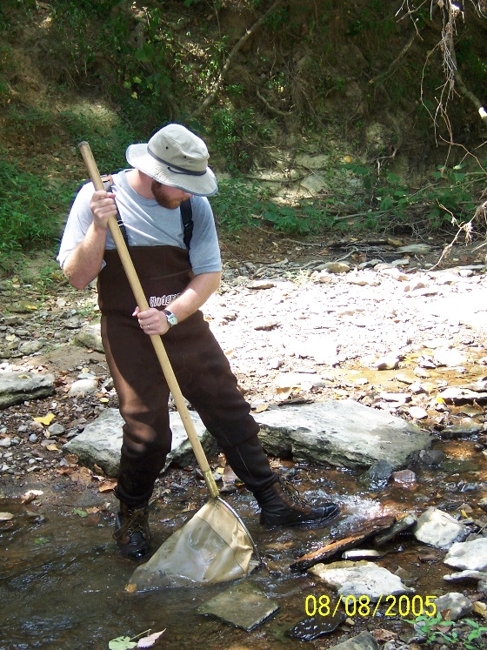Indiana Department of Environmental Management

Stacey Sobat

***Prepared by*:**

Benjamin Jessup

Jen Stamp

Tetra Tech, Inc.

73 Main Street, Suite 38, Montpelier, VT

**FINAL REPORT**

March 20, 2017

  

# Executive Summary

The Indiana Department of Environmental Management (IDEM) Office of Water Quality (OWQ) is responsible for sampling and assessing Indiana’s surface water quality pursuant to the Clean Water Act (CWA) Section 305(b) as well as, according to Section 303(d) of the CWA, identifying waterbodies of the State that are not meeting water quality criteria and are in need of developing a Total Maximum Daily Load (TMDL). To meet these requirements, IDEM monitors biological conditions and assesses the integrity of the macroinvertebrate and fish assemblages in streams.

The Indiana Administrative Code [327 IAC 2-1-3] has narrative biological criteria that states “all waters, except those designated as limited use, will be capable of supporting a well-balanced, warm water aquatic community.” The water quality standard definition of a “well-balanced aquatic community” is “an aquatic community which is diverse in species composition, contains several different trophic levels, and is not composed mainly of strictly pollution tolerant species” [327 IAC 2-1-9].

To measure whether or not the macroinvertebrate and fish biological communities are meeting this definition, IDEM uses Indices of Biotic Integrity (IBI). The IBIs are multimetric indices, which are numeric representation of biological conditions based on the combined signals of many assemblage measurements. The raw taxa lists and taxa attributes are recalculated as numerical expressions of the biological assemblage that respond to human disturbance in a predictable fashion. The process for index development included definition of site reference criteria, establishment of stream classes, calibration of multiple macroinvertebrate and fish metrics to disturbance categories, and combination of the most responsive metrics in an index. Each measurement, or metric, is selected to be included in the index if it shows a consistent response along a known disturbance gradient. The combined index gives a reliable indication of biological condition relative to the disturbance gradient. In these analyses, the disturbance gradient is represented by high quality reference and stressed site designations.

The recalibration of existing indices takes advantage of new data and new analytical techniques. In this recalibration, data from 1458 sites collected between 2003-2013 for fish and between 2004-2013 for macroinvertebrates. The new techniques included a comprehensive reference site identification and site classification process, determination of metric performance using discrimination efficiency (DE) and Z-scores, metric scoring on a 100 point scale, and combinations of multiple index alternatives for review.

The IBI recalibration resulted in indices for five benthic macroinvertebrate site classes and four fish site classes. The benthic macroinvertebrate site classes were defined by ecoregions and basins, including the Northern, North-Central, Southeast, South-Central, and Southwest. Index formulations included 6-7 metrics from five metric categories. Discrimination efficiencies ranged from 87.7 to 100% and Z-scores ranged from 1.6 to 2.3. No index was developed for the South-Central site class because metric trends with increasing stress in that class were contrary to expected patterns.

**Table ES – 1**. Benthic macroinvertebrate index summary by site class.

|  |  |  |  |  |  |
| --- | --- | --- | --- | --- | --- |
|  |  | North | North-Central | Southwest | Southeast |
| Metric Codes | | pt\_nonins | pt\_nonins | nt\_EPT | pt\_nonins | |
| pi\_EPT | pi\_dom03 | pi\_NonIns | pt\_EPT | |
| pi\_ffg\_pred | pi\_EPTnoBH | pi\_EPTnoBH | pi\_EPTnoBH | |
| nt\_hab\_clngr | pi\_Chiro | nt\_ffg\_scrap | pi\_Odon | |
| nt\_tv\_intol | pi\_ffg\_pred | pi\_ffg\_filtr | pi\_ffg\_colomn | |
| pt\_toler | pi\_ffg\_shred | pi\_hab\_clngr | pi\_hab\_clngr | |
|  | nt\_hab\_clngr | pi\_tv\_intol | pt\_intol | |
| Reference | 25th Quantile | 50.0 | 61.9 | 48.9 | 63.4 |
| Stressed | DE | 87.7 | 92.1 | 100 | 100 |
| Ref v. Strs | Z-score | 2.0 | 2.3 | 2.2 | 1.6 |

For fish, site classes were defined by stream size, slope, and sample collection method, including the small wadeable streams, small wadeable streams, low-gradient boatable streams, and high-gradient boatable streams. Index formulations included 6-7 metrics from five metric categories. Statewide discrimination efficiencies ranged from 75.9 to 100% and Z-scores ranged from 1.4 to 3.8. Performance statistics within ecoregional groups were calculated to allow different for region-specific assessment scales.

Thresholds for assessment using the IBI were suggested by the reference distribution 25th percentile values for each index and site class. Both macroinvertebrate and fish indices were also compared to Biological Condition Gradient (BCG) results to suggest other possible thresholds based on distribution statistics and regression interpolation. The BCG thresholds do not always match the. The BCG Level 4 median index value is an alternative general use threshold to the reference distribution 25th percentile values.

**Table ES – 2**. Fish index summary by site class.

|  |  |  |  |  |  |
| --- | --- | --- | --- | --- | --- |
|  |  | Small Wadeable | Large  Wadeable | Low-Gradient Boatable | High-Gradient Boatable |
| Metric Codes | | jnt\_native | jnt\_darter | jnt\_native | jnt\_native | |
| jnt\_dartmadsculp | nt\_Cyprin | pi\_rbs | nt\_darter | |
| jni\_total | ni\_Total\_perdist | pi\_dom01 | nt\_Cent | |
| pi\_CyprinNoCarp | pi\_CyprinNoCarp | BioNatNonTolnGS\_perdist | pb\_rbs | |
| pi\_osbh\_lithophil | pi\_sunfish | nt\_natCypinvert | pi\_insinv | |
| jpi\_headwater | pi\_omni | pi\_intolerant | pi\_omni | |
| pi\_pioneer | jpi\_toler | pb\_toler | pi\_intolerant | |
| jnt\_natinvert | pi\_delt | pi\_os\_lithophil | pb\_toler | |
| jpt\_toler |  | pi\_delt | pi\_os\_lithophil | |
| pi\_delt |  |  | pi\_delt | |
| Reference | 25th | 51.2 | 58.7 | 61.0 | 59.8 |
| Stressed | DE | 75.9 | 76.4 | 80.0 | 100 |
| Ref v. Strs | Z | 1.5 | 1.4 | 3.8 | 1.6 |

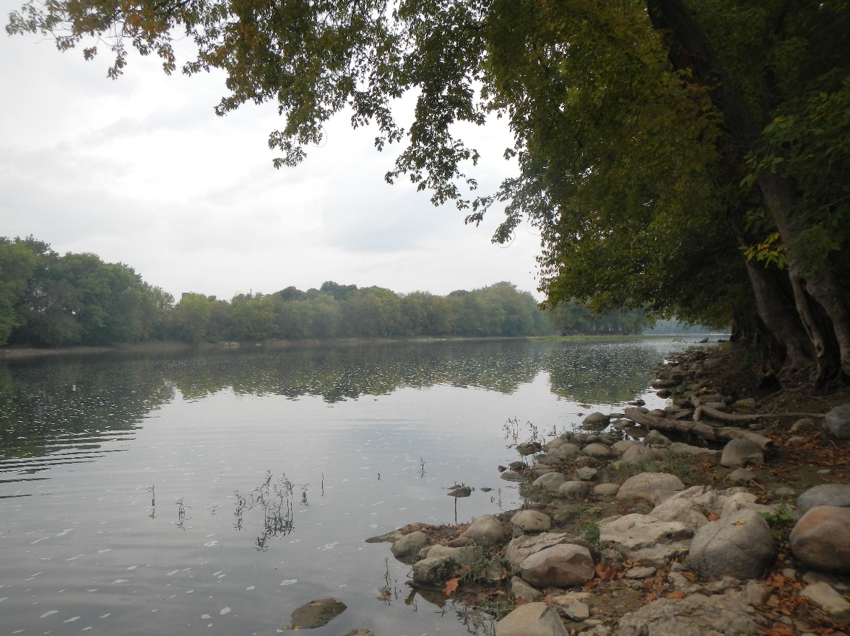

Wabash River at Georgetown Road in Cass County Indiana (2015)

# Acknowledgements

We are grateful for the hard work and enthusiasm of all the project participants. The index development process was supported by the U.S. EPA Region 5 through a contract with Tetra Tech, Inc. Marietta Newell and Ed Hammer of the U.S. EPA facilitate the contract and discussions to address the needs of the Indiana Department of Environmental Management. Stacey Sobat, Paul McMurray, and Kevin Gaston of IDEM and Reid Morehouse (formerly of IDEM) were especially engaged in reviewing analyses and drafts of the report. Chris Yoder of the Midwest Biodiversity Institute (MBI) was critical in reviewing attributes for fish and drafts of the fish indices. Erik Leppo and Chris Wharton from Tetra Tech supported analysis, database, and mapping tasks. The BCG was integral to interpretation of the indices, and participants in those parallel efforts are also appreciated.

All photos were provided by IDEM. Cover photos are of Stacey Sobat with a backpack electrofishing team (2000) and Paul McMurray collecting a kick in the riffle for a MHAB macroinvertebrate sample (2005).

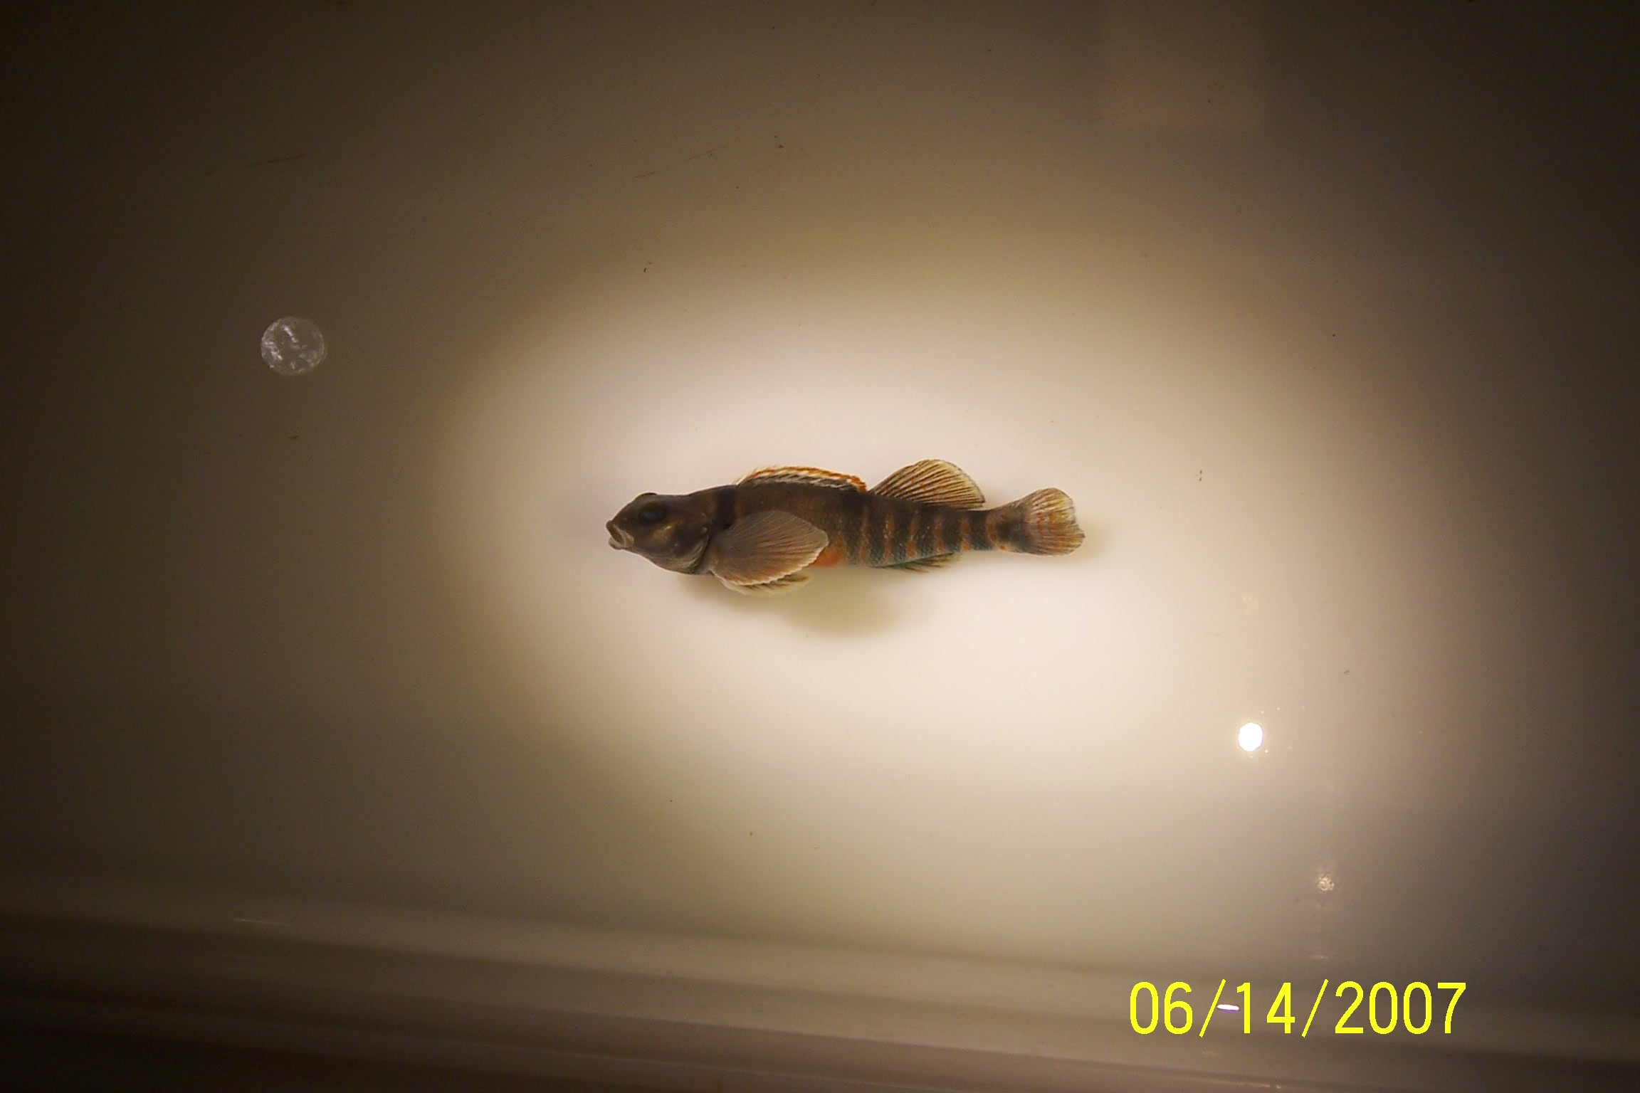 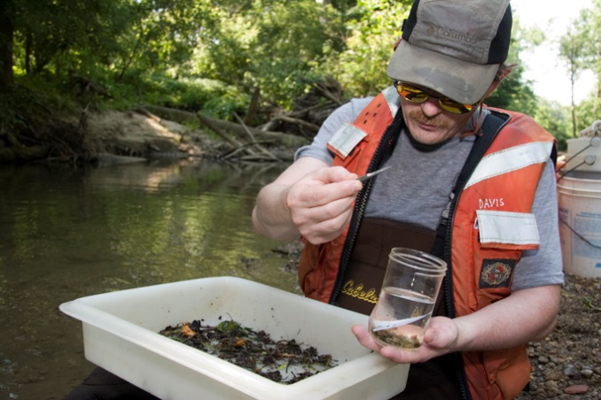

Variegate darter (Etheostoma variatum) photographed by Stacey Sobat (2007) and Todd Davis performing a 15 minute pick for a MHAB macroinvertebrate sample (2007).

Table of Contents

[Executive Summary i](#_Toc476900717)

[Acknowledgements iv](#_Toc476900718)

[List of Tables vii](#_Toc476900719)

[List of Figures ix](#_Toc476900720)

[1.0 Introduction 1](#_Toc476900721)

[2.0 Data Set Description 2](#_Toc476900722)

[3.0 Methods 5](#_Toc476900723)

[3.1 Reference conditions 5](#_Toc476900724)

[Reference Site Identification Approach 6](#_Toc476900725)

[Reference Site Designations 7](#_Toc476900726)

[3.2 Site Classification 10](#_Toc476900727)

[3.3 Metric Calculation 13](#_Toc476900728)

[3.4 Taxa Stressor-Response Analysis 20](#_Toc476900729)

[3.5 Metric scoring and discrimination efficiency 22](#_Toc476900730)

[3.6 Index Composition and Evaluation 25](#_Toc476900731)

[3.7 Threshold recommendations 25](#_Toc476900732)

[4.0 Results 27](#_Toc476900733)

[4.1 Reference conditions 27](#_Toc476900734)

[4.2 Site Classification 30](#_Toc476900735)

[4.3 Macroinvertebrates Index Development 34](#_Toc476900736)

[4.3.1 Site Classification for Macroinvertebrates 34](#_Toc476900737)

[4.3.2 Stressor Associations with Macroinvertebrate Taxa 46](#_Toc476900738)

[4.3.3 Metric Sensitivity 53](#_Toc476900739)

[4.3.4 Index alternatives 53](#_Toc476900740)

[4.3.5 Performance and thresholds 63](#_Toc476900741)

[4.4 Fish Index Development 70](#_Toc476900742)

[4.4.1 Site Classification for Fish 70](#_Toc476900743)

[4.4.2 Tolerance Values and Other Traits 80](#_Toc476900744)

[4.4.3 Metric Adjustments and Sensitivity 81](#_Toc476900745)

[4.4.4 Index alternatives 83](#_Toc476900746)

[4.4.5 Performance and thresholds 90](#_Toc476900747)

[5.0 Discussion 108](#_Toc476900748)

[6.0 References Cited 110](#_Toc476900749)

**Appendix A**: Primary Reference Site Criteria

**Appendix B**: Secondary Reference Site Criteria

**Appendix C**: Classification ordinations for benthic macroinvertebrates

**Appendix D**: Mapped macroinvertebrate distributions

**Appendix E**: Great Miami classification

**Appendix F**: Macroinvertebrate metric distributions

**Appendix G**: SubRef distributions

**Appendix H**: Macroinvertebrate sample size

**Appendix I**: Stressor-response plots

**Appendix J:**  Macroinvertebrate tolerance ranks

**Appendix K:**  Macroinvertebrate metric performance

**Appendix L:**  Mapped fish distributions

**Appendix M:** Fish traits

**Appendix N:** Fish metric adjustments - Wadeable

**Appendix O:** Fish metric adjustments - Boatable

**Appendix P:** The best wadeable index alternatives in each site class

# List of Tables

[Table 1. Data sources for geospatial analysis. 5](#_Toc476897943)

[Table 2. Site characteristics derived from remote sensing data and used for determining disturbance at sampling sites. 8](#_Toc476897944)

[Table 3. Descriptions of metric categories for macroinvertebrates and fish. 14](#_Toc476897945)

[Table 4. Macroinvertebrate metric descriptions. 15](#_Toc476897946)

[Table 5. Fish metric descriptions. 18](#_Toc476897947)

[Table 6. Reference (Ref) and Stressed (Strs) criteria for 13 primary variables, by catchment delineation: whole catchment (W), within 5 km (5K), and within 1km (1K). 28](#_Toc476897948)

[Table 7. Preliminary disturbance category assignments based on reference and stressed criteria. 29](#_Toc476897949)

[Table 8. Site counts by disturbance category and level III ecoregion. 30](#_Toc476897950)

[Table 9. Factor coordinates of the active and supplemental variables. 41](#_Toc476897951)

[Table 10 Spearman correlation coefficients among environmental variables 47](#_Toc476897952)

[Table 11 Correspondent Analysis using species and genus level relative abundance data and environmental variables 48](#_Toc476897953)

[Table 12. Macroinvertebrate metric DE (trend) and Z-score for selected metrics that show some consistency among site classes. 54](#_Toc476897954)

[Table 13. Metrics included in the all-subsets routine for evaluating macroinvertebrate indices. 55](#_Toc476897955)

[Table 14. The best seven macroinvertebrate index alternatives for the North site class. Metrics used in each alternative are listed as “1”. 56](#_Toc476897956)

[Table 15. Metrics in the North index. All values that calculate to < 0 or >100 are re-set to the 0-100 scale before averaging in the index 57](#_Toc476897957)

[Table 16. Correlation (Spearman rho) among metrics of the North macroinvertebrate index. 57](#_Toc476897958)

[Table 17. The best eight macroinvertebrate index alternatives for the North-Central site class. Metrics used in each alternative are listed as “1”. 58](#_Toc476897959)

[Table 18. Metrics in the North-Central index. All values that calculate to < 0 or >100 are re-set to the 0-100 scale before averaging in the index. 58](#_Toc476897960)

[Table 19. Correlation (Spearman rho) among metrics of the North-Central macroinvertebrate index. 59](#_Toc476897961)

[Table 20. The best eight macroinvertebrate index alternatives for the Southeast site class. Metrics used in each alternative are listed as “1”. 60](#_Toc476897962)

[Table 21. Metrics in the Southeast index. All values that calculate to < 0 or >100 are re-set to the 0-100 scale before averaging in the index. 60](#_Toc476897963)

[Table 22. Correlation (Spearman rho) among metrics of the Southeast macroinvertebrate index. 61](#_Toc476897964)

[Table 23. The best seven macroinvertebrate index alternatives for the Southwest site class. Metrics used in each alternative are listed as “1”. 62](#_Toc476897965)

[Table 24. Metrics in the Southwest index. All values that calculate to < 0 or >100 are re-set to the 0-100 scale before averaging in the index. 62](#_Toc476897966)

[Table 25. Correlation (Spearman rho) among metrics of the Southwest macroinvertebrate index. 63](#_Toc476897967)

[Table 26. Reference index and BCG Level distribution and performance statistics within site classes. 64](#_Toc476897968)

[Table 27. Validation statistics for the macroinvertebrate index by site class. 65](#_Toc476897969)

[Table 28. Correlation coefficients (Spearman rank r) for the index and environmental variables by site class. Red font indicates significant correlations (p<0.05). 65](#_Toc476897970)

[Table 29. Regression equations for predicting macroinvertebrate index values from BCG Levels. 66](#_Toc476897971)

[Table 30. Fish metrics used in boatable site classification. Refer to Table 5 for metric descriptions. 74](#_Toc476897972)

[Table 31. Metrics in the small wadeable stream fish index. All values that calculate to < 0 or >100 are re-set to the 0-100 scale before averaging in the index. 84](#_Toc476897973)

[Table 32. Correlation (Spearman rho) among metrics of the small wadeable stream fish index. 85](#_Toc476897974)

[Table 33. Metrics in the large wadeable stream fish index. All values that calculate to < 0 or >100 are re-set to the 0-100 scale before averaging in the index. 85](#_Toc476897975)

[Table 34. Correlations (Spearman rho) among metrics of the large wadeable stream fish index. 86](#_Toc476897976)

[Table 35. Metrics in the low gradient boatable stream fish index. All values that calculate to < 0 or >100 are re-set to the 0-100 scale before averaging in the index. 87](#_Toc476897977)

[Table 36. Correlations (Spearman rho) among metrics of the low gradient boatable fish index. 88](#_Toc476897978)

[Table 37. Metrics in the high gradient boatable stream fish index. All values that calculate to < 0 or >100 are re-set to the 0-100 scale before averaging in the index. 89](#_Toc476897979)

[Table 38. Correlations (Spearman rho) among metrics of the high gradient boatable fish index. 89](#_Toc476897980)

[Table 39. Performance measures and threshold statistics for the small wadeable stream fish index statewide and in site classes. Values in bold-type are displayed in Figure 45. 91](#_Toc476897981)

[Table 40. Regression equations for predicting small wadeable stream fish index values from BCG Levels. 93](#_Toc476897982)

[Table 41. Performance measures and threshold statistics for the large wadeable stream fish index statewide and in site classes. Values in bold-type are displayed in Figure 49. 95](#_Toc476897983)

[Table 42. Regression equations for predicting large wadeable stream fish index values from BCG Levels. 97](#_Toc476897984)

[Table 43. Performance measures and threshold statistics for the low gradient boatable fish index statewide and in site classes. Values in bold-type are displayed in Figure 52. 100](#_Toc476897985)

[Table 44. Regression equations for predicting low gradient boatable stream fish index values from BCG Levels. 102](#_Toc476897986)

[Table 45. Distribution statistics for BCG Level 4 index values for the high gradient boatable stream fish index. Values in bold are shown in Figure 55. 104](#_Toc476897987)

[Table 46. Regression equations for predicting high gradient boatable stream fish index values from BCG Levels. 106](#_Toc476897988)

# List of Figures

[Figure 1. Schematic description of areas used to discern disturbances in the whole catchment and sub-catchments within 5km and within 1km of the sampling site. 9](#_Toc476898010)

[Figure 2. Level III and IV ecoregions of Indiana (Woods et al. 1998). Ecoregion codes are Central Corn Belt Plains (54), Eastern Corn Belt Plains (55), So. Michigan / No. Indiana Drift Plains (56), Huron/Erie Lake Plains (57), Interior Plateau (71), and Interior River Lowlands (72). 11](file:///E:\CurrentData\Documents\Indiana\Reports\IN_Index_ReviewDraft20170113.docx#_Toc476898011)

[Figure 3. Illustration of discrimination efficiency using box plots to show that the 25th percentile of the reference distribution for nt\_EPT is the standard to which the stressed distribution is compared. In this example, where boxes show interquartile ranges, the DE is somewhat greater than 75%. 24](#_Toc476898012)

[Figure 4. Site locations and reference designations. The figure on the left includes only BestRef and Ref sites as used in site classification analysis. 31](#_Toc476898013)

[Figure 5. State river basins and hydrologic units (HUC6) in Indiana, overlaid on ecoregions. 32](#_Toc476898014)

[Figure 6. Natural regions of Indiana (Homoya et al. 1985). 33](#_Toc476898015)

[Figure 7. Topographic elevation (left) and the base-flow index (BFI, right) in Indiana, showing overlay with ecoregions. For elevation, brown areas are high elevation and blue-green areas are low areas. For the BFI, blue areas have more groundwater influence and orange areas have less groundwater influence. 34](#_Toc476898016)

[Figure 8. NMS ordinations showing strong associations of percent clay in soils and the BFI with the first axis. 36](#_Toc476898017)

[Figure 9. NMS ordination diagram showing sites in level 4 ecoregions. 36](#_Toc476898018)

[Figure 10. NMS ordination diagram showing sites in state monitoring basins. 37](#_Toc476898019)

[Figure 11. Site classes for macroinvertebrate index development. 38](#_Toc476898020)

[Figure 12. Macroinvertebrate taxa occuring predominantly in the south of Indiana. 39](#_Toc476898021)

[Figure 13. Macroinvertebrate taxa occuring predominantly in the north of Indiana. 40](#_Toc476898022)

[Figure 14. Macroinvertebrate taxa occuring predominantly in the east or west of Indiana. 40](#_Toc476898023)

[Figure 15. PCA factors 1-3 by proposed site classes and level 4 ecoregions. The ecoregions are shown to be associated with the site classes, though there are exceptions based on state basins. 42](#_Toc476898024)

[Figure 16. Numbers of reference (BestRef and Ref) samples in each proposed site class. 43](#_Toc476898025)

[Figure 17. Metric value distribution in reference (BestRef and Ref) sites among proposed site classes. Metrics include total taxa (nt150\_total), EPT taxa (nt150\_EPT), percent non-insects (pi\_NonIns), and percent EPT (pi\_EPT). 44](#_Toc476898026)

[Figure 18. Sample sizes by site class and disturbance category. 45](#_Toc476898027)

[Figure 19. Total taxa richness and EPT taxa richness by site class and disturbance category. 45](#_Toc476898028)

[Figure 20. Intolerant taxa richness and percent tolerant individuals by site class and disturbance category. 46](#_Toc476898029)

[Figure 21 Correlations between QHEI and imperviousness and watershed size 47](#_Toc476898030)

[Figure 22 Canonical correspondent analysis of species and genus level data and correspondent environmental factors 49](#_Toc476898031)

[Figure 23 Nonmetric multidimensional scaling, showing gradients of imperviousness, QHEI, conductivity, and watershed size related to taxonomic composition. 50](#_Toc476898032)

[Figure 24. Relationships between the number of EPT taxa and environmental variables. 51](#_Toc476898033)

[Figure 25. Relationships between the number of EPT taxa and environmental variables. 52](#_Toc476898034)

[Figure 26. Macroinvertebrate index distributions by site class and disturbance category. 64](#_Toc476898035)

[Figure 27. Macroinvertebrate index distributions by site class and predicted BCG Level. Half BCG Levels indicate ties. 67](#_Toc476898036)

[Figure 28. Macroinvertebrate IBI scores compared to BCG Levels within site classes, showing site disturbance designations and thresholds suggested by distribution statistics. 68](file:///E:\CurrentData\Documents\Indiana\Reports\IN_Index_ReviewDraft20170113.docx#_Toc476898037)

[Figure 29. Index scores and BCG Levels for reference sites in the Southeast site class, showing bedrock dominated sites and other effects. 69](#_Toc476898038)

[Figure 30. NMS ordination diagram of species presence/absence, showing site classes based on level 3 ecoregions. 70](#_Toc476898039)

[Figure 31. NMS ordination diagram of species presence/absence, showing site classes based on river basins. 71](#_Toc476898040)

[Figure 32. NMS ordination diagram of species presence/absence, showing association of similar samples with catchment size in square kilometers. Marker size indicates catchment size. Blue markers indicate Ohio tributary (south) sites. Red markers indicate central sites. 72](#_Toc476898041)

[Figure 33. NMS ordination diagram of species presence/absence, showing site classes based on North, Central, and South regions and two size classes. 73](#_Toc476898042)

[Figure 34. NMS ordination diagram of species relative abundance, showing site classes based on North, Central, and South regions and two size classes. 73](#_Toc476898043)

[Figure 35. PCA ordination diagram showing non-stressed boatable sites arranged by metric similarities and gradient class. 75](#_Toc476898044)

[Figure 36. Metric distributions in non-stressed boatable sites by gradient class, showing the number of native taxa (ni\_native) and the percent of round bodied sucker individuals (pi\_rbs). 76](#_Toc476898045)

[Figure 37. Fish species occurring predominantly in the north of Indiana. 77](#_Toc476898046)

[Figure 38. Fish species occurring predominantly in the south of Indiana. 77](file:///E:\CurrentData\Documents\Indiana\Reports\IN_Index_ReviewDraft20170113.docx#_Toc476898047)

[Figure 39. Fish species occurring in limited basins of Indiana. 78](file:///E:\CurrentData\Documents\Indiana\Reports\IN_Index_ReviewDraft20170113.docx#_Toc476898048)

[Figure 40. Scatterplots of total taxa richness vs drainage area (mi2). Samples are coded by collection gear. The x-axis is log-transformed. 80](#_Toc476898049)

[Figure 41. Examples of metrics that were adjusted for catchment size based on the 95th quantile regression line (dashed slope) and the LOWESS regression (blue curve). 82](#_Toc476898050)

[Figure 42. Examples of metrics that were not adjusted for catchment size because the 95th quantile regression line (dashed slope) does not agree with the LOWESS regression (blue curve). 82](#_Toc476898051)

[Figure 43. Comparison of the small wadeable stream fish index distributions among site classes and disturbance categories. 92](#_Toc476898052)

[Figure 44. Comparison of the small wadeable stream fish index distributions among site classes and BCG model predictions. Half BCG Levels indicate ties. 93](#_Toc476898053)

[Figure 45. The small wadeable stream fish index in BCG Levels, showing site disturbance status and thresholds suggested by distribution statistics. 94](#_Toc476898054)

[Figure 46. Comparison of the large wadeable stream fish index distributions among disturbance categories. 96](#_Toc476898055)

[Figure 47. Comparison of the large wadeable stream fish index distributions among site classes and disturbance categories. 97](#_Toc476898056)

[Figure 48. Comparison of the large wadeable stream fish index distributions among site classes and BCG model predictions. Half BCG Levels indicate ties. 98](#_Toc476898057)

[Figure 49. The large wadeable stream fish index in BCG Levels, showing site disturbance status and thresholds suggested by distribution statistics. 99](file:///E:\CurrentData\Documents\Indiana\Reports\IN_Index_ReviewDraft20170113.docx#_Toc476898058)

[Figure 50. Comparison of the low gradient boatable fish index distributions among disturbance categories. 101](#_Toc476898059)

[Figure 51. Comparison of the low gradient boatable fish index distributions among site classes and predicted BCG Levels. Half BCG Levels indicate ties. 102](#_Toc476898060)

[Figure 52. The low gradient boatable fish index in BCG Levels, showing site disturbance status and thresholds suggested by distribution statistics. 103](#_Toc476898061)

[Figure 53. Comparison of the high gradient boatable fish index distributions among disturbance categories. The red markers are Whitewater River sites that were displayed as verification of reference conditions. 105](#_Toc476898062)

[Figure 54. Comparison of the high gradient boatable fish index distributions among site classes and predicted BCG Levels. 106](#_Toc476898063)

[Figure 55. The high gradient boatable fish index in BCG Levels, showing site disturbance status and thresholds suggested by distribution statistics. 107](#_Toc476898064)

# 1.0 Introduction

The Indiana Department of Environmental Management (IDEM) Office of Water Quality (OWQ) is responsible for sampling and assessing Indiana’s surface water quality pursuant to the Clean Water Act (CWA) Section 305(b) as well as, according to Section 303(d) of the CWA, identifying waterbodies of the State that are not meeting water quality criteria and are in need of developing a Total Maximum Daily Load (TMDL). To meet these requirements, IDEM monitors biological conditions and assesses the integrity of the macroinvertebrate and fish assemblages in streams.

The Indiana Administrative Code [327 IAC 2-1-3] has narrative biological criteria that states “all waters, except those designated as limited use, will be capable of supporting a well-balanced, warm water aquatic community.” The water quality standard definition of a “well-balanced aquatic community” is “an aquatic community which is diverse in species composition, contains several different trophic levels, and is not composed mainly of strictly pollution tolerant species” [327 IAC 2-1-9].

To measure whether or not the macroinvertebrate and fish biological communities are meeting this definition, IDEM uses Indices of Biotic Integrity (IBI). The IBIs are multimetric indices, which are numeric representation of biological conditions based on the combined signals of many assemblage measurements (Karr 1981, Gerritsen 1995, Barbour et al. 1999). The raw measurements are recalculated or standardized as biological metrics, or numerical expressions of attributes of the biological assemblage (based on sample data) that respond to human disturbance in a predictable fashion (Barbour et al. 1999). The process for index development included definition of site reference criteria, establishment of stream classes, calibration of multiple macroinvertebrate and fish metrics to disturbance categories, and combination of the most responsive metrics in an index (Stoddard et al. 2008). Each measurement, or metric, is selected to be included in the index if it shows a consistent response along a known disturbance gradient. The combined index gives a reliable indication of biological condition relative to the disturbance gradient. In these analyses, the disturbance gradient is represented by high quality reference and non-reference site designations. Responsiveness of metrics is evaluated within site classes.

The U.S. Environmental Protection Agency (U.S. EPA) evaluated IDEM’s biological assessment program in January 2014. The review provided information on the strengths and limitations of the bioassessment program, resource allocation and prioritization for improving the bioassessment program, and integration of biological assessments to more precisely describe aquatic life uses and develop numeric biological criteria. Modernization of the fish and macroinvertebrate IBIs was the most obvious and urgently needed refinement to the bioassessment program as stated in the evaluation of 13 critical technical elements for State bioassessment programs (U.S. EPA 2013). An update of existing indices can now include recent data sets, new analytical methods, and attention to reference conditions. The existing fish and macroinvertebrate IBIs were developed and calibrated based on distributions of all stream conditions rather than a subset of reference sites (sites with the least anthropogenic disturbance).

The current fish IBIs (Simon 1991, 1992, 1994, 1997a, 1997b, 2006, DRAFT; Simon and Dufour 1998, 2005; U.S. EPA 1995) were developed from 1990­ to 2006 with over 800 sites in Indiana for the six different ecoregions in Indiana as well as information on, watershed and stream size. The macroinvertebrate IBI currently used by IDEM was developed from 2004-2007 with samples from 247 sites in Indiana processed to the lowest practical taxonomic level (McMurray, personal communication 2016. Both IBIs are composed of 12 community characteristics, or metrics. The 12 different metrics are scored 1, 3, or 5, which represents the deviation from expected biological community structure (i.e. 5 = no deviation from expectations, 1 = severe deviation from expected biological community structure). The total score can range from 12 (worst conditions for each metric) to 60 (excellent, comparable to “least impacted” conditions). At this time, Indiana expects streams to achieve a score at least 36 out of 60 to meet minimum aquatic life use water quality standards. Unlike the fish metrics, most macroinvertebrate metrics did not account for variations based on ecoregion or watershed which will be addressed in the IBI revisions. Only the EPT metrics were expected to increase (in a stepwise fashion) with stream size.

This project will enhance Indiana’s monitoring strategy by refining core indicators (fish and macroinvertebrate community structure) used to assess aquatic life use in

* IDEM’s Integrated Report, thus satisfying 305(b) and 303(d) reporting requirements to U.S. EPA
* Watershed characterization projects which identify critical areas and chemical/physical stressors to the biological communities
* Identifying improvements in the biological communities following watershed restoration efforts

The refinement of fish and macroinvertebrate IBIs will provide a more accurate assessment of ecological effects thus improving IDEM’s diagnostic ability to identify causes of degradation in water quality.

# 2.0 Data Set Description

The Indiana Water Quality Monitoring Strategy: 2011-2019 (WQMS) (DRAFT, IDEM 2011) facilitates monitoring for CWA requirements, in addition to other IDEM-specific management goals. The WQMS details a rotating basin plan which allows IDEM to intensively sample all Indiana surface waters for assessment in nine years. The original monitoring strategy was initiated in 1996 and the current updated strategy is for the fourth cycle of Indiana basin assessments. Assessments of the State’s waters are facilitated by various Watershed Assessment and Planning Branch (WAPB) programs involving probabilistic and targeted approaches by collecting biological, chemical, habitat, and physical stream data. For purposes of this project, data from 2003-2013 were used for fish and 2004-2013 for macroinvertebrates.

IDEM collects fish and macroinvertebrate data with water quality and habitat information to monitor the health of streams and rivers in Indiana. Existing Indiana biological assessment data (including, as relevant, biological, chemical, and habitat data) were compiled in a single database for the development of stream IBIs. Land use data were generated and compiled in the same database.

Streams were perennial flowing waters with catchment sizes ranging from 0.1 to 30,000 sq. mi. More than 90% of sites had catchment sizes in the range of 1 – 5,000 sq. mi. Artificial channels (ditches) were included in the data set, but reference conditions specific to this type were not pursued.

**Macroinvertebrates:** The macroinvertebrate sampling reach is defined as a 50m length of stream that includes the designated primary sampling “X-point” location (IDEM 2010). Within the reach, two sample types are collected and composited: a 10ft kicknet sample of 10 linear feet in riffle habitat (approximately 1 square meter of substrate) and a shoreline sample consisting of 25-30 sweeps along the 50m reach. Sweeps are from multiple habitats in proportion to the dominant habitat types.

The composited sample is picked for organisms at the sampling site. The sample is distributed in a white tray and the crew leader uses a pair of forceps to pick individual macroinvertebrates from the contents of the tray for 15 minutes. The objectives of the pick are to collect a sample that contains the greatest diversity of organisms and also reflects the relative abundance of organisms in the entire sample.

During laboratory processing, all macroinvertebrate individuals are counted with the exception of empty snail and clam shells, microcrustaceans (Ostracoda, Branchiopoda, Copepoda), larval and pupal insect exuviae, and terrestrial insects (including the terrestrial adults of aquatic insect larvae); invertebrate specimens missing their head are also excluded. The level of taxonomic resolution used in the identification of macroinvertebrates may depend in large part on the condition (instar and physical condition) of the specimens and the availability of taxonomic resources that are comprehensive and appropriate for Indiana's fauna. Specimens are generally identified to the “lowest practical" taxonomic level. Oligochaeta (aquatic worms, Hirudinea and Branchiobdellida), Planaria and Acari are only identified to family or a higher level; freshwater snails and clams are identified to genus; freshwater Crustacea are identified to genus (Amphipoda and Isopoda) or species (Decapoda); aquatic insects are identified to family (Collembola and several Dipteran families) or genus and species (all other insects).

**Fish:** The fish community sampling reach is defined as 15x the average stream wetted width, with a minimum reach of 50 meters and a maximum reach of 500 meters that includes the designated “X-point”. Single pass electrofishing is performed using various standardized electrofishing methodologies and equipment depending on stream size and site accessibility. The possible list of electrofishing equipment includes backpack, longline, tote-barge or canoe, as well as a dropper anode boom with canoe for deeper pools. The targeted habitat includes all available habitat types and should encompass at least two pool-riffle-run sequences. All fish greater than or equal to 20 mm in total length are sorted by species. Measurements include the number of individuals for each species, weight as a "batch" per species, largest and smallest individuals (total length), and external anomalies (deformities, eroded fins, lesions, and tumors).

Because the boatable data set did not have many high quality reference sites or very disturbed sites, the data set was augmented with targeted samples that were outside of the standard data frame. High quality boatable sites were sampled in the Whitewater basin in southeastern Indiana in 2014, after the last date of the standard calibration data. These two samples from IDEM were considered comparable to the standard data set. However, samples were collected with a mixture of boatable and wadeable methods and the difference in methods might affect results. Highly disturbed samples from the Ottawa River in Ohio were also included. These samples were from earlier years (1987 - 1991), outside of Indiana, and collected with Ohio methods. However, they represent severely impacted conditions that are currently unobservable in Indiana. These additional data were not used in index calibration, but were tested after calibration.

**Water quality:** Water quality measurements at the primary sampling location are made using a data sonde and through sample collection for laboratory analysis (IDEM 2005). Hydrolab measurements included temperature, dissolved oxygen, conductivity, pH, and turbidity. Separate sample bottles are filled for analysis of metals, nutrients, cyanide, and general chemistry. Although IDEM OWQ collects information on many different chemical parameters, there were relatively few sites in which the full list of chemical parameters were analyzed.

**Habitat:** Stream habitat assessment was performed using the IDEM Qualitative Habitat Evaluation Index (QHEI; OH EPA 2006) data sheet, which was modified to accommodate sample metadata for IDEM. QHEI scores were included in the dataset as an indicator of in-stream habitat and riparian zone influences on the site. The QHEI is composed of six sections that measure different components of a sites instream habitat and riparian zone: Substrate (20 points), Instream Cover (20 points), Channel Morphology (20 points), Stream Bank and Riparian Zone (10 points), Pool/Glide and Riffle/Run Quality (20 points) and Gradient (10 points). The highest total possible score is 100; a score of 51 is considered “passing” although the QHEI is not used to assess sites for 303d purposes.

**Geospatial Data:** The catchments of all sites were delineated and analyzed using ArcMap software (ESRI). The delineated catchment sizes were checked against those previously defined by IDEM and discrepancies were rectified either through correction or elimination of data. Partial catchments were also delineated using 1km and 5km arcs from the sampling point and within the catchment. Data were analyzed within the catchments and partial catchments. Disturbance and classification statistics were derived from existing geospatial data coverages (Table 1). The data set included 1458 sites that were evaluated for site reference conditions. However, not all sites had valid data for both macroinvertebrates and fish.

Table . Data sources for geospatial analysis.

|  |  |
| --- | --- |
| Data Source and URL | Data Types |
| National Hydrography Dataset Plus version 2 (NHDPlusV2)  [www.horizon-systems.com/NHDPlus/NHDPlusV2\_data.php](http://www.horizon-systems.com/NHDPlus/NHDPlusV2_data.php) | Stream name, reach code, stream order, elevation, % canal & pipes, HUC, soils, ecoregion, stream density, point sources (NPDES, CERCLIS, CAFO, TRI) |
| National Land Cover Database 2011 (NLCD2011)  [www.mrlc.gov/nlcd11\_data.php](http://www.mrlc.gov/nlcd11_data.php) | Land use and land cover categories, imperviousness, road density and crossings |
| USGS Active Mines and Mineral Plants in the US  <http://mrdata.usgs.gov/mineplant/> | Mine coverage |
| National Inventory of Dams  <http://nationalmap.gov/small_scale/mld/dams00x.html> | Dam locations |
| Population density at the site (individuals/km2)  <http://catalog.data.gov/dataset/demographic-data-census-blckgrps-tiger00-popdens-in-indiana-population-density-2000-u-s-census> | Census data |

# 3.0 Methods

## 3.1 Reference conditions

The basis for biological criteria in the United States is biological integrity, defined as “the capability of supporting and maintaining a balanced, integrated, adaptive community of organisms having a species composition, diversity, and functional organization comparable to that of natural habitats of the region” (Karr and Dudley 1981 after Frey 1977), and has been widely adopted by USEPA to be consistent with the purpose of the US Clean Water Act. The definition clearly relies on natural condition, and bioassessment is based on comparison of conditions in assessable waterbodies to relatively natural reference conditions. Reference conditions are derived from conditions observed in populations of waterbodies, and take into account geographic classifications (e.g., ecoregions) and natural physical and chemical characteristics of waterbodies.

In order to develop a reference condition from a population of reference sites, it is necessary to specify criteria for the reference sites. Recognizing that many pristine sites no longer exist in some regions, Stoddard et al. (2006) proposed description of the least disturbed condition (LDC) as the best attainable condition recognizable in the existing landscape based on criteria for common and measured disturbances. This is the approach used in development of the IBI in Indiana. Given the intensive urban and agricultural land uses in many parts of Indiana, reference sites in these areas may not meet biological integrity as defined above. Also, given improvements in stressor mitigation over time, the most degraded sites now observed may not be as impaired as they might have been in 1960’s and 1970’s. Nevertheless, an index can be calibrated that is responsive to the observed range of stressors in the Indiana landscape. In separate studies (Stamp et al. 2016, Jessup and Stamp 2017), the Biological Condition Gradient (BCG, Davies and Jackson 2006, U.S. EPA 2016) is being developed to help characterize the observable reference biological condition relative to standardized narrative conditions so that meaningful impairment thresholds can be established regardless of somewhat degraded LDC.

Reference sites are used to identify metric expectations with the least levels of disturbance. When a set of stressed sites are identified using criteria at the opposite end of the disturbance scale, the response of metrics along the resulting stressor gradient can be detected. The direction and strength of response can be used for selecting candidate metrics for inclusion in an assessment index and properly scoring them.

One of the principal uses of reference samples is to determine how metrics vary independent of human disturbance and how they respond to human disturbance. In the site classification process, the distribution and abundance of biota or the distribution of metric values in least disturbed sites are used to identify biological groups and responses to natural gradients.

The distribution of index values in the reference condition can be used in setting thresholds of impairment: How much deviation from the reference condition is the State willing to tolerate under the Clean Water Act? How many taxa is the State willing to lose from a stream assemblage before triggering a management action? Application of thresholds based on the reference distribution of index values must account for the expectations of reference conditions relative to the reference criteria and whether the reference sites represent a minimally disturbed condition or only the least disturbed, or best observed, condition. Calibration of the index scale to a universally understood condition scale such as the BCG adds interpretive information to the reference condition.

The Biological Condition Gradient (BCG) includes a comprehensive scale of conditions that can be conceptualized by stream ecologists and translated into an assessment tool. A BCG model codifies the decision rules used by stream ecologists to evaluate the integrity of biological communities. Once developed from considerations of sample data in relation to BCG concepts and discussions among stream ecologists, a calibrated BCG model can either be a second assessment tool or an independent measure of stream integrity that can be used to interpret the IBI and to assign condition thresholds.

## Reference Site Identification Approach

Most states have reference criteria based on land use/cover, anthropogenic activities in the watershed, and possibly habitat or water quality (e.g., Pond et al. 2012). Single indices of land use have been developed. For example, Florida currently uses the Landscape Development Index, a weighted average of land uses based on anthropogenic energy inputs (Fore et al. 2007; Brown and Vivas 2005). The land use/land cover criteria (whether single index or multiple measures) may be based on buffers around a stream or lake, or for the entire watershed of a sample point. Common categories of land uses that are summarized and used as criteria include forests, all natural cover, agriculture, and urban (including residential, commercial, industrial, and transportation).

The U.S. EPA advocates using only watershed measures of human influence (primarily land cover) but not habitat and water quality measures (U.S. EPA 2013). Using water quality and physical habitat data as primary filters can result in circularity for reference sites, which serve as a background for assessment of ecological condition. Other arguments for avoiding habitat and water quality as reference criteria stem from unpredictable measurement variability over time, maintaining reference site designations for multiple endpoints, and maintaining independence of the biological responses from the direct stressors, only some of which might have established physical or chemical criteria. If we maintain the independence from physical and chemical criteria, we are not assuming that the immediate stressors (e.g., conductivity, nutrients, and substrates) are caused by human disturbance and in turn cause biological degradation.

Selecting reference sites is a screening process: we wish to eliminate streams where anthropogenic stressors are present, and also where the stressors *might* be present. For this, we can simply define screening levels for acceptance/rejection as candidate reference sites.

## Reference Site Designations

An analysis to designate reference site status was conducted on a statewide basis. Streams were associated with a conceptual disturbance gradient that was based mostly on GIS-derived information on population density, land uses, road density and crossings, canals and piped waterways, and specific activities. The activities included mines (gravel and coal), National Pollution Discharge Elimination System (NPDES) discharges, Toxic Release Inventory (TRI) sites, Superfund sites (Comprehensive Environmental Response, Compensation, and Liability Information System [CERCLIS]), concentrated animal feeding operations (CAFOs), and dams. The criteria for each variable were established based on value distributions for each variable across all sites. Uniform application of reference criteria across the state allowed for conceptualization of six reference condition categories: Best Reference, Reference, Sub-Reference, Other, Stress, and High Stressed. Some parts of the state were expected to be lacking in the best reference sites or the worst stressed sites based on predominant development patterns. Having multiple reference categories allowed flexibility in using the available disturbance gradient for regional index calibration. For those regions lacking sites at one end of the disturbance gradient, the remaining gradient could be used to test metric responsiveness.

Disturbances in the immediate vicinity of a sampling site have more impact than disturbances in the remote portions of the watershed (Van Sickle and Johnson 2008, King et al. 2005). Such cumulative disturbances and relative impacts were considered through definition of multiple zones around each stream sampling site, from whole watershed to buffer zones from the sampling site. We examined two land use measures in particular: agriculture and urban. In addition, we used other measures of development, including % imperviousness, road density, and road crossing density (number of bridges per unit area).  We also had information on specific disturbances in the vicinity of each stream, including mines, NPDES discharges, CERCLIS sites, TRI sites, and dams.

The process for identifying reference conditions relative to a generalized disturbance gradient included establishing criteria for land uses and activities, applying the criteria to designate disturbance categories for each site, and review of the site designations for refinement based on IDEM familiarity. The initial reference site criteria were based entirely on 13 land uses and activities. These primary reference variables were related to land use coverage for agricultural and urban uses, population density, imperviousness, road density and stream crossings, artificial channel percentage, densities of dams, and densities of potential point source pollutants (Table 2). The land uses and activities were evaluated in the whole catchment and in sub-catchments defined within 5km and within 1km of the sampling site (Figure 1).

Table . Site characteristics derived from remote sensing data and used for determining disturbance at sampling sites.

|  |  |
| --- | --- |
| Code | Description |
| POP\_DENSITY | Population density at the site (#/km2 in census block groups) |
| %\_URBAN | Proportion of the upstream catchment in urban land use |
| %\_AGRIC | Proportion of the upstream catchment in agriculture land use |
| %\_IMPERV | Proportion of the upstream catchment in imperviousness cover |
| RD\_DENSE | Density of roads in the upstream catchment (km/km2) |
| RD\_CROSS | Count of road/stream crossings (#/100km2) |
| CANAL/PIPE | Proportion of the waterways that are canals and piped |
| MINES | Density of mines in the upstream catchment (#/100km2) |
| NPDES | Density of National Pollutant Discharge Elimination System (NPDES) permits in the upstream catchment (#/100km2) |
| CERCLIS | Density of Comprehensive Environmental Response, Compensation and Liability Information System (CERCLIS or Superfund) sites in the upstream catchment (#/100km2) |
| CAFO | Density of concentrated animal feeding operations (CAFO) sites (#/100km2) |
| TRI | Density of Toxics Release Inventory (TRI) sites in the upstream catchment (#/ 100 km2) |
| DAMS | Density of dams in the upstream catchment (#/100km2) |



Figure . Schematic description of areas used to discern disturbances in the whole catchment and sub-catchments within 5km and within 1km of the sampling site.

Criteria for each of these variables was based on distributions of the values overall and within site classes. The thresholds were set with the intent of identifying approximately 15% of the sites as high quality reference sites and another 15% as stressed sites. Another goal was to have reference and stressed sites in each ecoregion so that the spatial distribution of reference sites would be somewhat even across the state. The thresholds evolved through an iterative process to meet these goals. There were no standards or literature values for establishing thresholds.

Each site was evaluated against each reference criterion and was given scores of 1, 0, or -1 depending on whether the criterion was met at the reference level, at an intermediate level, or at the stressed level. Combination of the 13 scores for the primary variables determined the reference status of each site. For a site to be considered in a reference category, none of the scores could be -1. The sum of the positive scores determined whether a site was the best of the reference (BestRef), a standard reference (Ref), or a suboptimal reference (SubRef). Likewise on the negative side of the scale, addition of negative scores determined whether a site had a minimal amount of stress (SomeStrs), a substantial amount of stress (Strs), or indications of severe and multiple stressors (HighStrs).

Review by IDEM included a thorough examination of each site and the designations resulting from the criteria-based reference analysis. During the review process sites designated as BestRef and Ref were thoroughly investigated because these would be used in classification analysis and would become a standard for comparison when evaluating the index and possibly when assessing sites. The IDEM staff was familiar with most sites and had additional insights on appropriate designations. During review, they had access to secondary reference site variables related to water quality and habitat conditions. These variables were not used as criteria for changing reference status of a site, but were considered for support of a changed designation. The secondary variables included dissolved oxygen, specific conductivity, total phosphorous, total nitrogen, total suspended solids, sulfate, chloride and the Qualitative Habitat Evaluation Index (QHEI). The secondary variables were not used systematically because there was an effort to maintain some independence from those variables that might go through a criteria setting process using reference sites. The secondary variables were used in evaluation of index performance after calibration was established.

Their review resulted in changes in reference status, mostly towards the middle of the disturbance scale. For example, they moved sites from a reference to a sub-reference designation based on site familiarity. Moving sites to the extremes of the disturbance range (e.g., from sub-reference to reference) was not easily justified based on familiarity alone.

## 3.2 Site Classification

In developing a multimetric IBI, natural variability among biological community types is accounted for though explorations of sample characteristics in reference sites. The biological characteristics associated with the natural environmental setting are best recognized when they are not confounded by the effects of human disturbance. By accounting for such natural biological variability, an IBI can be specifically calibrated to the natural stream type and the responses to disturbance that might be unique to each type. One way to account for the natural variability in biological metrics is to create distinct classes of streams that have similar biological expectations within each class. By examining the structure and composition of samples in least disturbed reference sites, a reasonable number of biological types can be recognized so that variability is reduced relative to the variability in all sites. Assigning sites into classes that reflect the biological types is accomplished by identifying the environmental conditions that determine the biological variation. The site classification procedures were similar but separately applied for the macroinvertebrate and fish assemblages.

The first step in site classification includes description of natural conditions and variability of the landscape in the study area. For this step, maps of natural conditions were displayed to show ecoregions, river basins, hydrological units, topographic elevation, and the base-flow index (BFI). Level 3 and 4 ecoregions have been used for classifying stream biota in several statewide assessment programs (Weigel 2003, Gerritsen et al. 2000, Van Sickle and Hughes 2000, Barbour et al. 1996, Bryce and Sharon 1996, Rohm et al. 1987). Because ecoregions are such a prominent classification consideration they are displayed in Figure 2 and applied to several steps in the index development process.



Figure . Level III and IV ecoregions of Indiana (Woods et al. 1998). Ecoregion codes are Central Corn Belt Plains (54), Eastern Corn Belt Plains (55), So. Michigan / No. Indiana Drift Plains (56), Huron/Erie Lake Plains (57), Interior Plateau (71), and Interior River Lowlands (72).

Three analyses were conducted to explore and corroborate indications that the macroinvertebrate assemblage has distinct characteristics depending on the natural environmental setting. These methods included ordination of taxa and metrics, mapping spatial distributions of taxa across Indiana, and a PCA of natural environmental characteristics. Metric distributions were examined in proposed site classes for confirmation.

Ordination was conducted using non-metric multidimensional scaling (NMS) of taxa presence/absence. The similarities among sample taxonomic composition are based on a Bray-Curtis distance measure that considers the commonality among each taxon within each sample. Samples with similar taxa will have short Bray-Curtis distances and will be plotted in close proximity in a non-metric, multidimensional diagram (meaning that the axes are only relatively scaled and many dimensions are possible). The NMS presence/absence ordination was supported with secondary NMS analyses of taxa relative abundance and PCA analysis of metrics. The NMS and PCA ordinations were conducted using PC-Ord software (MJM Software, Version 5.33, 2006, Gleneden Beach, Oregon).

The NMS ordination routine assumes that all taxa are unique. Ambiguity in distinguishing taxa is often introduced by identifications at multiple hierarchical taxonomic levels (family, genus, and species). Taxa that are commonly identified at family levels may be immature, damaged, or from an esoteric taxonomic group for which the taxonomists had inadequate expertise. If these higher level identifications occur commonly along with more refined identifications within the same family, then either the parent identifications must be eliminated or the child identifications must be reassigned to the higher level (lumped up). The decision to eliminate or lump is based on minimizing loss of information. In addition, rare and ubiquitous taxa are screened from the ordination because they can have undue influence on the similarity measures and therefore the whole ordination diagram. When taxa are rare (e.g., occurring in less than 5% of reference samples), they are eliminated or lumped to an appropriate higher taxonomic level. The procedure for identifying unambiguous taxonomic units (UTU) includes examination of a list of taxa counts and individual sums for all taxa in reference sites. UTU are assigned and associated with any taxa in the reference samples that are lumped up or eliminated.

The NMS algorithm in PC-ORD includes a randomization of possible diagram configurations as the function searches for configurations with minimal stress. To prevent a spurious random pathway and suboptimal ordination results, we first conduct a Detrended Correspondence Analysis (DCA) and use those results as a starting point for the NMS ordination. The final stress of the ordination should be less than 20. Stress decreases with the number of axes used.

Once the ordination was established, environmental variables were related to the principle axes. This included graphic overlays (symbolizing environmental characteristics in the NMS diagram) and correlations among axes and variables. Samples with similar taxonomic composition appear in close proximity in the diagram. If site groupings are evident and associated with environmental characteristics in the diagram, those characteristics are potential site classification variables. Environmental variables that are appropriate as determinants of site classes (classification variables) are those variables that are available, easily replicated for future classification application, and not overly influenced by human activity. These would include both categorical classes (e.g., ecoregions, drainage basins, sampling methods) and continuous variables such as latitude, longitude, elevation, watershed size, stream size, climate variables, and sampling metadata (e.g., sequential day of the year).

Ordination analysis is exploratory, providing partial evidence for establishing site classes. In addition to and carrying equal weight as the site classification analyses, was the discussion and consensus of relevant classes by the group of experts convened for the BCG exercises. At the time of the workshop, we presented site classification analyses and asked for the group to adopt the recommended classes or propose alternative classes that were known to discern biological types. The group recommendation was essential for the BCG exercise, and would be adopted for IBI development if it was not contradicted by the classification ordinations. Having parallel classification schemes for BCG and IBI assessments increases confidence in the expert-endorsed classes and simplifies application of both assessment tools. The endorsement of site classes by IDEM is necessary to ensure confidence during assessment applications and communications with stakeholders.

The spatial distribution of macroinvertebrate and fish taxa across Indiana was a mapping exercise that allowed inspection of the occurrence and relative abundance of taxa, aggregated at a common identification level and regardless of disturbance category. Taxon maps were reviewed and spatial patterns were identified if there was evidence of regional dominance or absence. The spatial patterns were related to ecoregions or other classification schemes if appropriate.

A PCA of classification variables was used to reduce the many variables to a few axes that organized sites by similar environmental features. All sites, not just reference, were used because the classification variables are relatively unresponsive to human disturbance. In using all sites, it is possible to further investigate regions of Indiana that are not well-represented by reference sites. The principal factors for sites were displayed by level 4 ecoregion and the proposed site classes to confirm that the proposed classes included regions with similar environmental characteristics.

## 3.3 Metric Calculation

All metrics were calculated in a relational database that associates sample taxa lists with taxa traits. Metric categories included taxa richness by taxa group, composition of individuals by taxa group, richness and composition of feeding or trophic groups, richness and composition of habit types (methods of attachment or locomotion), and richness and composition of pollution tolerance groups (Table 3). Several metrics in each category were calculated for macroinvertebrates (Table 4) and fish (Table 5).

Each metric category addresses aspects of the sample that are expected to change with general or specific stressors. Richness is high when habitats are complex and water quality does not limit sensitive taxa. Homogeneous habitats within a sampling reach or polluted water can limit taxonomic diversity overall or in specific groups of taxa. Composition of taxa or numbers of individuals in various groups, can vary with stressor intensity depending on the tolerances or opportunistic abilities of each group. Feeding group and habit metrics exhibit patterns when niche space in stressed sites is limited due to food resource quality or habitat types. Tolerance metrics are based on standardized scales of pollution tolerance to which each taxon is measured. Typically, general types of pollution are incorporated into the scale, including nutrients, sediments, and organic pollutants.

All macroinvertebrate richness metrics (e.g., total taxa or EPT taxa) were calculated such that only unique taxa were counted. Taxa that were identified at higher taxonomic levels because of damage or under-developed features were not counted as unique taxa if other individuals in the sample were identified to a lower taxonomic level within the same sample. Macroinvertebrate samples were not subsampled for metric calculations. All fish metrics were calculated excluding hybrid taxa.

Table . Descriptions of metric categories for macroinvertebrates and fish.

|  |  |  |
| --- | --- | --- |
| Category | Description | Examples |
| Taxa Richness | Counts of taxa, percentage of taxa | Total taxa, Darter species |
| Density | Number of individuals | Total individuals, Total biomass |
| Taxa Composition | Percentages of taxa groups | Percent EPT, Percent sunfish |
| Feeding/Trophic | Mechanism for obtaining food | Percent insectivores, Scraper taxa |
| Habit | Mode of locomotion or attachment | Clinger taxa, Percent burrowers |
| Pollution Tolerance | Sensitivity to stressors | Percent tolerant taxa, Sensitive taxa |
| Condition | Individual health | Percent DELT anomalies |
| Habitat/Reproduction | Environmental requirements | Percent lithophilic spawners |

Table . Macroinvertebrate metric descriptions.

| Metric Code | Metric Description |
| --- | --- |
| **Richness** |  |
| nt\_total | Total number of taxa in the sample |
| ni\_total | Total number of individuals in the sample |
| InsectTax | Number of insect taxa in the sample |
| TaxaperLogIndiv | Number of taxa per log10(individuals) |
| pt\_nonins | Non-insect taxa as a percentage of all taxa |
| nt\_EPT | Number of EPT taxa in the sample |
| pt\_EPT | EPT taxa as a percentage of all taxa |
| nt\_Ephem | Number of Ephemeroptera (E) taxa in the sample |
| nt\_Pleco | Number of Plecoptera (P) taxa in the sample |
| nt\_Trich | Number of Trichoptera (T) taxa in the sample |
| nt\_Coleo | Number of Coleoptera taxa in the sample |
| nt\_Ptero | Number of Pteronarcyidae taxa in the sample |
| nt\_Dipt | Number of Diptera taxa in the sample |
| pt\_Dipt | Diptera taxa as a percentage of all taxa |
| nt\_Chiro | Number of chironomid taxa in the sample |
| pt\_Chiro | Chironomidae taxa as a percentage of all taxa |
| nt\_Ortho | Number of Orthocladiinae (Chironomidae) taxa in the sample |
| nt\_Tanyt | Number of Tanytarsini (Chironomidae) taxa in the sample |
| nt\_Amph | Number of amphipod taxa in the sample |
| pt\_Amph | Amphipod taxa as a percentage of all taxa |
| nt\_Decap | Number of decopod taxa in the sample |
| pt\_Decap | Decopod taxa as a percentage of all taxa |
| nt\_Isop | Number of isopod taxa in the sample |
| pt\_Isop | Isopod taxa as a percentage of all taxa |
| nt\_CruMol | Number of Crustacea or Mollusca taxa in the sample |
| pt\_Gastr | Gastropod taxa as a percentage of all taxa |
| nt\_Bival | Number of bivalve taxa in the sample |
| pt\_Bival | Bivalve taxa as a percentage of all taxa |
| nt\_Gastr | Number of gastropod taxa in the sample |
| nt\_Oligo | Number of oligochaete taxa in the sample |
| nt\_Tubif | Number of Tubificidae taxa in the sample |
| Shan\_2 | Shannon-Weiner Index (base 2) |
| D | Simpson's Index |
| D\_Mg | Margaleff's Index |
| Evenness | Evenness |
| pi\_dom01 | % individuals in the dominant taxon of all individuals |
| pi\_dom02 | % individuals in the 2 dominant taxa of all individuals |
| pi\_dom03 | % individuals in the 3 dominant taxa of all individuals |
| pi\_dom04 | % individuals in the 4 dominant taxa of all individuals |
| pi\_dom05 | % individuals in the 5 dominant taxa of all individuals |
| **Composition** |  |
| pi\_EPT | % EPT individuals of all individuals |
| pi\_Ephem | % Ephemeroptera individuals of all individuals |
| pi\_Pleco | % Plecoptera individuals of all individuals |
| pi\_Trich | % Trichoptera individuals of all individuals |
| pi\_EnoB | % EPT excluding Baetidae of all individuals |
| pi\_Baet | % Baetidae of all individuals |
| pi\_EPTnoBH | % EPT excluding Baetidae and Hydropsychidae of all individuals |
| Baet2EphPct | % Baetidae of Ephemeroptera individuals |
| pi\_Hydro | % Hydropsychidae of all individuals |
| Hyd2EPTPct | % Hydropsychidae of EPT individuals |
| Hyd2TriPct | % Hydropsychidae of Trichoptera individuals |
| pi\_TnoH | % Trichoptera excluding Hydropsychidae of all individuals |
| pi\_Coleo | % Coleoptera individuals of all individuals |
| pi\_Odon | % Odonata individuals of all individuals |
| pi\_Dipt | % Diptera individuals of all individuals |
| pi\_Chiro | % Chironomidae individuals of all individuals |
| pi\_CrCh | % Cricotopus + Chironomus of all individuals |
| pi\_Ortho | % Orthocladiinae of all individuals |
| pi\_Tanyp | % Tanypodinae of all individuals |
| pi\_Tanyt | % Tanytarsini of all individuals |
| pi\_NonIns | % Non-Insect individuals of all individuals |
| pi\_Amph | % Amphipoda individuals of all individuals |
| pi\_Decap | % Decapoda individuals of all individuals |
| pi\_Isop | % Isopoda individuals of all individuals |
| pi\_Crus | % Crustacea individuals of all individuals |
| pi\_CruMol | % Crustacea and Mollusca individuals of all individuals |
| pi\_Bival | % Bivalvia individuals of all individuals |
| pi\_Mllsc | % Mollusca individuals of all individuals |
| pi\_Gastr | % Gastropoda individuals of all individuals |
| pi\_Corb | % Corbicula individuals of all individuals |
| pi\_Clite | % Clitellata individuals of all individuals |
| pi\_Oligo | % Oligochaeta individuals of all individuals |
| pi\_Tubif | % Tubificidae of all individuals |
| **Functional Feeding Group** | |
| FFG\_Count | Number of FFG categories represented |
| FFG\_Dom | Percent individuals of the most dominant feeding group |
| FFG\_sm2 | Percent individuals of the second least dominant feeding group |
| nt\_ffg\_colomn | Number of Carnivore/omnivore taxa |
| nt\_ffg\_cllct | Number of Collector Taxa |
| nt\_ffg\_filtr | Number of Filterer Taxa |
| nt\_ffg\_pred | Number of Predator Taxa |
| nt\_ffg\_scrap | Number of Scraper Taxa |
| nt\_ffg\_shred | Number of Shredder Taxa |
| pi\_ffg\_colomn | % Carnivore/omnivore individuals of all individuals |
| pi\_ffg\_cllct | % Collector individuals of all individuals |
| pi\_ffg\_filtr | % Filterer individuals of all individuals |
| pi\_ffg\_pred | % Predator individuals of all individuals |
| pi\_ffg\_srcap | % Scraper individuals of all individuals |
| pi\_ffg\_shred | % Shredder individuals of all individuals |
| **Habit** |  |
| Hab\_Count | Number of habit categories represented |
| Hab\_Dom | Percent individuals of the most dominant habit category |
| Hab\_sm2 | Percent individuals of the second least dominant habit category |
| nt\_hab\_brrwr | Number of Burrower Taxa |
| nt\_hab\_clmbr | Number of Climber Taxa |
| nt\_hab\_clngr | Number of Clinger Taxa |
| nt\_hab\_sprwlr | Number of Sprawler Taxa |
| nt\_hab\_swmmr | Number of Swimmer Taxa |
| pi\_hab\_brrwr | % Burrower individuals of all individuals |
| pi\_hab\_clmbr | % Climber individuals of all individuals |
| pi\_hab\_clngr | % Clinger individuals of all individuals |
| pi\_hab\_sprwl | % Sprawler individuals of all individuals |
| pi\_hab\_swmmr | % Swimmer individuals of all individuals |
| **Tolerance** |  |
| nt\_tv\_intol | Number of Intolerant Taxa |
| pt\_intol | Intolerant taxa as a percentage of all taxa |
| nt\_tv\_toler | Number of Tolerant Taxa |
| pt\_toler | Tolerant taxa as a percentage of all taxa |
| nt\_tv\_inMol | Intolerant Mollusca taxa as a percentage of all taxa |
| pi\_tv\_intol | % Intolerant individuals of all individuals |
| pi\_tv\_toler | % Tolerant individuals of all individuals |
| BeckBI | Beck's Index (taxa richness weighted by taxa sensitivity) |
| HBI | Hilsenhoff's Index (average IEPA tolerance value of individuals in the sample) |
| **Voltinism** |  |
| nt\_vol\_semi | Number of semi-voltine taxa |
| pi\_vol\_semi | Percent of semi-voltine individuals of all individuals |
| pi\_vol\_uni | Percent of uni-voltine individuals of all individuals |
| pi\_vol\_multi | Percent of multi-voltine individuals of all individuals |

Table . Fish metric descriptions.

| Metric Code | Metric Description |
| --- | --- |
| **Richness** |  |
| nt\_total | Total number of taxa in the sample |
| nt\_native | Total number of native taxa in the sample |
| nt\_Cent | Total number of Centrarchidae taxa in the sample |
| nt\_sunfish | Total number of sunfish taxa in the sample |
| nt\_Cyprin | Total number of Cyprinidae taxa in the sample |
| pt\_Cyprin | Percent taxa of Cyprinidae fish in the sample |
| nt\_darter | Total number of darter taxa in the sample |
| nt\_dartmadsculp | Total number of darter, madtom, or sculpin taxa in the sample |
| nt\_Salm | Total number of salmonid taxa in the sample |
| nt\_Cato | Total number of Catostomidae taxa in the sample |
| nt\_rbs | Total number of round bodied sucker taxa in the sample |
| nt\_natrbs | Total number of native round bodied suckers taxa in the sample |
| nt\_dbs | Total number of deep bodied sucker taxa in the sample |
| x\_evenness | Evenness |
| x\_shann\_e | Shannon-Wiener Index (base e) |
| pi\_dom01 | Percent individuals of the most abundant taxon in the sample |
| **Density** |  |
| ni\_total | Total number of individuals in the sample |
| ni\_total\_nat\_nontol | Total number of native nontolerant individuals |
| ni\_total\_nontol | Total number of individuals in the sample less tolerant individuals |
| ni\_total\_noGizzShad | Total number of individuals in the sample less gizzard shad |
| ni\_total\_perdist | Total number of individuals per distance fished |
| ni\_total\_persec | Total number of individuals per second fished |
| bio\_total | Total biomass in the sample (log transformed) |
| bio\_total\_perdist | Total biomass in the sample per distance fished |
| bioNatNonTolnGS\_  perdist | Total biomass in the sample less tolerant and gizzard shad individuals per distance fished |
| bio\_total\_persec | Total biomass in the sample per second fished |
| bio\_nat\_nontol | Total native nontolerant biomass in the sample |
| pb\_Centrarchid | Percent biomass of Centrarchids |
| pb\_RBS | Percent biomass of round-bodied suckers |
| pb\_DBS | Percent biomass of deep-bodied suckers |
| pb\_toler | Percent biomass of tolerant taxa |
| pb\_modtol | Percent biomass of moderately tolerant taxa |
| **Composition** |  |
| pi\_Cato | Percent Catostomidae individuals in the sample |
| pi\_ccbnd | Percent creek chub or blacknose dace individuals in the sample |
| pi\_Centrarch | Percent Centrarchidae individuals in the sample |
| pi\_sunfish | Percent sunfish individuals in the sample |
| pi\_Cyprin | Percent Cyprinidae individuals in the sample |
| pi\_CyprinNoCarp | Percent Cyprinidae individuals in the sample without carp |
| pi\_dace | Percent Rhinichthys individuals in the sample |
| pi\_rbs | Percent round body sucker individuals in the sample |
| pi\_dbs | Percent deep body sucker individuals in the sample |
| **Trophic** |  |
| nt\_benins | Total number of benthic insectivore taxa in the sample |
| nt\_NatInvert | Total number of native invertivore taxa in the sample |
| nt\_natinvCyp | Total number of native invertivore Cyprinidae taxa in the sample |
| pi\_invertivore | Percent invertivore individuals in the sample |
| pi\_insinv | Percent insectivore and invertivore individuals in the sample |
| pi\_invCyp | Percent invertivorous Cyprinidae individuals in the sample |
| pi\_omnivore | Percent omnivore individuals in the sample |
| pi\_omnherb | Percent omnivore and herbivore individuals in the sample |
| pi\_invsch | Percent schooling invertivore individuals in the sample |
| pi\_omnsch | Percent schooling omnivore individuals in the sample |
| pi\_carnpisc | Percent carnivore or piscivore individuals in the sample |
| pi\_carnpiscmod | Percent carnivore or piscivore individuals, excluding certain taxa in the sample |
| pi\_detritivore | Percent detritivore individuals in the sample |
| pi\_omndetr | Percent omnivore and detitivore individuals in the sample |
| **Habitat** |  |
| pi\_headwater | Percent headwater individuals in the sample |
| pi\_pioneer | Percent pioneer individuals in the sample |
| pi\_schooling | Percent schooling individuals in the sample |
| nt\_river | Total number of large river taxa in the sample |
| pi\_river | Percent large river individuals |
| nt\_headwater | Total number of headwater taxa in the sample |
| nt\_pioneer | Total number of pioneer taxa in the sample |
| pi\_cold | Percent cold-water individuals in the sample |
| pi\_cool | Percent cool-water individuals in the sample |
| **Reproduction** |  |
| pi\_osbh\_lithophil | Percent non-guarding, open-substrate +brood hiding lithophil individuals in the sample |
| pi\_os\_lithophil | Percent non-guarding, open-substrate, lithophil individuals in the sample |
| **Condition** |  |
| pi\_delt | Percent individuals with DELT anomalies |
| **Tolerance** |  |
| nt\_nat\_nontol | Total number of native non-tolerant taxa in the sample |
| nt\_sensitive | Total number of sensitive taxa in the sample |
| pi\_sensitive | Percent sensitive individuals in the sample |
| pi\_intolerant | Percent intolerant individuals in the sample |
| nt\_intolerant | Total number of intolerant taxa in the sample |
| nt\_modtoler | Total number of tolerant and moderately tolerant taxa in the sample |
| pi\_modtoler | Percent tolerant and moderately tolerant individuals in the sample |
| pi\_toler | Percent tolerant individuals in the sample |
| nt\_nontoler | Total number of non-tolerant taxa in the sample |

## 3.4 Taxa Stressor-Response Analysis

To refine biological attributes related to pollution tolerance, a stressor association analysis was conducted using disturbance variables, chemical data, and habitat evaluation information. The stressor associations between taxa (macroinvertebrates and fish) and stressor variables (chemical, physical, habitat, and landscape variables) were examined using multiple statistical analyses. Results of these analyses were reviewed by IDEM, Tetra Tech, and Midwest Biodiversity Institute (MBI) biologists. For the fish assemblage, the results were only used in the BCG attribute assignment exercises. For benthic macroinvertebrates, the results were used to modify tolerance values for all taxa and the modified tolerance values were used in metric calculations.

A number of statistical techniques were applied to develop response curves and tolerance values. The commonly used approaches examined the central location of a species’ niche and its spread in the niche along the environmental gradient. Developing indicator values of taxa in relation to various environmental stressors focused on four different statistical approaches i.e., (1) central tendencies, (2) environmental limits, (3) optima, and (4) curve shapes (see Yuan 2006). Tolerance values expressed in terms of central tendencies attempt to describe the average environmental conditions under which a species is likely to occur. Indicator values expressed in terms of environmental limits attempt to capture the maximum or the minimum level of an environmental variable under which a species can persist. Indicator values expressed in terms of optima define the environmental conditions that are most preferred by a given species. These three types of indicator values are expressed in terms of locations on a continuous numerical scale that represents the environmental gradient of interest. In the meantime, both abundance based and presence/absence based models could be built using these three statistical approaches.

The indicator values can be considered as either optima (central tendency, WA or 50th percentile) or tolerance (limits, 95th percentile). The individual methods have their own benefits and limitations, but indicator values developed from these statistical methods were generally correlated or similar to each other. Variations due to statistical approaches were minimized by taking an average of results from all methods. Correlation analysis, Principal Components Analysis (PCA), Canonical Correspondent Analysis (CCA), and Non-metric Multidimensional Scaling (NMS) ordination were used to establish basic patterns of response. Weighted averaging, weighted cumulative distribution functions (weighted CDF), and multiple regression models (linear (LRM), quadratic (QLRM) logistic regression models, or generalized additive models (GAM)) were used to rank taxa sensitivity to the most prevalent stressor gradients.

1. Weighted averaging (WA) was used to estimate the central tendency of a taxon along an environmental gradient. It computes the mean of the product of species abundance and the environmental variable of interest. It was calculated on both abundance and presence/absence. It is one of the most commonly used approaches for characterizing species preferences along an environmental gradient.
2. When using weighted averages, a normal distribution across the environmental gradient was assumed. The width of the bell shape is often called tolerance, a term which can be confused with the tolerance scale used to describe general taxon sensitivity (Hilsenhoff 1987). Statistical tolerance was used to characterize the breadth of the environmental niche for a species along an environmental gradient. This statistical tolerance was also used as an indicator value.
3. Environmental limits were used to represent the extreme condition a species can tolerate. Limits were estimated by computing cumulative percentiles (CPs) from observational data. The 5th or 95th percentile value under which a taxon was observed was assumed to be the extreme condition the taxon can tolerate.
4. When using CP, problems arise due to non-uniform distributions of samples. This problem was solved by weighting samples within equal width bins and then using these binned data to compute the CPs. This is referred as weighted cumulative distribution function (weighted CDF).
5. Regression estimates of taxon-environment relationships were developed using linear (LRM), quadratic (QLRM) logistic regression models, or generalized additive models (GAM) to model the relationships. Presence/absence data were used to model the binomial distribution. After the models were established, the 95th percentile cumulative probability (area under the curve of models) was estimated as the environmental limits a taxon can tolerate.
6. Similarly, the central tendency was estimated from CPs and regression models using the median value of the cumulative distribution function and the median cumulative probability of the regression models. The central tendencies were interpreted as the optimal conditions.

For the analysis of macroinvertebrate tolerance values, results were generated from a total of 17 parametric models (both optima and tolerances) for taxa occurring in at least 10 samples, though cautions have to be made for any tolerance value derived from less than 20 samples. Each of the 17 indicator values were ranked from 1 to 10 for each taxon, including species, genera, and families. The indicator value considered for each taxon and stressor was the average of the 17 ranks. Analytical results were qualified based on the numbers of samples in which each taxon appeared and the range of stressor intensity used to develop a response signal. Numeric tolerance values were associated with each taxon with sufficient representation in the data sets. In consultation with Tetra Tech and MBI, IDEM biologists made the final decisions on revising existing taxa tolerance values.

## 3.5 Metric scoring and discrimination efficiency

Metric scoring for multimetric indices is often based on a database-wide optimal observed value for the metric. Such values were originally estimated as breaks in the range of values (Karr et al. 1986). Recently, optimal values have been estimated using the 5th or 95th percentile value corresponding to the undisturbed end of the stressor gradient (Whittier et al. 2007, Blocksom 2003). Some developments have used the 95th percentile value in reference sites as the optimal value (Stoddard et al. 2008). For this analysis, optimal metric values for scoring were derived from the entire metric distribution, not from reference sites alone. Once the metric trend with increasing disturbance is established, then the 95th percentiles of reference or of all sites are similar and when using all sites, the possibility that conditions are better outside of the identified reference sites will be accounted for.

Metrics were scored on a common scale prior to combination in an index. The metric scores were combined as an average to arrive at a single index score. The metric scoring scale ranges from 0 to 100 as in Hughes et al. (1998) and Barbour et al. (1999). For metrics that decrease with increasing stress, the 95th percentile of all data was considered optimal and the 5th percentile was used as the lower end of the scoring scale. Using the 95th and 5th percentiles instead of the maximum and minimum reduces the influence of outliers (Barbour et al. 1999). We calculated percentiles within each site class, compared statistics among site classes, and established statewide scoring optima based on common percentiles among the classes. Scores on a 100 point scale are derived from metric values using the equation:

**

Metrics that increase with increasing stress (reverse metrics) were scored using the 5th percentile of data as the optimal, receiving a score of 100. Decreasing scores were calculated as metric values increased to the 95th percentile using the equation:

**

The metric scoring range was from 0 to 100. Scores of more than 100 were re-set to 100 and scores less than zero were re-set to zero before the index was calculated.

For metrics that were adjusted to account for a continuous or partial-continuous variation with natural conditions (such as drainage area), the 95th quantile regression line was used to define the optimal (or abysmal) conditions for the scoring scale. For an individual sample and metric, the 95th quantile of the data set for the site’s drainage area was substituted in the equations above. For these adjustments, the 5th percentile value was not used, rather, the floor was assumed to be zero.

The ability of each metric to distinguish between reference and stressed sites within a site class was measured as discrimination efficiency (DE) (Flotemersch et al. 2006, Maxted et al. 2000, Ofenböck et al. 2004). The simplest distinction between reference and stressed sites is shown with box plots that show several attributes of the distribution graphically: median, upper and lower quartiles, tails, outliers and/or minimum and maximum (Barbour et al. 1999). The box plots show exactly how much the distributions differ or overlap. The DE is a quantification of the visually apparent distinctions. DE was calculated as the percentage of metric scores in stressed sites that were worse than the worst quartile of those in the reference sites. For metrics with a pattern of decreasing value with increasing environmental stress, DE is the percentage of stressed values below the 25th percentile of reference site values. For metrics that increase with increasing stress, DE is the percentage of stressed sites that have values higher than the 75th percentile of reference values. DE can be visualized on box plots of reference and stressed metric or index values with the inter-quartile range plotted as the box (Figure 3). Higher DE denotes more frequent correct association of metric values with site conditions. DE values ≤25% show no discriminatory ability in one direction. Metrics with DE values ≥50% were generally considered for inclusion in an index. However, in a site class, metric selection was usually dependent on relative DE values within a metric category.

A second measure of metric discrimination was the *Z*-score, which was calculated as the difference between reference and stressed metric or index values divided by the standard deviation of reference values. The *Z-*score is similar to Cohen’s D (Cohen, 1992) and gives a combined measure of index sensitivity and precision. There is no absolute *Z*-score value that indicates adequate metric performance, but among metrics or indices, higher *Z*-scores suggest better separation of reference and stressed values. Cohen proposed that Z values ≥ 0.80 indicated a “large” effect.

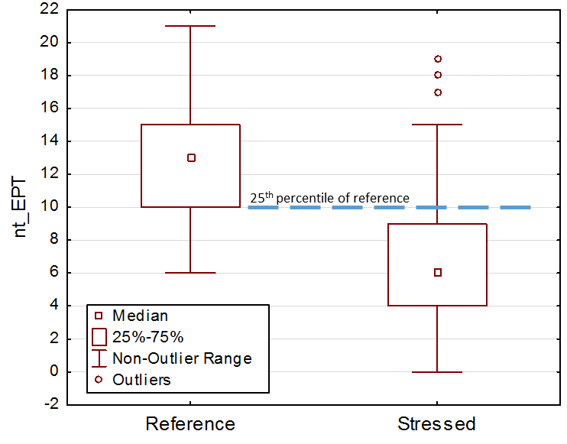

Figure . Illustration of discrimination efficiency using box plots to show that the 25th percentile of the reference distribution for nt\_EPT is the standard to which the stressed distribution is compared. In this example, where boxes show interquartile ranges, the DE is somewhat greater than 75%.

The DE and *Z*-scores epitomize the difference in distributions at critical potential threshold levels and incorporate precision of the reference distribution. They were used in favor of a t-test or signal:noise (S:N) ratio. The DE is an estimate of the percentage of correct impaired assessments and can be interpreted for management applications. While the *t*-test has been used elsewhere (Stoddard et al. 2008), we did not use it because we are not testing a hypothesis about the difference between reference and stressed sites. The *Z*-score and S:N ratio are similar measures of responsiveness as a function of variability.

**Calibration and Confirmation Data**

Index performance was validated with a set of samples that were not used in index calibration. Validation data were expected to perform nearly as well as calibration data. This was evaluated by comparing validation data to the reference calibration 25th or 75th percentiles. Where sufficient data were lacking for both calibration and validation, only calibration results were reported. Assessments using unvalidated indices should be tentative.

## 3.6 Index Composition and Evaluation

Alternative index compositions were formulated from the best performing metrics in each metric category. The metrics were combined by first scoring them and then averaging the scores. Each alternative index was then evaluated for discrimination efficiency and other measures of representativeness and sensitivity. Multiple index formulations were created and evaluated in two ways: manual metric substitutions and automatic all-subsets modeling.

In the manual substitution method, the best metrics were included in an initial index and subsequent index alternative were formulated by removing, adding, or substituting metrics. The performance of each index formulation was used to determine whether the latest alternative was an improvement. New formulations built upon the best performing alternatives.

In automatic all-subsets modelling, which was only applied in the macroinvertebrate assemblage, the best 10-20 candidate metrics in each site class were selected for inclusion in index trials based on discrimination efficiency and Z-score. An “all subsets” routine in R software was used to combine up to 8 metrics in multiple index trials and evaluate each index for performance using DE, Z-score, number of metric categories, and redundancy of component metrics. Those models including two or more correlated metrics (-0.75≤ r ≥0.75) were excluded from consideration. As many metric categories as practical were represented in the index alternatives so that signals of various stressor-response relationships would be integrated into the index. While several metrics should be included to represent biological integrity, redundant metrics can bias an index to show responses specific to certain stressors or taxonomic responses.

Models were further screened and preference was given to those:

* With relatively high DE and Z-scores
* With a set of metrics representing a higher number of metric categories
* With individual metrics having the following characteristics:

- High overall DE within and among site classes

- Familiar response mechanisms

- No conceptual redundancy regardless of statistical correlations

- Straightforward calculations

## 3.7 Threshold recommendations

Biological assessment using an index lends itself to define thresholds between acceptable and unacceptable conditions. The thresholds can be used to identify sites and samples that represent impaired biological conditions. Management actions can be triggered or prioritized based on assessment relative to an index threshold.

A threshold for an index can be defined in several ways. While index thresholds will not be finalized through this analysis, they will be suggested along with possible interpretations of passing or failing biological conditions. Threshold setting approaches include divergence from reference conditions and calibration to the BCG scale.

The distribution of index values from reference sites and statistics of that distribution can be used as a standard for assessing new samples. If the new sample has an index value that is similar to the reference values, then the assessed condition of the test sample is that it is similar to reference conditions. That is often equated with ‘unimpaired’ biological conditions. A threshold can be derived from the reference distribution that recognizes the variability and error in sampling and identifying reference sites. For example, the 25th percentile of reference is a standard that has often been used as an assessment threshold (e.g., Yoder and Rankin 1995). The 25th percentile is highlighted in this section as a possible general use threshold.

The BCG Levels are associated with narrative conditions that are ecologically meaningful. BCG Levels 2 and 3 are generally associated with high quality conditions, possibly representing exceptional aquatic life use conditions. At BCG Level 4, there are moderate changes in the structure of the fish assemblage and minimal changes in ecosystem function relative to natural conditions (USEPA 2016). BCG Levels 5 and 6 are characterized by moderate to severe changes in community structure and function. When modified uses are recognized, such as in channelized streams, biological expectations might be derived from Level 5.

BCG Level 4 is a critical level for deriving thresholds for general use (Bouchard et al. 2016). Biological experts involved with BCG calibrations have indicated that general use aquatic life goals are characterized by BCG Levels 3 or 4 (Davies and Jackson 2006, Gerritsen et al. 2013). There are usually more samples in Level 4 than in other Levels, allowing calculation of Level 4 statistics in smaller data sets that might not have many samples in other BCG Levels. The moderate changes in structure at Level 4 are due to replacement of some intermediate sensitive taxa by more tolerant taxa, and reproducing populations of some sensitive taxa are maintained. Overall, there is a balanced distribution of all expected major taxonomic groups in Level 4.

When adequate samples are available in BCG Level 3, index statistics can be derived that might be appropriate for evaluating streams for exceptional use. Exceptional use conditions are generally associated with sites with minimal disturbance, such as the best reference sites, where they exist. BCG Levels 2 and 3 might also represent exceptional biological conditions. The median of index scores in BCG Level 3 are highlighted as a possible index threshold for identifying exceptional biological conditions. Thresholds for exceptional use have also been derived from the upper quantiles of reference distributions (Bouchard et al. 2016, Yoder and Rankin 1995).

Thresholds for modified uses could be established for streams with modified channels such as agricultural ditches or armored urban channels. Modified channels were not explicitly addressed in the index development process, so there is not an established expectation for modified use conditions (no reference channels have been identified). IDEM intends to best attainable conditions for modified channels. In Minnesota, the median of index scores for BCG Level 5 were appropriate for deriving a modified use threshold (Bouchard et al. 2016). The median of Level 5 index scores is therefore highlighted as a potential lower threshold in Indiana. However, at this time such a lower threshold is not validated.

The statistics from BCG levels are compared to reference distribution statistics. While these might be appropriate for evaluating exceptional, general, or modified uses, the establishment of uses and thresholds are not in the scope of this report. IDEM might establish thresholds based on the statistics presented after consideration of other analyses and factors.

# 4.0 Results

## 4.1 Reference conditions

Criteria were set for the 13 primary criteria based on distributions of values in the entire upstream catchments and in partial catchments 1 and 5 km upstream from the sampling sites (Table 6). Population density was the only variable not measured at the 1 and 5 km scale because population information was spatially coarse, based on political units instead of remotely sensed land units. Reference thresholds for individual variables were set so that several sites would pass. When combining criteria, the number of sites is reduced because most reference criteria must pass at the site. Conversely, failure of a single stressed criterion could remove a site from the possible reference pool and only 2 stressed criteria were required to designate a stressed site, so the stressed criteria for individual variables were set to identify a smaller proportion of sites than the reference criteria. Distributions for each variable in the whole catchment are shown in Appendix A. For a site to pass a criterion for a reference designation, it was required to pass at all 3 spatial scales. Failure of a stressed criterion was based on failure of one or more of the spatial scales.

Table . Reference (Ref) and Stressed (Strs) criteria for 13 primary variables, by catchment delineation: whole catchment (W), within 5 km (5K), and within 1km (1K).

|  |  |  |  |
| --- | --- | --- | --- |
|  | Ref Criterion | Strs Criterion | Units |
| POP\_DENSITY | <10 | >200 | People/km2 |
| W\_%\_URBAN | <5 | >40 | % in catchment |
| 5K\_%\_URBAN | <5 | >40 | % within 5km |
| 1K\_%\_URBAN | <5 | >40 | % within 1km |
| W\_%\_AGRIC | <40 | >90 | % in catchment |
| 5K\_%\_AGRIC | <40 | >90 | % within 5km |
| 1K\_%\_AGRIC | <40 | >90 | % within 1km |
| W\_%\_IMPERV | <2 | >12 | % in catchment |
| 5K\_%\_IMPERV | <2 | >12 | % within 5km |
| 1K\_%\_IMPERV | <2 | >12 | % within 1km |
| Wd\_RD\_CROSS | <50 | >100 | #/100km2 |
| 5K\_RD\_CROSS | <5 | >25 | # within 5km |
| 1K\_RD\_CROSS | <1 | >5 | # within 1km |
| W\_RD\_DENSE | <1 | >5 | km road/km2 |
| 5K\_RD\_DENSE | <1 | >5 | km/km2 within 5km |
| 1K\_RD\_DENSE | <1 | >5 | km/km2 within 1km |
| W\_%\_CANAL/PIPE | <20 | >80 | % in catchment |
| 5K\_%\_CANAL/PIPE | <20 | >80 | % within 5km |
| 1K\_%\_CANAL/PIPE | 0 | >80 | % within 1km |
| Wd\_MINES | <0.1 | >0.5 | #/100km2 |
| 5K\_MINES | <1 | >2 | # within 5km |
| 1K\_MINES | 0 | >1 | # within 1km |
| Wd\_NPDES | <1 | >15 | #/100km2 |
| 5K\_NPDES | 0 | >10 | # within 5km |
| 1K\_NPDES | 0 | >2 | # within 1km |
| Wd\_CERCLIS | <0.5 | >2 | #/100km2 |
| 5K\_CERCLIS | 0 | >2 | # within 5km |
| 1K\_CERCLIS | 0 | >1 | # within 1km |
| Wd\_CAFO | <2 | >10 | #/100km2 |
| 5K\_CAFO | <1 | >4 | # within 5km |
| 1K\_CAFO | 0 | >1 | # within 1km |
| Wd\_TRI | <1 | >10 | #/100km2 |
| 5K\_TRI | <1 | >10 | # within 5km |
| 1K\_TRI | 0 | >2 | # within 1km |
| Wd\_dDAMS | <0.1 | >1 | #/100km2 |
| 5K\_DAMS | <1 | >2 | # within 5km |
| 1K\_DAMS | 0 | >1 | # within 1km |

The preliminary disturbance categories were assigned to sites based on the numbers of primary reference criteria that indicated either reference or stressed conditions (Table 7). For a site to be considered in any of the reference categories, it could not have any indications of stress. In contrast, the levels of stress were assigned regardless of the number of reference criteria that were passed.

Table . Preliminary disturbance category assignments based on reference and stressed criteria.

|  |  |
| --- | --- |
| Category | Rule or description |
| Reference | No criteria indicate stress for BestRef, Ref, or SubRef |
| BestRef | 12 -13 of 13 criteria indicate reference |
| Ref | 10 - 11 of 13 criteria indicate reference |
| SubRef | 8 - 9 of 13 criteria indicate reference |
| Other | <8 criteria indicate reference and <2 criteria indicate stress |
| Stressed | Stressed designations do not depend on reference indications |
| Strs | 2 – 3 of 13 criteria indicate stress |
| HiStrs | 4 or more variables indicate stress |

The IDEM review of preliminary reference designations was principally done using staff familiarity with the sites and their professional judgment regarding accuracy of the designations. They were encouraged to veto reference designations when they had justification or knowledge that was not available in the data set. Reference designations that reviewers disagreed with were moved towards the middle of the scale, towards the “Other” designation. Justification included the secondary variables related to habitat and chemistry. IDEM developed criteria for habitat and 7 water quality variables (Appendix B). They used those criteria for general guidelines in confirming or re-designating reference designations. The review process resulted in changes for 73 reference designations, demoting 2 BestRef designations, 32 Ref designations, and 39 SubRef designations.

The final count of sites by reference designation and level III ecoregion reveals that BestRef and Ref sites are relatively sparse in the Central Corn Belt Plains, So. Michigan / No. Indiana Drift Plains, and Interior River Valleys & Hills (Table 8). At the other end of the scale, stressed sites are limited in the Interior Plateau. The uneven distribution of reference and stressed sites across the state was considered as the reference criteria were established. It was decided that the criteria should be consistent in all ecoregions instead of relaxing the criteria to allow more reference sites in some areas. Some of the sites had both fish and macroinvertebrate data, but not all sites had both biological communities collected, so the numbers in Table 8 might be reduced for some categories and regions when conducting specific analyses.

Table . Site counts by disturbance category and level III ecoregion.

|  |  |  |  |  |  |  |  |
| --- | --- | --- | --- | --- | --- | --- | --- |
| Ecoregion | n | Best  Ref | Ref | Sub  Ref | Other | Strs | Hi  Strs |
| 54 - Central Corn Belt Plains | 284 | 1 | 5 | 10 | 139 | 80 | 49 |
| 55 - Eastern Corn Belt Plains | 701 | 9 | 55 | 89 | 412 | 94 | 42 |
| 56 - So. MI / No. IN Drift Plains | 140 | 1 | 12 | 8 | 73 | 28 | 18 |
| 57 - Huron/Erie Lake Plains | 3 | 0 | 0 | 0 | 2 | 1 | 0 |
| 71 - Interior Plateau | 180 | 22 | 50 | 26 | 74 | 8 | 0 |
| 72 - Interior River Valleys & Hills | 150 | 4 | 6 | 26 | 98 | 14 | 2 |
| Totals | 1458 | 37 | 128 | 159 | 798 | 225 | 111 |

## 4.2 Site Classification

Site classification proceeded separately for macroinvertebrates and fish, but the underlying characteristics of the landscape in Indiana are common to both assemblages and can be described in this section. They provide background on the physical conditions that might result in naturally different expectations for macroinvertebrate and fish assemblages in different parts of the state. Additional site classification analyses are described in the macroinvertebrates and fish sections.

Only reference sites (BestRef and Ref) were used in site classification analyses. Reference sites were sparse in most areas of Indiana, with concentrated areas west of Bloomington, IN and in the Indian Kentuck River basin (Figure 4). Reference sites in the Interior River Lowlands were mostly along the eastern edge of that region.

Ecoregions incorporate important classification characteristics such as topography, soils, vegetation, elevation, latitude, longitude and more. In addition, they are easy to communicate because they are regional units of the landscape that are generally understood to have distinct characteristics that are important to aquatic organisms (please refer back to Figure 2 earlier in the document).

Other categorical regional classes were included in the classification analyses, including state river basins, hydrologic units, and natural regions. State basins are nine river basins that are used in the state rotating basin design for IDEM’s Surface Water Quality Monitoring Strategy (Figure 5). The hydrologic units (HUC6) are river drainage basins as defined for USGS categorization (Figure 5). They align with many of the state basins. The natural regions are alternatives to ecoregions, using similar landscape features to define homogenous regions in Indiana (Figure 6, Homoya et al. 1985).

 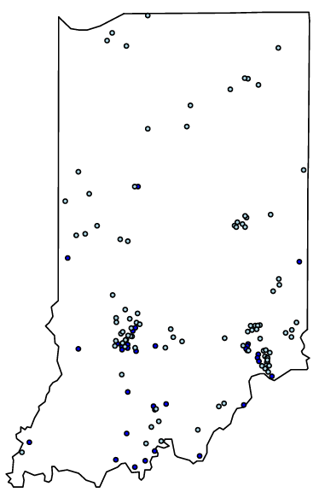 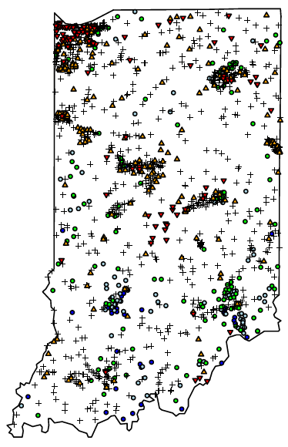

Figure . Site locations and reference designations. The figure on the left includes only BestRef and Ref sites as used in site classification analysis.



Figure . State river basins and hydrologic units (HUC6) in Indiana, overlaid on ecoregions.

Elevation in Indiana varies from the highest elevations on the eastern border with Ohio to the lowest elevations in the Interior River Lowlands in the southwest (Figure 7). In the east, the low hills range up to 383m above sea level at the highest elevation (Hoosier Hill). Low elevations are about 98m, along the Ohio River. The elevation of Lake Michigan is approximately 176m.

The Base Flow Index (BFI) is a measure of the base flow contributions to total stream flows, where low numbers indicate less groundwater discharge into stream channels. Groundwater discharge can influence stream temperature and consistency of flow. In Indiana, groundwater influence is highest along the state’s northern border (ecoregion 56) and is relatively low in the southeast corner of the state (ecoregion 55d) (Figure 7).

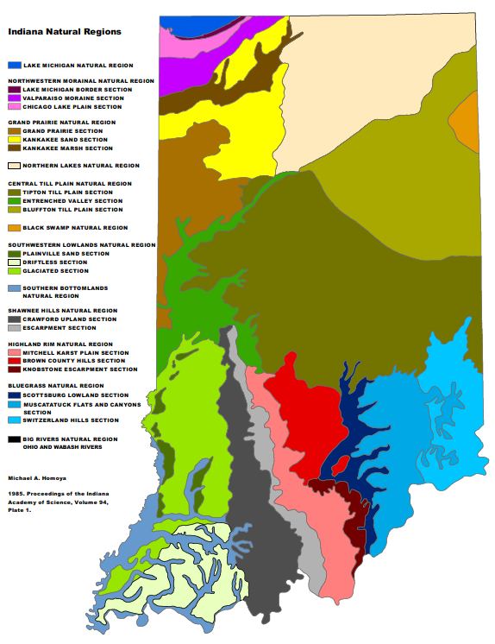

Figure . Natural regions of Indiana (Homoya et al. 1985).

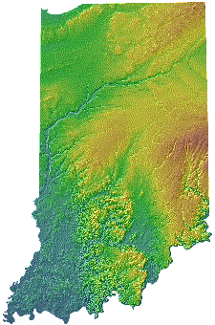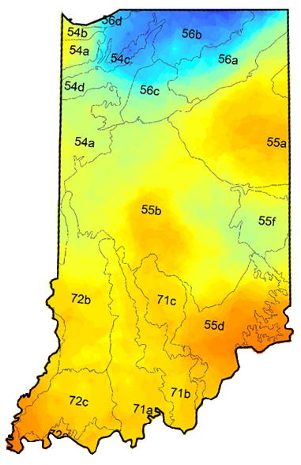

Figure . Topographic elevation (left) and the base-flow index (BFI, right) in Indiana, showing overlay with ecoregions. For elevation, brown areas are high elevation and blue-green areas are low areas. For the BFI, blue areas have more groundwater influence and orange areas have less groundwater influence.

## 4.3 Macroinvertebrates Index Development

### 4.3.1 Site Classification for Macroinvertebrates

Three analyses were conducted to explore and corroborate indications that the macroinvertebrate assemblage has distinct characteristics depending on the natural environmental setting. These methods included ordination of taxa and metrics, mapping spatial distributions of taxa across Indiana, and a PCA of natural environmental characteristics. Metric distributions were examined in proposed site classes for confirmation. Results are presented below in that order.

**Ordination Analysis**

Best reference and reference sites with macroinvertebrate data and minimal disturbance (N = 93) were used in non-metric multidimensional scaling (NMS) ordinations. There was a high concentration of sites in the south-central (east of Bloomfield) and southeast (Indian Kentuck Creek) regions (see Figure 4 (above)). The imbalanced spatial distribution of reference sites was recognized in the classification analysis as a possible source of bias, possibly indicating more specific site classification where reference sites were dense.

The macroinvertebrate samples were standardized in terms of sample size and taxonomic specificity. Sample sizes ranged from 26 – 443 individuals (median 100), with 25 samples having >150 individuals. For this analysis, the large samples were re-sampled to 150 individuals through a simple random selection of individuals for ordination analysis. Small samples can appear as outliers at the borders of the ordination diagrams.

There were 112 common taxa after reducing the list to eliminate uncommon taxa and inconsistent taxonomic levels. The operational taxonomic units (OTU) were determined as the most common taxonomic identification occurring in more than 4 reference samples. Family-level identifications were eliminated if genus-level information within the family was abundant and diverse. If the genera were uncommon (< 5 occurrences) or were limited to a single common genus, then all identifications were rolled up to the family-level. Genus and species identifications were treated in the same fashion. In all cases, the OTU were established to weigh the advantages of retaining specificity against losing information of uncommon or coarse identifications. *Caenis* and *Orconectes* were the most commonly occurring taxa.

The NMS ordination using taxa presence/absence (PA) data took precedence over ordinations based on relative abundance or metrics. The PA ordination identified 3 significant axes and had a final stress of 20.4, compared to a target stress of 20 or less. Axes 1 and 2 distinguished the greatest amount of taxonomic variability in the diagram. Variables associated with the first axis included the BFI, sandy soils, and total taxa, which had high values on the left side of the diagram. The right of the diagram had eastern sites with clay soils collected later in the year. The BFI and percent clay in the soils were strongly associated with the first axis (Figure 8), as was longitude. The second and third axes were not strongly related to environmental variables or metrics.

When ecoregions were overlaid in the ordination diagram, the Central Corn Belt Plains and So. Michigan / No. Indiana Drift Plains (54 and 56) are in the lower left where there is relatively high BFI and low percent clay in the soils (Figure 9). Ecoregion 71a is left central, 71d is upper right, and 55d is general on the right. Ecoregions 71a and 71d contain the large numbers of reference sites associated with the south central and Indian Kentuck Creek regions, respectively.

Additional distinctions are evident when overlaying the state basins on the diagram (Figure 10). The Ohio tributaries are mostly in the upper right of the diagram. The Great Lakes and Kankakee-Iroquois basins appear in the lower left. The center of the diagram has sites from the Lower Wabash, White River, Patoka, Great Miami, with some distinction between the east and west forks of the White River.



Figure . NMS ordinations showing strong associations of percent clay in soils and the BFI with the first axis.



Figure . NMS ordination diagram showing sites in level 4 ecoregions.



Figure . NMS ordination diagram showing sites in state monitoring basins.

The NMS ordination indicated that latitude and longitude were relatively strong determinants of taxonomic types in reference sites, suggesting that a regional classification scheme could be appropriate for parsing the natural variability in the macroinvertebrate assemblage. Groundwater influence, as measured by the BFI, varied regionally and the regional differences were aligned with ecoregions. Soil characteristics were correlated to the first NMS axis and also vary regionally. State basins showed some distinctions in the NMS ordination that were clearer than the distinctions based on ecoregions alone. For example, the Ohio tributaries are grouped in the upper right of the diagram, where ecoregions 55d and 71d overlap. Classes based on a combination of level 4 ecoregion and state basin aggregations appeared to account for some biological types. North-central and Southwest regions are represented by few reference sites, so differences in these regions were investigated with other classification methods. Patterns observed in the presence/absence NMS diagram were generally supported in the relative abundance NMS and metric PCA (Appendix C).

Site classes for macroinvertebrates were drafted based on the NMS ordinations and were confirmed through additional analysis to determine validity for index development (Figure 11). In concurrent exercises, the BCG workgroup considered these classes and decided to combine classes for the BCG models. They defined a northern model, including the Northern, North-Central, and Southwest classes, and a southern model, including the Southeast and South-Central classes.

1 **Northern**: Ecoregions 54 and 56

2 **North-Central**: Ecoregions 55a, b, f, and d if it is in Great Miami. Also 57

3 **Southeast**: Ohio Tributaries of ecoregions 71d and 55d

4 **South-Central**: Ecoregions 71 and 55d in the EFWR

5 **Southwest**: Ecoregion 72

**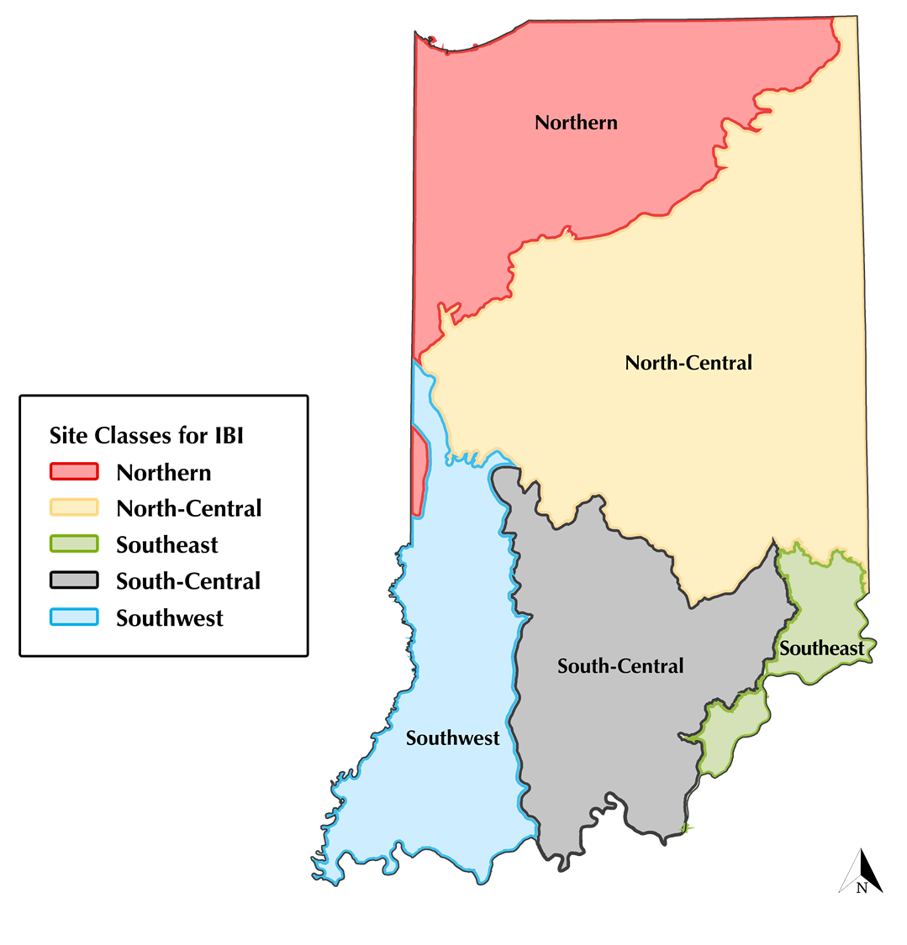**

Figure . Site classes for macroinvertebrate index development.

**Taxa Distributions**

The spatial distribution of macroinvertebrate taxa across Indiana was a mapping exercise that allowed inspection of the occurrence and relative abundance of taxa, aggregated at a common identification level and regardless of disturbance category. Therefore, 168 taxa represented in 777 sites (including all sites, not just reference sites) were mapped and spatial patterns were observed in the context of regional classes suggested by the ordination analysis. The following shows pertinent examples of spatial patterns. All distributions are shown in Appendix D.

Several taxa occurred predominantly in the south of Indiana, such as *Basiaeshna* (Odonata: Aeshnidae), *Stenonema* (Ephemeroptera: Heptageniidae), and Psephenidae (Coleoptera) (Figure 12). Taxa occurring mostly in the north of the state included *Aeshna* (Odonata: Aeshnidae), *Dubiraphia quadrinotata* (Coleoptera: Elmidae), and *Gammarus* (Amphipoda: Gammaridae), among others (Figure 13). Distinctions in taxa distributions from east to west in the state were less common and less consistent than those from north to south. Taxa in the east included *Helicopsyche* (Trichoptera: Helicopsychidae) and in the west included *Coptotomus* (Coleoptera: Dytiscidae) and *Stylurus* (Odonata: Gomphidae) (Figure 14). Some taxa were conspicuously absent from particular regions. For example *Leucrocuta* (Ephemeroptera: Heptageniidae), *Maccaffertium pulchellum* (Ephemeroptera: Heptageniidae), and *Optioservus* (Coleoptera: Elmidae) were missing from the Interior River Lowlands in southwest Indiana.

The spatial patterns observed in taxa throughout Indiana generally supported site classes suggested by the ordination analysis. Distinctions were common and consistent from north to south, though not along clear-cut ecoregional lines. Distinctions east to west were less obvious, though a few taxa fit the site class patterns due to conspicuous absence from one or more site class or ecoregion.

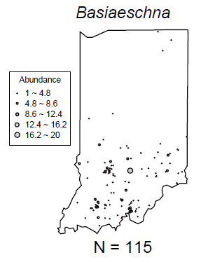 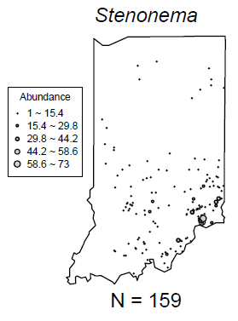 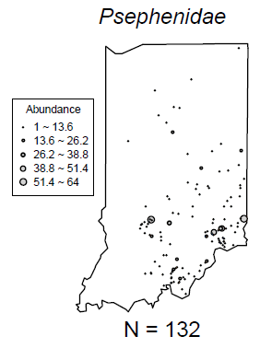

Figure . Macroinvertebrate taxa occuring predominantly in the south of Indiana.

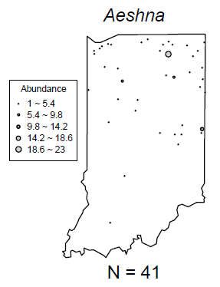 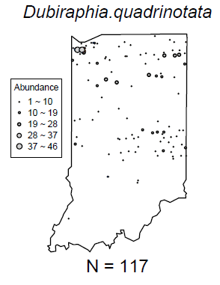 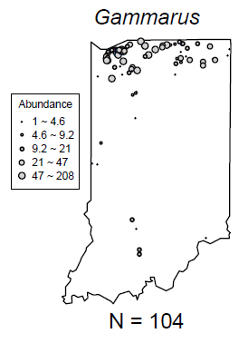

Figure . Macroinvertebrate taxa occuring predominantly in the north of Indiana.

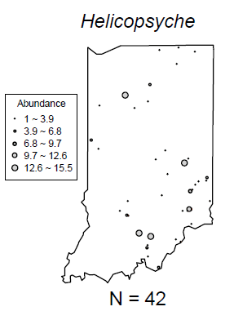 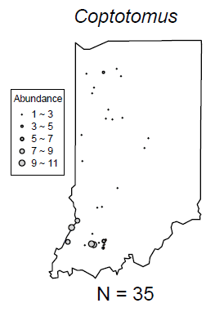 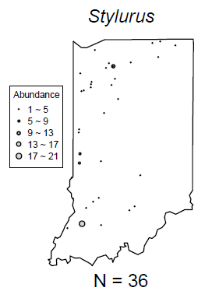

Figure . Macroinvertebrate taxa occuring predominantly in the east or west of Indiana.

**PCA of Environmental Variables**

The first three PCA factors explained 75% of the variability in the classification variables. The first factor explained 37% of the variability and was related to latitude, elevation, BFI, and sandy soils on the positive end and to temperature, precipitation, and land slope on the negative end (Table 9). Of the macroinvertebrate metrics, which were supplemental variables, the percent non-insect metric was positively related to the first component. The southeast, south-central and southwest site classes had similar factor scores on the first component (Figure 15 (top)). The north and north central factor scores were distinct.

Factor two explained an additional 26% of variability and was related to catchment area and flow on the positive end and with stream gradient on the negative end. The southeast site class was distinctive, generally having higher stream gradients and smaller catchments than the other regions (Figure 15 (middle)). Macroinvertebrate metrics were not strongly related to the second component.

Factor three was related to longitude (east), elevation, area, and flow on the positive end and with sandy soils on the negative end. Factor 3 coordinates were somewhat different in ecoregions 55, 57, and 71d in contrast to the other ecoregions (Figure 15 (bottom)). A similar pattern is observed in the proposed site classes, where the North-Central and Southeast classes are different from the North and Southwest classes (Figure 15 (bottom)). South-Central factor three coordinates were intermediate of those class groupings. Several metrics were moderately correlated to the third factor.

Table . Factor coordinates of the active and supplemental variables.

|  |  |  |  |  |  |  |  |
| --- | --- | --- | --- | --- | --- | --- | --- |
| Active Variable | Factor 1 | Factor 2 | Factor 3 | Supplemental Variable | Factor 1 | Factor 2 | Factor 3 |
| Latitude | 0.94 | 0.14 | -0.10 | nt150\_EPT | -0.04 | 0.07 | 0.37 |
| Longitude | 0.15 | -0.30 | 0.88 | nt150\_Coleo | -0.05 | -0.01 | 0.13 |
| Gradient | 0.07 | -0.89 | 0.07 | nt150\_ffg\_scrap | -0.11 | -0.09 | 0.30 |
| Slope | 0.09 | -0.83 | 0.05 | nt150\_ffg\_pred | -0.03 | 0.13 | -0.02 |
| Elevation | 0.70 | -0.32 | 0.54 | nt150\_total | 0.04 | 0.02 | 0.27 |
| Drainage Area | -0.27 | 0.82 | 0.40 | nt150\_tv\_intol | 0.00 | 0.02 | 0.34 |
| Stream Density | -0.04 | 0.27 | 0.04 | pi\_Chiro | -0.03 | -0.04 | 0.02 |
| Land Slope | -0.60 | -0.42 | 0.01 | pi\_dom05 | 0.06 | 0.03 | -0.25 |
| Sand in Soils | 0.67 | 0.29 | -0.31 | pi\_EPT | -0.16 | -0.12 | 0.37 |
| BFI | 0.82 | 0.14 | -0.18 | pi\_NonIns | 0.41 | -0.14 | -0.27 |
| Air Temperature | -0.96 | -0.05 | -0.14 | pi\_tv\_toler | 0.21 | -0.02 | -0.32 |
| Precipitation | -0.94 | -0.16 | -0.05 |  |  |  |  |
| Stream Flow | -0.32 | 0.79 | 0.40 |  |  |  |  |

In general, the PCA analysis supports the proposed site classes. The basic PCA analysis suggested that the Great Miami state basin sites in 71d and 55d should be classified with the north-central region. IDEM suggested that the Great Miami sites might be better classified with the South-Central class, prompting a targeted investigation for the sites (Appendix E). The additional investigations confirmed the original classification scheme.

 

 

 

Figure . PCA factors 1-3 by proposed site classes and level 4 ecoregions. The ecoregions are shown to be associated with the site classes, though there are exceptions based on state basins.

**Metric Distributions**

Value distributions of selected metrics that are typically seen in multimetric indices were displayed in the proposed site classes to discern differences or similarities that could be used to lump similar classes or split diverse classes. Only reference (BestRef and Ref) sites were used to limit the effects of stressors on the classification signals. Sample sizes differed among site classes, with the North, North-Central, and Southwest classes having very few sites upon which to make any robust interpretations (Figure 16).



Figure . Numbers of reference (BestRef and Ref) samples in each proposed site class.

The reference metric distributions generally show distinctions for one or two site classes per metric, confirming the proposed site classes. The Southwest and South-Central regions have several overlapping metric distributions. The Southeast metric distributions are most often distinctive from the other classes. For example, the Southeast region has the least richness compared to other classes and the greatest percent individuals of EPT after resampling to a consistent subsample size of 150 individuals (Figure 17). Ephemeroptera, Plecoptera, and Trichoptera (EPT) taxa are most diverse in the North-Central region, in general (Figure 17). The percent non-insects metric is greatest in the North compared to other regions (Figure 17). Additional metric distributions are displayed in Appendix F.



 

Figure . Metric value distribution in reference (BestRef and Ref) sites among proposed site classes. Metrics include total taxa (nt150\_total), EPT taxa (nt150\_EPT), percent non-insects (pi\_NonIns), and percent EPT (pi\_EPT).

Because there are few reference sites in the North, North-Central, and Southwest site classes, sub-reference, other, and stressed sites were also evaluated for metric distributions. The Sub-reference (SubRef) sites could supplement the BestRef and Ref sites, making development of indices feasible for site classes with few BestRef and Ref sites (e.g., North, North-Central, and Southwest classes (Figure 18).

In general, the SubRef distributions resemble Ref and BestRef in each class (Figure 19 and Appendix G). They differ among site classes in ways that resemble differences observed in the BestRef and Ref categories. When SubRef distributions differ from Ref and BestRef within classes, the SubRef metric values shift in the direction of those in stressed sites. These patterns suggest that the classes derived from BestRef and Ref sites are robust when adding more sites, but with somewhat increased disturbance levels.

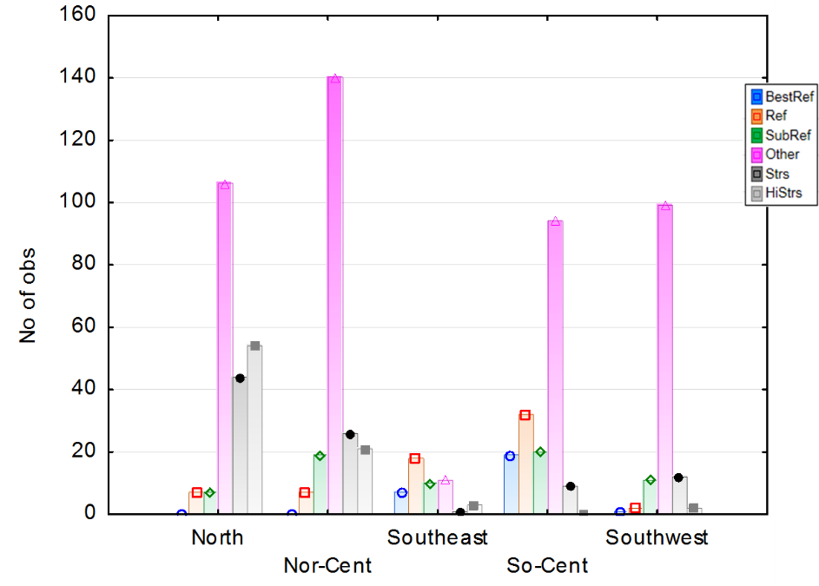

Figure . Sample sizes by site class and disturbance category.

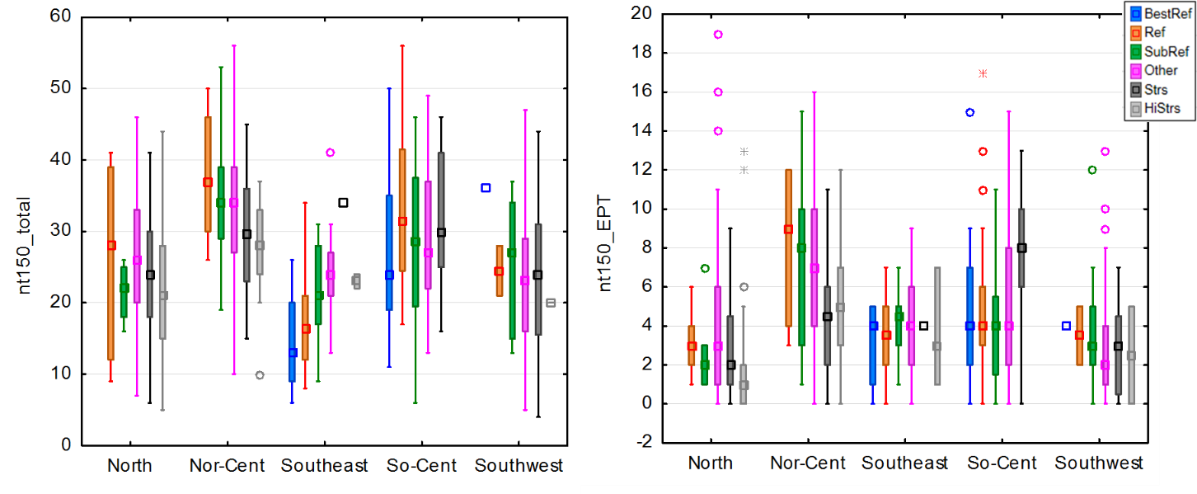

Figure . Total taxa richness and EPT taxa richness by site class and disturbance category.

The pattern with metric distributions among disturbance categories also suggests that the SubRef samples could be used in the stressor gradient for index development. The intolerant taxa richness metric decreases noticeably between Ref and SubRef disturbance categories in the North and North-Central site classes (Figure 20). The use of SubRef samples as part of the reference set in index development was decided through iterative testing of metric responsiveness and performance evaluation. In general, the SubRef sites masked some of the metric responsiveness.

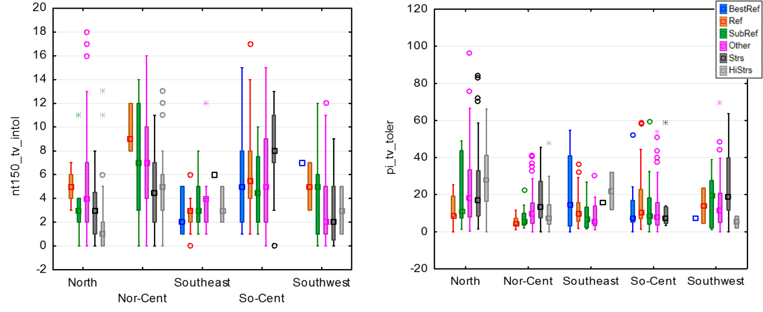

Figure . Intolerant taxa richness and percent tolerant individuals by site class and disturbance category.

**Effects of macroinvertebrate sample size**

The number of organisms in Indiana macroinvertebrate samples is highly variable, ranging from 6 – 1559 individuals. The intraquartile range is from 84 – 183 individuals. This variability was not known to be associated with either natural environmental conditions or with stressors. The number of taxa in samples is typically related to the number of individuals, so that subsampling to standardize sample size is often recommended to assess taxa richness on a relative scale. Because IDEM does not subsample or otherwise target a sample size, the effect of the sample size variability on assessment signals was suspected of being confounded with effects associated with environmental conditions.

The suspected pattern of increasing richness with increasing sample size was evident in the Indiana data. However, the number of individuals in the sample was not strongly related to site class, watershed area, gradient, or any of the PCA factors developed during site classification analysis (Appendix H). Except for rarefaction during classification, the samples were not re-sampled during index development.

### 4.3.2 S*tressor Associations with Macroinvertebrate Taxa*

As a first step in assessing stressor-response relationships with macroinvertebrate taxa, the prominent stressors in the landscape and available in the data set were compared to select the most meaningful and available stressors and to eliminate potentially redundant stressor signals. A Spearman correlation analysis among stressors revealed that conductivity was strongly related to both chloride and sulfate (Table 10). Conductivity was more commonly measured and might be a better stressor to analyze than these other ions. Conductivity was related to a lesser degree to imperviousness and percent agricultural and urban land. Imperviousness reflects the degree of urban hard-scape in the catchment, which would affect stream flow conditions and not just the concentration of ions. TN and TP were correlated at 0.49 rho, indicating a fairly strong association. The Qualitative Habitat Evaluation Index (QHEI) was only somewhat related to watershed size, with better habitat in larger catchments (Figure 21).

Table 10 Spearman correlation coefficients among environmental variables

|  |  |  |  |  |  |  |  |  |  |  |  |  |
| --- | --- | --- | --- | --- | --- | --- | --- | --- | --- | --- | --- | --- |
|  | Impv | AgUrb | Ag | QHEI | TP | TN | cond | Cl | Sulfate | WShd | Turb | DO |
| AgUrb | 0.36 |  |  |  |  |  |  |  |  |  |  |  |
| Ag | 0.03 | 0.84 |  |  |  |  |  |  |  |  |  |  |
| QHEI | -0.11 | 0 | 0.08 |  |  |  |  |  |  |  |  |  |
| TP | 0.32 | 0.42 | 0.40 | -0.08 |  |  |  |  |  |  |  |  |
| TN | 0.16 | 0.61 | 0.63 | -0.1 | 0.49 |  |  |  |  |  |  |  |
| cond | 0.52 | 0.45 | 0.33 | -0.05 | 0.31 | 0.22 |  |  |  |  |  |  |
| Cl | 0.75 | 0.43 | 0.19 | -0.02 | 0.38 | 0.21 | 0.66 |  |  |  |  |  |
| Sulfate | 0.38 | 0.12 | 0.07 | -0.21 | 0.12 | 0.1 | 0.65 | 0.35 |  |  |  |  |
| WShd | 0.15 | 0.1 | 0.21 | 0.32 | 0.2 | 0.24 | 0 | 0.01 | 0.02 |  |  |  |
| Turb | -0.04 | -0.02 | 0.05 | -0.22 | 0.29 | 0.15 | -0.03 | 0.04 | 0.1 | 0.18 |  |  |
| DO | -0.03 | 0.05 | 0.11 | 0.23 | -0.22 | 0 | 0.1 | 0.11 | 0.13 | 0 | -0.16 |  |
| TSS | 0.15 | 0.18 | 0.2 | -0.2 | 0.53 | 0.31 | 0.08 | 0.14 | 0.15 | 0.25 | 0.63 | -0.1 |



Figure 21 Correlations between QHEI and imperviousness and watershed size

**Canonical correspondence analysis (CCA)**

Canonical correspondence analysis (CCA) was performed separately on two different sets of data. The first was based on relative abundance of the original taxonomic Final ID without further manipulation, the second merged species level data into genus level data. Both of the CCA did well in explaining more than 40% total variances in the first two axes of environmental variables (Table 11).

The two main axes of the CCA were slightly different in the species vs. genus level analyses, but consistently represented two main environmental factors. The first axis was related to watershed size and the second axis was related to habitat quality. Other factors were significant but not as strong as these two factors. Though the QHEI and watershed size were somewhat related in the correlation analysis, they are almost orthogonal when also related to the relative abundance taxonomic data (Figure 22). This suggests that the QHEI can be assessed as a stressor that is not just a reflection of catchment size.

Table 11 Correspondent Analysis using species and genus level relative abundance data and environmental variables

|  |  |  |  |  |
| --- | --- | --- | --- | --- |
|  | Species CCA | | Genus CCA | |
|  | Axis 1 | Axis 2 | Axis 1 | Axis 2 |
| Eigenvalue | .301 | .244 | .293 | .253 |
| Prop. Explained | .224 | .182 | .237 | .206 |
| Cumul. Prop | .224 | .406 | .238 | .444 |

C:\AllFiles\Current_Project\BCG\IN\SI_BUG\results\CCA.both.tif

Figure 22 Canonical correspondent analysis of species and genus level data and correspondent environmental factors

**Nonmetric multidimensional scaling (NMS)**

NMS analysis was performed using Bray-Curtis taxonomic dissimilarity among stations. Environmental variables were superimposed on the ordination diagram to discern gradients related to sample composition. NMS shows the same pattern as the CCA plots. Four variables are shown in Figure 23: imperviousness, QHEI, conductivity, and watershed size. QHEI and watershed size were among the strongest factors, along with nutrients, conductivity, and imperviousness.

C:\AllFiles\Current_Project\BCG\IN\SI_BUG\results\Invert_NMDS.tif

Figure 23 Nonmetric multidimensional scaling, showing gradients of imperviousness, QHEI, conductivity, and watershed size related to taxonomic composition.

**Community Stressor-Response**

The mayfly, stonefly, and caddisfly diversity (EPT taxa) is typically used as an indicator of stream biological conditions. In a correlation analysis of EPT taxa against stressors, the strongest relationships between EPT taxa and environmental variables were with ammonia, habitat, and watershed size (Figure 24 and 25). EPT taxa richness is highest with low population density, a mid-range of dissolved oxygen (6-12 mg/L), and a mid-range of specific conductance (300-900 µS/cm).

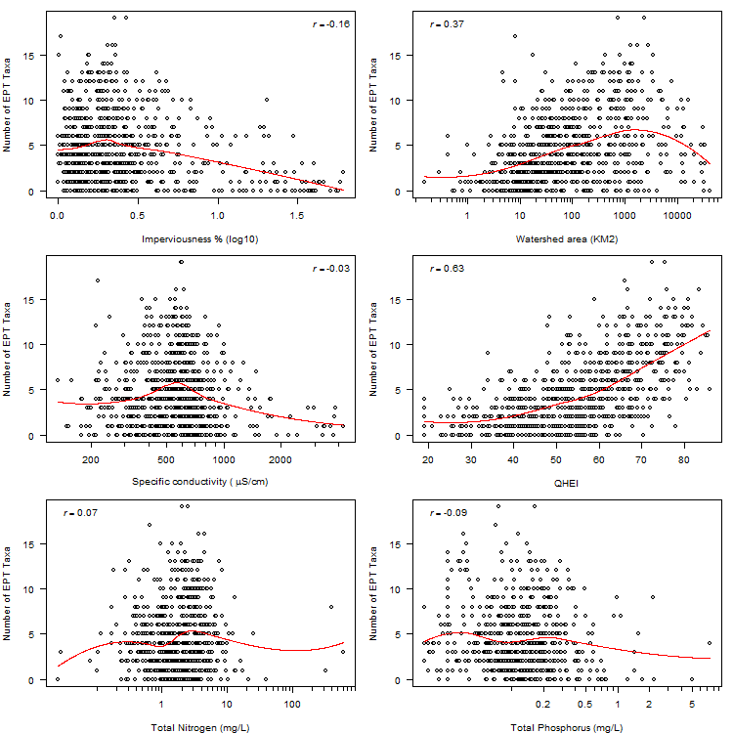

Figure . Relationships between the number of EPT taxa and environmental variables.

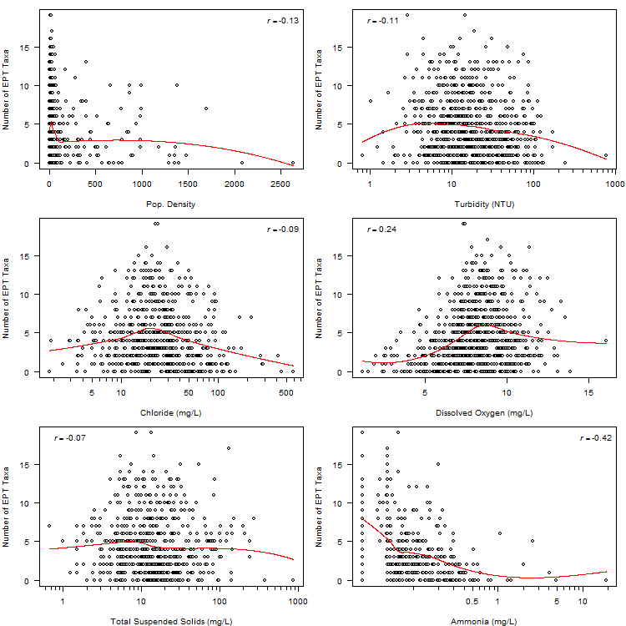

Figure . Relationships between the number of EPT taxa and environmental variables.

**Tolerance Value Designations**

Five stressors were selected for application of the stressor-response models, including imperviousness, conductivity, QHEI habitat score, TP, and ammonia. A total of 565 taxa (family, genus, and species) with more than 10 occurrences in the data set were ranked. Greater confidence was afforded to 351 taxa that had more than 20 occurrences in the data set. Plots of each taxon against the stressors with the GAM model curves are shown in Appendix I. From these plots and tolerance ranks derived from the ranked results of 17 stressor-response models, IDEM biologists either confirmed existing tolerance values or revised them to reflect information from the stressor-response analysis (Appendix J). These results were also considered when IDEM and others assigned taxa attributes in the context of a BCG calibration.

### 4.3.3 Metric Sensitivity

No metrics showed consistent and strong trends in all site classes. Of those metrics that were somewhat consistent (Table 12), the tolerance metrics were most common. There was more consistency in metrics among the North, North-Central, and Southwest classes compared to the Southeast and South-Central classes. In the Southeast, there were only 4 stressed sites, which is a low number to give confidence to the response signal. Some of the most sensitive and consistent metrics included pt\_nonins, pt\_EPT, pi\_EPT, pi\_hab\_clngr, and pt\_intol. The South-Central class often showed metric trends that were opposite those in the other classes. Metric performance for all metrics is shown in Appendix K.

Metrics were correlated with specific stressors within each site class using all sites (not just reference and stressed). In the South-Central site class, almost all correlations that were stronger than 0.30 related to the habitat score. However, the average habitat score in reference and stressed sites was equal at 61 points each. The other stressors differed between reference and stressed sites (percent imperviousness, percent agricultural and urban land, TN, TP, and conductivity), but these were not correlated to the metrics. In addition, there were only 10 stressed sites. The inconsistent metric responses in the South-Central class can be interpreted as weak signals from few sites along a limited disturbance gradient.

### 4.3.4 Index alternatives

The best performing metrics that showed sensitivity and consistency among site classes were selected to be tested in alternative index compositions. Metrics were selected as good candidates for inclusion in indices based on DE and Z-scores within and among the site classes. Metrics that performed well in a single class, but showed opposite responses in other classes, were sidelined in favor of more dependable responses. Up to 20 metrics were selected in each of four site classes (excluding the South-Central class) (Table 13). The selected metrics were not the same for each site class. Instead, the strongest metrics in each site class were selected. The all-subsets model calculation and screening resulted in 20,000 – 40,000 index combinations to evaluate for each site class (except the South-Central).

Table . Macroinvertebrate metric DE (trend) and Z-score for selected metrics that show some consistency among site classes.

|  | North | | North-Central | | Southwest | | South-Central | | Southeast | |
| --- | --- | --- | --- | --- | --- | --- | --- | --- | --- | --- |
| Metric | DE (trend) | *Z-score* | DE (trend) | *Z-score* | DE (trend) | *Z-score* | DE (trend) | *Z-score* | DE (trend) | *Z-score* |
| **RICHNESS** |  |  |  |  |  |  |  |  |  |  |
| nt\_total | 58 (--) | 0.41 | 47.4 (-) | ***0.75*** | 45.5 (--) | 0.38 | 40 (++) | -0.39 | NR | -0.55 |
| pt\_nonins | 56.8 (++) | ***-1.04*** | 68.4 (++) | ***-1.75*** | 63.6 (++) | ***-1.35*** | NR | 0.06 | 75 (++) | -0.40 |
| nt\_Ephem | 40.7 (--) | -0.37 | 50 (-) | ***0.64*** | 54.5 (--) | ***0.73*** | 50 (++) | -0.36 | NR | 0.25 |
| nt\_EPT | 65.4 (--) | 0.36 | 42.1 (-) | ***0.67*** | 63.6 (--) | 0.59 | 80 (++) | ***-0.85*** | NR | 0.11 |
| pt\_EPT | 51.9 (--) | **0.51** | 44.7 (-) | 0.54 | 54.5 (--) | 0.45 | 50 (++) | -0.49 | 75 (--) | 0.41 |
| nt\_ECT | 66.7 (--) | **0.55** | 65.8 (--) | ***1.00*** | 54.5 (--) | ***0.62*** | 70 (++) | ***-0.85*** | NR | 0.31 |
| pi\_dom03 | 54.3 (++) | -0.07 | 50.8 (++) | ***-2.37*** | 50.8 (++) | ***-1.05*** | NR | 0.21 | 59.3 (--) | ***1.61*** |
| **COMPOSITION** |  |  |  |  |  |  |  |  |  |  |
| pi\_Ephem | NR | 0.13 | 65.8 (--) | ***0.70*** | 81.8 (--) | ***0.74*** | NR | 0.30 | 100 (--) | ***1.27*** |
| pi\_EPT | 55.6 (--) | 0.35 | 55.3 (-) | ***0.66*** | 72.7 (--) | ***0.69*** | 30 (+) | -0.31 | 100 (--) | ***1.27*** |
| pi\_NonIns | 29.6 (-) | 0.22 | 42.1 (++) | -1.42 | 63.6 (++) | -1.75 | NR | 0.24 | 75 (++) | -1.01 |
| pi\_Odon | 50.6 (++) | ***-2.05*** | NR | ***-0.93*** | NR | -0.27 | 50 (--) | 0.39 | 100 (++) | ***-5.91*** |
| **FEEDING GRP** |  |  |  |  |  |  |  |  |  |  |
| nt\_ffg\_scrap | 61.7 (--) | 0.30 | 63.2 (--) | ***1.19*** | 81.8 (--) | ***0.92*** | 60 (++) | -0.39 | 50 (++) | -0.42 |
| pi\_ffg\_shred | 35.8 (+) | ***-1.48*** | 57.9 (++) | ***-1.65*** | 81.8 (++) | ***-6.60*** | NR | -0.18 | 50 (++) | ***-2.43*** |
| **HABIT** |  |  |  |  |  |  |  |  |  |  |
| pi\_hab\_clngr | 46.9 (--) | **0.53** | 55.3 (-) | 0.60 | 81.8 (--) | ***0.62*** | 60 (++) | ***-1.04*** | 75 (--) | ***0.67*** |
| **TOLERANCE** |  |  |  |  |  |  |  |  |  |  |
| nt\_tv\_intol | 92.6 (--) | ***1.99*** | 89.5 (--) | ***1.71*** | 81.8 (--) | ***0.80*** | 40 (++) | -0.18 | NR | 0.06 |
| pi\_tv\_intol | 91.4 (--) | ***1.14*** | 97.4 (--) | ***1.63*** | 90.9 (--) | ***0.96*** | NR | 0.21 | NR | 0.41 |
| pi\_tv\_toler | 75.3 (++) | ***-1.85*** | 55.3 (++) | ***-4.13*** | 54.5 (++) | -0.53 | 40 (-) | 0.48 | NR | 0.28 |
| pt\_intol | 88.9 (--) | ***0.86*** | 100 (--) | ***1.97*** | 72.7 (--) | ***0.84*** | NR | 0.29 | 75 (--) | 0.44 |
| pt\_toler | 72.8 (++) | ***-1.86*** | 60.5 (++) | ***-2.30*** | 45.5 (++) | -0.53 | NR | 0.34 | NR | 0.12 |
| BeckBI | 80.2 (--) | ***1.64*** | 71.1 (--) | ***1.37*** | 90.9 (--) | ***0.87*** | 60 (++) | -0.45 | NR | -0.22 |
| HBI | 64.2 (++) | ***-0.80*** | 76.3 (++) | ***-2.42*** | 81.8 (++) | ***-0.84*** | 40 (-) | 0.23 | 75 (--) | 0.56 |

Table . Metrics included in the all-subsets routine for evaluating macroinvertebrate indices.

|  |  |  |  |  |  |  |
| --- | --- | --- | --- | --- | --- | --- |
| Category | Metric | North | North-Central | Southwest | South-Central | Southeast |
| Richness | TaxaperLogIndiv | X | X | X |  |  |
|  | ni\_total |  |  |  | X |  |
|  | pt\_nonins | X | X | X |  | X |
|  | nt\_EPT | X | X | X |  |  |
|  | pt\_EPT | X |  |  |  | X |
|  | nt\_ECT | X | X | X |  |  |
|  | pi\_dom03 | X | X | X |  |  |
|  | Shan\_2 |  | X |  |  |  |
|  | nt\_Coleo |  |  | X |  |  |
|  | pt\_Chiro |  |  |  |  | X |
| Composition | pi\_EPT | X | X | X |  | X |
|  | pi\_EPTnoBH |  | X | X |  | X |
|  | pi\_ETnoBH | X |  |  |  |  |
|  | pi\_ECTnoBH |  |  | X |  |  |
|  | pi\_Odon | X |  |  |  | X |
|  | pi\_Coleo |  |  | X |  |  |
|  | pi\_NonIns |  |  | X |  | X |
|  | pi\_Chiro |  | X |  |  |  |
| FFG | nt\_ffg\_scrap | X | X | X |  |  |
|  | pi\_ffg\_colomn | X | X |  |  | X |
|  | pi\_ffg\_pred | X | X |  |  | X |
|  | pi\_ffg\_shred |  | X | X |  |  |
|  | pi\_ffg\_filtr |  |  | X | X |  |
| Habit | nt\_hab\_clngr | X | X | X |  |  |
|  | pi\_hab\_clngr | X | X | X |  | X |
|  | Hab\_sm2 |  |  | X |  |  |
|  | Hab\_Dom |  |  |  | X |  |
| Tolerance | nt\_tv\_intol | X | X | X |  |  |
|  | pi\_tv\_toler | X | X | X |  |  |
|  | pt\_intol | X | X |  |  | X |
|  | pt\_toler | X |  |  |  |  |
|  | BeckBI | X |  |  |  |  |
|  | HBI |  | X | X |  |  |

The best performing indices were identified from among the all-subsets alternatives, while those resulting from the manual substitution generally did not perform as well. The substitution method was not exhaustive and usually included metrics that were more familiar as responsive indicators. The best seven or eight index alternative in each site class were presented to the IDEM biologists for their review, comment, and selection. The indices selected for final application were not necessarily those with the highest DE and Z-scores. No index was identified for the South-Central site class because the metric responses were inconsistent with expectations (see Table 12 above).

**North Site Class**

In the North site class, the selected index had DE and Z-scores, 87.7% and 2.0, that were nearly the best of all alternatives. This index (#6\_22454 in Table 14) included 6 metrics and all 5 metric categories. It was selected over other possible index alternatives because it favors richness over relative abundance metrics and does not contain the percent carnivore and omnivore metric. IDEM expressed preference for richness metrics when there was a choice. The two possible feeding group metrics were conceptually redundant and there was a preference to include only % predators. Percent predators increased with increasing stress in this site class. Total taxa richness was not an important metric in the best performing alternatives, while % non-insect taxa appeared in all the alternatives. Even though some alternative index compositions performed well without % EPT individuals, the metric was considered important to represent the composition metric category.

Table . The best seven macroinvertebrate index alternatives for the North site class. Metrics used in each alternative are listed as “1”.

|  |  |  |  |  |  |  |  |
| --- | --- | --- | --- | --- | --- | --- | --- |
| **NORTH** |  |  | Selection |  |  |  | Best Manual |
| ModelID | 6\_23896 | 6\_24884 | 6\_22454 | 6\_16349 | 6\_23483 | 5\_9228 |
| nt\_total | 0 | 0 | 0 | 0 | 0 | 0 | 1 |
| TaxaperLogIndiv | 0 | 1 | 0 | 0 | 0 | 0 | 0 |
| pt\_nonins | 1 | 1 | 1 | 1 | 1 | 1 | 1 |
| nt\_EPT | 0 | 0 | 0 | 1 | 0 | 0 | 1 |
| pi\_EPT | 0 | 1 | 1 | 0 | 1 | 1 | 1 |
| pi\_ffg\_colomn | 1 | 0 | 0 | 0 | 1 | 0 | 1 |
| pi\_ffg\_pred | 1 | 1 | 1 | 1 | 1 | 1 | 1 |
| nt\_hab\_clngr | 1 | 0 | 1 | 1 | 1 | 1 | 1 |
| pi\_hab\_clngr | 1 | 0 | 0 | 0 | 0 | 0 | 0 |
| pi\_tv\_toler | 0 | 0 | 0 | 0 | 0 | 1 | 1 |
| nt\_tv\_intol | 0 | 1 | 1 | 1 | 0 | 0 | 1 |
| pt\_toler | 1 | 1 | 1 | 1 | 1 | 0 | 0 |
| **DE** | 90.1 | 87.7 | 87.7 | 86.4 | 84.0 | 84.0 | 82.7 |
| **Z-score** | 2.0 | 2.2 | 2.0 | 2.1 | 2.0 | 1.8 | 1.8 |

All metrics showed individual DE greater than 50%, with the tolerance metrics having the best DEs (Table 15). Metrics included in the index were not redundant, having correlation coefficient magnitudes less than 0.65 (Table 16).

Table . Metrics in the North index. All values that calculate to < 0 or >100 are re-set to the 0-100 scale before averaging in the index

|  |  |  |  |
| --- | --- | --- | --- |
| **Metric Code** | **Category** | **DEa** | **Scoring Equationb** |
| pt\_nonins | Richness | 56.8+ | 100\*(33.3-MetVal)/28.8 |
| pi\_EPT | Composition | 55.6 | 100\*MetVal/57.5 |
| pi\_ffg\_pred | Feeding Group | 61.7+ | 100\*(56.9-MetVal)/53.6 |
| nt\_hab\_clngr | Habit | 69.1 | 100\*(MetVal-1)/13 |
| nt\_tv\_intol | Tolerance | 92.6 | 100\*MetVal/12 |
| pt\_toler | Tolerance | 72.8+ | 100\*(61.6-MetVal)/53.3 |

a: DE = discrimination efficiency, + = metric increases with increasing stress

b: MetVal = metric value

Table . Correlation (Spearman rho) among metrics of the North macroinvertebrate index.

|  |  |  |  |  |  |
| --- | --- | --- | --- | --- | --- |
|  | pt\_nonins | pi\_EPT | pi\_ffg\_pred | nt\_hab\_clngr | nt\_tv\_intol |
| pt\_nonins |  |  |  |  |  |
| pi\_EPT | -0.20 |  |  |  |  |
| pi\_ffg\_pred | -0.32 | -0.40 |  |  |  |
| nt\_hab\_clngr | -0.26 | 0.40 | 0.10 |  |  |
| nt\_tv\_intol | -0.43 | 0.20 | 0.28 | 0.62 |  |
| pt\_toler | 0.27 | -0.63 | 0.27 | -0.50 | -0.34 |

**North-Central Site Class**

In the North-Central site class, the selected index had DE and Z-scores, 92.1% and 2.3. The best performing indices had a DE of 100% and Z-scores up to 3.1. This index (#45507a in Table 17) included 8 metrics and all 5 metric categories. Index 7\_45507 was considered as a first choice. It was selected over other possible index alternatives because it had meaningful richness metrics, richness of clingers instead of percent individuals, and a high DE. IDEM suggested adding in the percent EPT individuals without Baetidae and Hydropsychidae (pi\_EPTnoBH) metric. After adding this metric, the DE dropped a little, but was still acceptable. Percent predators decreased with increasing stress in this site class. All metrics showed individual DEs greater than 50%, with percent intolerant individuals having the best DE (Table 18). Metrics included in the index were not redundant, having correlation coefficient magnitudes less than 0.80 (Table 19).

Table . The best eight macroinvertebrate index alternatives for the North-Central site class. Metrics used in each alternative are listed as “1”.

|  |  |  |  |  |  |  |  |  |
| --- | --- | --- | --- | --- | --- | --- | --- | --- |
| **NORTH-CENTRAL** |  |  |  |  | Selection |  |  | Best Manual |
| ModelID | 6\_26190 | 6\_22978 | 8\_74752 | 7\_45507 | 45507a | 7\_45416 | 8\_26852 |
| InsectTax | 0 | 0 | 0 | 0 | 0 | 0 | 0 | 1 |
| TaxaperLogIndiv | 1 | 0 | 1 | 0 | 0 | 0 | 0 | 0 |
| pt\_nonins | 0 | 0 | 1 | 1 | 1 | 1 | 1 | 1 |
| nt\_ECT | 0 | 0 | 0 | 0 | 0 | 0 | 0 | 1 |
| pi\_dom03 | 0 | 1 | 1 | 1 | 1 | 1 | 1 | 1 |
| pi\_EPTnoBH | 0 | 0 | 0 | 0 | 1 | 1 | 1 | 1 |
| pi\_Chiro | 1 | 1 | 1 | 1 | 1 | 1 | 1 | 0 |
| pi\_ffg\_pred | 0 | 0 | 0 | 1 | 1 | 0 | 0 | 1 |
| pi\_ffg\_shred | 1 | 1 | 1 | 1 | 1 | 1 | 1 | 0 |
| nt\_hab\_clngr | 0 | 1 | 0 | 1 | 1 | 1 | 1 | 1 |
| pi\_hab\_clngr | 1 | 0 | 1 | 0 | 0 | 0 | 0 | 0 |
| pi\_tv\_intol | 1 | 1 | 1 | 1 | 1 | 1 | 1 | 1 |
| pt\_intol | 1 | 1 | 1 | 0 | 0 | 0 | 0 | 0 |
| HBI | 0 | 0 | 0 | 0 | 0 | 0 | 1 | 0 |
| **DE** | 100.0 | 100.0 | 100.0 | 97.4 | 92.1 | 92.1 | 92.1 | 89.5 |
| **Z-score** | 2.3 | 2.6 | 2.9 | 3.1 | 2.3 | 2.1 | 2.3 | 2.1 |

Table . Metrics in the North-Central index. All values that calculate to < 0 or >100 are re-set to the 0-100 scale before averaging in the index.

|  |  |  |  |
| --- | --- | --- | --- |
| **Metric Code** | **Category** | **DEa** | **Scoring Equationb** |
| pt\_nonins | Richness | 68.4+ | 100\*(33.3-MetVal)/28.8 |
| pi\_dom03 | Richness | 84.2+ | 100\*(76.8-MetVal)/51.2 |
| pi\_EPTnoBH | Composition | 65.8 | 100\*MetVal/40.2 |
| pi\_Chiro | Composition | 76.3+ | 100\*(48.7-MetVal)/47.8 |
| pi\_ffg\_pred | Feeding Group | 52.6 | 100\*(MetVal-3.3)/53.6 |
| pi\_ffg\_shred | Feeding Group | 57.9+ | 100\*(21.4-MetVal)/21.4 |
| nt\_hab\_clngr | Habit | 65.8 | 100\*(MetVal-1)/13 |
| pi\_tv\_intol | Tolerance | 97.4 | 100\*MetVal/32.1 |

a: DE = discrimination efficiency, + = metric increases with increasing stress

b: MetVal = metric value

Table . Correlation (Spearman rho) among metrics of the North-Central macroinvertebrate index.

|  |  |  |  |  |  |  |  |
| --- | --- | --- | --- | --- | --- | --- | --- |
|  | pt\_nonins | pi\_dom03 | pi\_EPTnoBH | pi\_Chiro | pi\_ffg\_pred | pi\_ffg\_shred | nt\_hab\_clngr |
| pt\_nonins |  |  |  |  |  |  |  |
| pi\_dom03 | 0.36 |  |  |  |  |  |  |
| pi\_EPTnoBH | -0.29 | -0.22 |  |  |  |  |  |
| pi\_Chiro | 0.02 | 0.30 | -0.01 |  |  |  |  |
| pi\_ffg\_pred | -0.32 | -0.66 | -0.12 | -0.24 |  |  |  |
| pi\_ffg\_shred | -0.11 | -0.45 | -0.04 | -0.04 | 0.32 |  |  |
| nt\_hab\_clngr | -0.26 | -0.47 | 0.44 | -0.10 | 0.10 | 0.13 |  |
| pi\_tv\_intol | -0.40 | -0.50 | 0.55 | -0.19 | 0.24 | 0.20 | 0.53 |

**Southeast Site Class**

In the Southeast site class, the selected index had DE and Z-scores, 100% and 1.6. The best performing indices had a DE of 100% and Z-scores up to 3.3. This index (#7\_175a in Table 20) included 7 metrics and all 5 metric categories. The best manual index alternative was considered as a first choice, though it did not have any feeding group metrics. The feeding group metrics increase with stress and the percent collectors and omnivores metric was preferred over others. Index 7\_175 was modified to include the percent EPT individuals without Baetidae and Hydropsychidae (pi\_EPTnoBH) metric instead of percent EPT. This is consistent with metrics used in other site classes. All metrics showed individual DEs of 75% or better (Table 21), reflecting the four stressed sites that were used in the calibration of the metrics and index. Metrics included in the index were not redundant, having correlation coefficient magnitudes less than 0.60 (Table 22).

Table . The best eight macroinvertebrate index alternatives for the Southeast site class. Metrics used in each alternative are listed as “1”.

|  |  |  |  |  |  |  |  |  |
| --- | --- | --- | --- | --- | --- | --- | --- | --- |
| **SOUTHEAST** |  |  |  |  | Selection |  |  | Best Manual |
| ModelID | 6\_390 | 7\_308 | 8\_134 | 7\_175 | 7\_175a | 7\_296 | 6\_447 |
| pt\_nonins | 0 | 1 | 1 | 1 | 1 | 0 | 1 | 1 |
| pt\_Chiro | 1 | 0 | 0 | 0 | 0 | 1 | 1 | 0 |
| pt\_EPT | 0 | 1 | 1 | 1 | 1 | 0 | 0 | 1 |
| pi\_EPT | 0 | 0 | 0 | 1 | 0 | 0 | 0 | 0 |
| pi\_NonIns | 0 | 0 | 0 | 0 | 0 | 1 | 0 | 1 |
| pi\_Odon | 1 | 1 | 1 | 1 | 1 | 1 | 1 | 1 |
| pi\_EPTnoBH | 0 | 0 | 1 | 0 | 1 | 0 | 0 | 1 |
| pi\_ffg\_colomn | 1 | 1 | 1 | 1 | 1 | 1 | 0 | 0 |
| pi\_ffg\_pred | 1 | 1 | 1 | 0 | 0 | 1 | 1 | 0 |
| pi\_hab\_clngr | 1 | 1 | 1 | 1 | 1 | 1 | 1 | 1 |
| pt\_intol | 1 | 1 | 1 | 1 | 1 | 1 | 1 | 1 |
| **DE** | 100 | 100 | 100 | 100 | 100 | 100 | 100 | 100 |
| **Z-score** | 3.3 | 2.0 | 2.0 | 1.6 | 1.6 | 3.2 | 2.5 | 1.6 |

Table . Metrics in the Southeast index. All values that calculate to < 0 or >100 are re-set to the 0-100 scale before averaging in the index.

|  |  |  |  |
| --- | --- | --- | --- |
| **Metric Code** | **Category** | **DEa** | **Scoring Equationb** |
| pt\_nonins | Richness | 75+ | 100\*(33.3-MetVal)/28.8 |
| pt\_EPT | Richness | 75 | 100\*MetVal/35.2 |
| pi\_EPTnoBH | Composition | 100 | 100\*MetVal/40.2 |
| pi\_Odon | Composition | 100+ | 100\*(25.8-MetVal)/25.8 |
| pi\_ffg\_colomn | Feeding Group | 75+ | 100\*(23.9-MetVal)/23.9 |
| pi\_hab\_clngr | Habit | 75 | 100\*(MetVal-1)/48.5 |
| pt\_intol | Tolerance | 75 | 100\*MetVal/30.3 |

a: DE = discrimination efficiency, + = metric increases with increasing stress

b: MetVal = metric value

Table . Correlation (Spearman rho) among metrics of the Southeast macroinvertebrate index.

|  |  |  |  |  |  |  |
| --- | --- | --- | --- | --- | --- | --- |
|  | pt\_nonins | pt\_EPT | pi\_EPTnoBH | pi\_Odon | pi\_ffg\_colomn | pi\_hab\_clngr |
| pt\_nonins |  |  |  |  |  |  |
| pt\_EPT | -0.16 |  |  |  |  |  |
| pi\_EPTnoBH | -0.29 | 0.56 |  |  |  |  |
| pi\_Odon | -0.31 | -0.60 | -0.11 |  |  |  |
| pi\_ffg\_colomn | -0.04 | -0.35 | -0.01 | 0.43 |  |  |
| pi\_hab\_clngr | -0.03 | 0.60 | 0.33 | -0.46 | -0.05 |  |
| pt\_intol | -0.39 | 0.28 | 0.55 | 0.09 | 0.13 | 0.19 |

**Southwest Site Class**

In the Southwest site class, the selected index had DE and Z-scores, 100% and 2.2, that were nearly the best of all alternatives. This index (#7\_68037 in Table 23) included 7 metrics and all 5 metric categories. It was selected over other possible index alternatives because it had a relatively high Z-score and some favorable metrics, including percent EPT individuals without Baetidae and Hydropsychidae (pi\_EPTnoBH) and percent intolerant individuals (pi\_tv\_intol). All metrics showed individual DE greater than 60% (Table 24). Metrics included in the index were not redundant, having correlation coefficient magnitudes less than 0.70 (Table 25).

Table . The best seven macroinvertebrate index alternatives for the Southwest site class. Metrics used in each alternative are listed as “1”.

|  |  |  |  |  |  |  |  |
| --- | --- | --- | --- | --- | --- | --- | --- |
| **SOUTHWEST** |  | Selection |  |  |  |  | Best Manual |
| ModelID | 7\_39301 | 7\_68037 | 7\_68002 | 7\_37900 | 6\_31739 | 8\_73496 |
| pt\_nonins | 0 | 0 | 0 | 0 | 0 | 0 | 1 |
| nt\_ECT | 0 | 0 | 0 | 0 | 0 | 0 | 1 |
| nt\_EPT | 1 | 1 | 1 | 1 | 1 | 1 | 0 |
| pi\_dom03 | 0 | 0 | 0 | 0 | 0 | 0 | 1 |
| pi\_NonIns | 1 | 1 | 1 | 1 | 1 | 1 | 1 |
| pi\_Coleo | 0 | 0 | 0 | 0 | 0 | 1 | 0 |
| pi\_ECTnoBH | 0 | 0 | 0 | 0 | 0 | 0 | 1 |
| pi\_EPT | 1 | 0 | 1 | 1 | 0 | 1 | 0 |
| pi\_EPTnoBH | 0 | 1 | 0 | 0 | 0 | 0 | 0 |
| nt\_ffg\_scrap | 0 | 1 | 1 | 1 | 1 | 0 | 0 |
| pi\_ffg\_scrap | 0 | 0 | 0 | 0 | 0 | 0 | 1 |
| pi\_ffg\_filtr | 1 | 1 | 1 | 1 | 0 | 1 | 0 |
| pi\_ffg\_shred | 1 | 0 | 0 | 0 | 1 | 1 | 0 |
| Hab\_sm2 | 0 | 0 | 0 | 0 | 0 | 0 | 1 |
| nt\_hab\_clngr | 1 | 0 | 0 | 1 | 0 | 1 | 1 |
| pi\_hab\_clngr | 0 | 1 | 1 | 0 | 1 | 0 | 0 |
| pi\_tv\_intol | 0 | 1 | 1 | 0 | 1 | 0 | 1 |
| HBI | 1 | 0 | 0 | 1 | 0 | 1 | 0 |
| **DE** | 100.0 | 100.0 | 100.0 | 90.9 | 100.0 | 100.0 | 100.0 |
| **Z-score** | 2.3 | 2.2 | 2.0 | 2.1 | 1.9 | 1.9 | 0.4 |

Table . Metrics in the Southwest index. All values that calculate to < 0 or >100 are re-set to the 0-100 scale before averaging in the index.

|  |  |  |  |
| --- | --- | --- | --- |
| **Metric Code** | **Category** | **DEa** | **Scoring Equationb** |
| nt\_EPT | Richness | 63.6 | 100\*MetVal/14 |
| pi\_NonIns | Composition | 63.6+ | 100\*(62.2-MetVal)/60.8 |
| pi\_EPTnoBH | Composition | 90.9 | 100\*MetVal/40.2 |
| nt\_ffg\_scrap | Feeding Group | 81.8 | 100\*MetVal/8 |
| pi\_ffg\_filtr | Feeding Group | 63.6+ | 100\*(36.1-MetVal)/36.1 |
| pi\_hab\_clngr | Habit | 81.8 | 100\*(MetVal-1)/48.5 |
| pi\_tv\_intol | Tolerance | 90.9 | 100\*MetVal/32.1 |

a: DE = discrimination efficiency, + = metric increases with increasing stress

b: MetVal = metric value

Table . Correlation (Spearman rho) among metrics of the Southwest macroinvertebrate index.

|  |  |  |  |  |  |  |
| --- | --- | --- | --- | --- | --- | --- |
|  | nt\_EPT | pi\_NonIns | pi\_EPTnoBH | nt\_ffg\_scrap | pi\_ffg\_filtr | pi\_hab\_clngr |
| nt\_EPT |  |  |  |  |  |  |
| pi\_NonIns | -0.32 |  |  |  |  |  |
| pi\_EPTnoBH | 0.68 | -0.31 |  |  |  |  |
| nt\_ffg\_scrap | 0.37 | 0.13 | 0.23 |  |  |  |
| pi\_ffg\_filtr | 0.21 | -0.43 | 0.11 | -0.45 |  |  |
| pi\_hab\_clngr | 0.42 | -0.42 | 0.33 | -0.12 | 0.50 |  |
| pi\_tv\_intol | 0.57 | -0.12 | 0.55 | 0.49 | -0.22 | 0.13 |

### 4.3.5 Performance and thresholds

Index performance in responding to disturbance is evaluated by comparing index value distributions among disturbance categories, especially between reference and stressed sites. The discrimination efficiency (DE) is a direct measure of index sensitivity based on the stressed sites in comparison to the lower reference quartile. Performance is also measured using the Z-score, which is a measure of the difference between reference and stressed mean values divided by the reference standard deviation.

Index distributions decline in general as stressors increase in the sites, so that the reference sites always have the highest index scores (Figure 26). Distribution statistics from the BestRef and Ref site categories are presented to show potential thresholds and differences among site classes (Table 26). The 25th quantile was used in calculating the DE and could be considered for a general use threshold.



Figure . Macroinvertebrate index distributions by site class and disturbance category.

Table . Reference index and BCG Level distribution and performance statistics within site classes.

|  |  |  |  |  |  |
| --- | --- | --- | --- | --- | --- |
|  |  | North | North-Central | Southwest | Southeast |
| Reference | 75th Quantile | 54.2 | 72.9 | 58.7 | 81.9 |
|  | Median | 52.3 | 69.5 | 55.9 | 74.5 |
|  | 25th Quantile | **50.0** | **61.9** | **48.9** | **63.4** |
|  | 10th Quantile | 40.6 | 53.8 | 44.6 | 44.4 |
| Stressed | DE | 87.7 | 92.1 | 100 | 100 |
| Ref v. Strs | Z-score | 2.0 | 2.3 | 2.2 | 1.6 |
| BCG 3 | 75th Quantile | 68.2 | 65.1 | 73.7 |  |
| Median | **64.4** | **61.2** | **67.0** | 83.1 |
| 25th Quantile | 60.4 | 52.3 | 58.6 |  |
| Interpolation | 70.5 | 59.8 | 52.1 | 81.3 |
| BCG 4 | 75th Quantile | 57.5 | 55.2 | 46.0 | 79.9 |
| Median | **50.2** | **49.8** | **38.5** | **72.2** |
| 25th Quantile | 42.8 | 43.2 | 34.1 | 56.5 |
| Interpolation | 49.0 | 48.5 | 42.7 | 70.0 |
| BCG 5 | 75th Quantile | 32.3 | 42.4 | 35.9 | 66.7 |
| Median | **25.7** | **34.9** | **31.3** | **48.6** |
| 25th Quantile | 16.7 | 29.5 | 26.5 | 43.5 |
| Interpolation | 27.5 | 37.2 | 33.3 | 58.7 |

Performance of the index was similar among site classes (DE range: 87.7 – 100%). The DE was lowest in the North site class, which had the highest index scores in the Other site category (Figure 26). Indices were validated in each site class. The percentage of validation reference index values that were above the calibration reference 25th percentile and the percentage of validation stressed index values that were below the calibration reference 25th percentile were acceptable for validation when there were enough samples to validate (Table 27).

Table . Validation statistics for the macroinvertebrate index by site class.

|  |  |  |  |  |
| --- | --- | --- | --- | --- |
|  | % Correct Validation Samples (N) | | | |
| Data set | North | North-Central | Southwest | Southeast |
| Reference | 0 (1) | NA (0) | NA (0) | 83 (6) |
| Stressed | 100 (20) | 100 (10) | 100 (3) | NA (0) |

The macroinvertebrate index was responsive to stressors, though not always significantly responsive to the same stressors in all site classes (Table 28). The strongest correlations were with habitat scores in all site classes except the Southeast, where the index was more responsive to imperviousness. The index was more responsive to phosphorus than nitrogen in all but the North-Central site class. It was also responsive to dissolved oxygen concentrations in all but the Southwest site class. The index was positively correlated with catchment size in the North and North-Central site classes. This relationship with catchment size was not significant when the correlation was evaluated in reference sites alone.

Table . Correlation coefficients (Spearman rank r) for the index and environmental variables by site class. Red font indicates significant correlations (p<0.05).

|  |  |  |  |  |
| --- | --- | --- | --- | --- |
|  | North | North-Central | Southwest | Southeast |
| % Agriculture & Urban | 0.07 | -0.07 | -0.19 | -0.23 |
| Impervious % | -0.44 | -0.11 | -0.25 | -0.55 |
| Habitat Score | 0.66 | 0.47 | 0.32 | 0.15 |
| Total Nitrogen | 0.13 | -0.17 | -0.05 | -0.13 |
| Total Phosphorus | -0.17 | -0.14 | -0.28 | -0.38 |
| Specific Conductance | -0.01 | -0.30 | -0.07 | 0.15 |
| Dissolved Oxygen | 0.35 | 0.20 | 0.13 | 0.45 |
| Catchment Size | 0.41 | 0.25 | 0.10 | -0.06 |

The index decreased steadily in all site classes relative to model predictions of BCG Levels (Figure 27). The gradual decline in index values along the BCG scale was more pronounced than the decline among disturbance categories (compare Figures 26 and 27). Index value distributions were similar in BCG Levels for the North, North-Central, and Southwest site classes. In the Southeast, index values were consistently higher than the other site classes in each BCG level. In BCG Level 4, the median of which could be considered for a general use threshold, index distributions in the North and North-Central site classes are almost identical and are intermediate to Level 3 and Level 5 median values. The median of index values in the Southwest site class is lower relative to other classes and is below the interpolated median between Levels 3 and 5.

The median index value in BCG Level 4 and the 25th percentile of reference index values have both been suggested as possible general use thresholds. The median index value in BCG Level 4 coincides with the reference 25th percentile in the North site class (Figure 28, Table 26). In other classes, the Level 4 median and the reference 25th percentile differ by 10-12 index points. In the North-Central site class, the median index value of BCG Level 3 coincides with the reference 25th percentile.

The North-Central is the only class in which reference sites were identified at BCG Levels 2 and 3. Most other reference sites were predicted to be in BCG Levels 4 and 5. Reference sites were selected as the best available based on land use variables in a region with intensive land use throughout. Figure 28 suggests that there are Level 2 and 3 biological conditions in sites that are not necessarily reference.

Figure 28 also suggests that there is a linear relationship between the BCG Levels and the macroinvertebrate index in each site class. The BCG Levels are categorical, but the categories are qualified as better or worse (“+” or “-”) and ties are also possible. Therefore, regressions can be derived from the relationships and interpolation at each level gives another potential threshold – one that is less sensitive to sample size in each level. Regression equations for index values in the site classes are shown in Table 29 and interpolated values are in Table 26.

Table . Regression equations for predicting macroinvertebrate index values from BCG Levels.

|  |  |
| --- | --- |
| Site Class | Regression Equation |
| North | Index = 135.0 - 21.5 \* BCG |
| North-Central | Index = 93.7 - 11.3 \* BCG |
| Southwest | Index = 80.3 - 9.4 \* BCG |
| Southeast | Index = 115.2 - 11.3 \* BCG |



Figure . Macroinvertebrate index distributions by site class and predicted BCG Level. Half BCG Levels indicate ties.

In the North site class, the reference 25th quantile, median of BCG Level 4, and interpolation of BCG Level 4 are all close to an index score of 50. This would be an appropriate general use threshold, given the corroboration of the different approaches.

In the North-Central site class, the median and interpolation of BCG Level 4 are near 50, which is closer to the 10th quantile of reference. Because there are several reference sites in BCG Level 3 in this site class, it would be appropriate to use a smaller percentile of the reference distribution to derive a threshold --- there is more confidence that reference sites are minimally disturbed.

In the Southwest site class, the interpolated index value at BCG Level 4 (42.7 index points) is between the median of Level 4 and the reference 25th quantile. The median of Level 4 is lower than the midpoint between index values in Levels 3 and 5. The reference 25th is also a good option for a general use threshold.

In the Southeast site class, several reference sites are predicted to be in Levels 5 and 6. Therefore, the 25th quantile of reference might be too low and the 50th would be more appropriate – to recognize a greater likelihood of error in identifying reference in this class. The median of reference, median of Level 4 and interpolation of Level 4 are all in the range of 70 – 75 index points, which would be a reasonable general use threshold.



Figure . Macroinvertebrate IBI scores compared to BCG Levels within site classes, showing site disturbance designations and thresholds suggested by distribution statistics.

Several sites in the Southeast were dominated by bedrock substrates. These substrates occurred in 11 of 27 reference sites. IDEM considered that bedrock substrates might affect the benthic community characteristics. Using bedrock substrate to classify sites was not considered in calibration of either the index or the BCG. The index and BCG model show that bedrock sites have the lowest index scores and the worst BCG Levels (Figure 29). The 25th quantile of reference southeast index scores after removing bedrock sites is 69.9 index points, which is similar to the median of BCG Level 4 index score (72.2). No southeast stressed sites were bedrock dominated, nor were any sites in the other site classes. IDEM might choose to establish a new site class and assess bedrock sites separately when sufficient data from this site type are available.



Figure . Index scores and BCG Levels for reference sites in the Southeast site class, showing bedrock dominated sites and other effects.

## 4.4 Fish Index Development

### 4.4.1 Site Classification for Fish

The approach used to classify sites for the fish index proceeded with a review of the regional characteristics presented in Section 4.2, NMS ordination using taxa presence/absence (PA) and relative abundance (RA), taxa distribution mapping, and consideration of BCG expert consensus on appropriate site classes. Analyses of metric responsiveness, index composition, and performance testing also contributed to ultimate site classification decisions.

**Wadeable Stream Site Classification**

The NMS ordination was conducted using 110 samples from sites with minimal disturbance (Best Reference and Reference sites). The taxa list was simplified to 71 common species that occurred in at least 4 reference samples. Creek Chub was the most common identification. Classification variables were overlaid on the ordination diagram, including basin, ecoregion, natural area, geology, soils, latitude, longitude, catchment size, gradient, and elevation.

Final stress for the 3-dimensional solution for presence/absence was 15.9, less than the target maximum of 20.0. There was considerable overlap among level 3 ecoregion in the first two axes, especially for the Interior River Lowlands and the Eastern Corn Belt Plains (Figure 30). This overlap was also observed on the third axis. Samples from the SMNIDP ecoregion were the most distinct in the diagram.



Figure . NMS ordination diagram of species presence/absence, showing site classes based on level 3 ecoregions.

The river basins also showed considerable overlap in the NMS diagram (Figure 31), though some distinctions became clearer after combining similar basins and breaking out sites by catchment size (Figure 32). Samples from the upper Wabash (UppWabsh), Great Lakes tributaries (GrLksTrb), and Kankakee/Iroquois (KankIroq), all in the northern third of Indiana (please refer back to Figure 5 earlier in the document) were all in the upper right of the NMS diagram. Samples from the central regions of the state, the middle and lower Wabash (MdLoWbsh), east fork of the White River (EFWR), west fork of the White River (WFWR), Patoka River (PatokaRv), and Great Miami River (GrtMiami), were mostly central in the diagram. Samples from the Ohio tributaries were mostly in the lower part of the diagram, with a few exceptions.



Figure . NMS ordination diagram of species presence/absence, showing site classes based on river basins.

Towards the right of the first axis sites have larger catchments (Figure 32). Catchments less than 50 km2 (19 mi2) were all towards the left half of the diagram. Reference sites in the north all had catchments less than 50 km2. The largest catchments of the reference sites were less than 350 km2 (135 mi2).



Figure . NMS ordination diagram of species presence/absence, showing association of similar samples with catchment size in square kilometers. Marker size indicates catchment size. Blue markers indicate Ohio tributary (south) sites. Red markers indicate central sites.

For the fish assemblage, five wadeable stream site classes were proposed based on river basin and stream size, as follows:

* **North**: upper Wabash, Great Lakes tributaries, and Kankakee/Iroquois basins
* **Central Small**: middle and lower Wabash, east fork of the White River, west fork of the White River, Patoka River, and Great Miami River basins and < 50 km2
* **Central Large**: middle and lower Wabash, east fork of the White River, west fork of the White River, Patoka River, and Great Miami River basins and > 50 km2
* **South Small**: Ohio tributaries basin and < 50 km2
* **South Large**: Ohio tributaries basin and > 50 km2

These site classes were distinct in the NMS of species presence/absence (Figure 33). The NMS of species relative abundance showed more overlap between classes, especially between Central Small and South Small classes (Figure 34).



Figure . NMS ordination diagram of species presence/absence, showing site classes based on North, Central, and South regions and two size classes.

 

Figure . NMS ordination diagram of species relative abundance, showing site classes based on North, Central, and South regions and two size classes.

**Boatable Site Classification**

For classification of boatable sites, 87 sites without evidence of stress of the 143 boatable sites were used in a PCA with 21 fish metrics that are commonly responsive to stress and were conceptually non-redundant (Table 30). Seven samples from the Grand Calumet River were removed because the drainage areas were very small and the sites resemble a canal that might have backflow from downstream sources. Otherwise, the range of drainage areas was from 50 to 30,000 square miles. The Wabash and White rivers had the largest drainage areas. The Whitewater River samples collected in 2014 were not included in this analysis.

Table . Fish metrics used in boatable site classification. Refer to Table 5 for metric descriptions.

|  |  |  |
| --- | --- | --- |
| nt\_total | pt\_Cyprin | pi\_schooling |
| LogBioTotal | nt\_intol | pi\_river |
| nt\_nat\_nontol | nt\_modtoler | pi\_osbh\_lithophil |
| x\_evenness | pi\_toler | nt\_natinvert |
| nt\_sunfish | pi\_Cyprin | pi\_insinv |
| nt\_Cato | pi\_sunfish | pi\_carnpisc |
| nt\_dbs | pi\_Cato | pi\_omnherb |

The first two axes of the PCA explained 45% of the variation in metrics. The first axis was associated with habitat, especially the gradient and riffle scores. Taxa richness and biomass were also correlated with the first axis. The second axis was associated with longitude and drainage area. Ecoregions showed some distinction in the ordination diagram, mostly on the second axis. Sites in the IRL (ecoregion 72 in the southwest) had large catchments and separated on the 2nd axis.

After consideration of ecoregions and riffle presence/absence for defining classes, these were rejected because there were insufficient reference sites in each ecoregion, ecoregions spanned the first axis, and riffle presence/absence was more subjective than gradient measurements. Gradient measurements were based on mapped contour intervals. Therefore, stream and river gradient was considered for parsing the natural variability associated with low gradient (<1.5 feet per mile), slow velocity, fine substrate systems compared to higher gradient systems. The low gradient systems typically had no riffles. Higher gradient systems showed modest separation in the PCA ordination (Figure 35). They generally had more taxa and differed in composition for some taxa groups, such as higher percentages of round-bodied suckers (Figure 36).

The low gradient boatable fish class included 67 sites, 10 with some riffles. After removing small samples with less than 50 individuals, there were 2 SubRef, 43 Others, 4 Strs, 4 HighStrs, and 2 Stressed Ottawa sites. The high gradient class included 36 sites, 13 with no riffles. After removing small samples there were 1 SubRef, 25 Others, 3 Strs, 1 HighStrs, and 10 Stressed Ottawa sites for index calibration.



Figure . PCA ordination diagram showing non-stressed boatable sites arranged by metric similarities and gradient class.



Figure . Metric distributions in non-stressed boatable sites by gradient class, showing the number of native taxa (nt\_native) and the percent of round bodied sucker individuals (pi\_rbs).

**Fish species distributions**

The spatial distribution of fish species across Indiana was a mapping exercise that allowed inspection of the occurrence and relative abundance of taxa, aggregated at a common identification level and regardless of disturbance category. Therefore, 113 taxa represented in 1891 sites were mapped (Appendix L) and spatial patterns were observed. The following figures show regional patterns that coincide with ecoregions or river basins, or both.

Several species occurred predominantly in the north of Indiana, such as the central mudminnow, common shiner, hornyhead chub, and pumpkinseed (Figure 37). Taxa occurring mostly in the south of the state included bigeye shiner, eastern sand darter, mud darter, and slough darter (Figure 38). Other species appeared to be limited to river drainages, such as the banded darter, bullhead minnow, Mississippi silvery minnow, and scarletfin shiner (Figure 39).

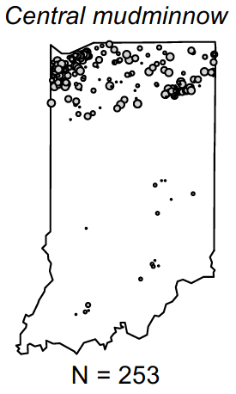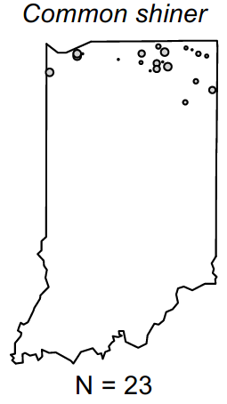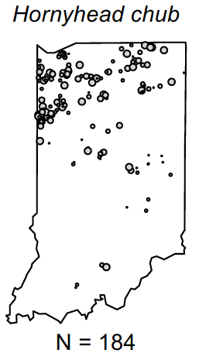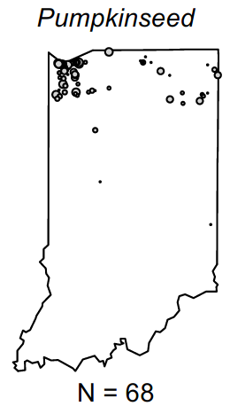

Figure . Fish species occurring predominantly in the north of Indiana.

Figure . Fish species occurring predominantly in the south of Indiana.

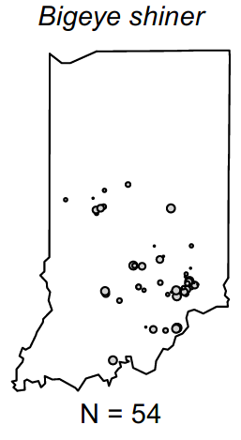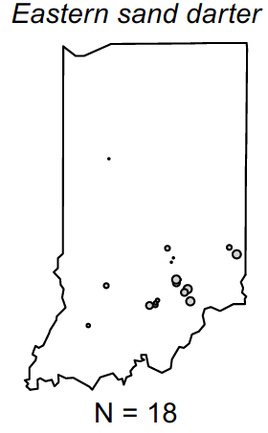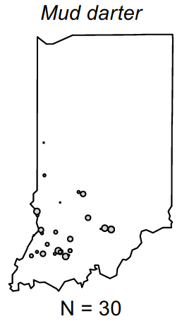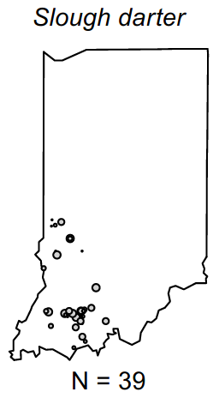

Figure . Fish species occurring in limited basins of Indiana.

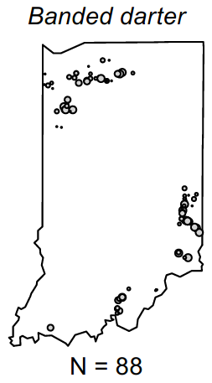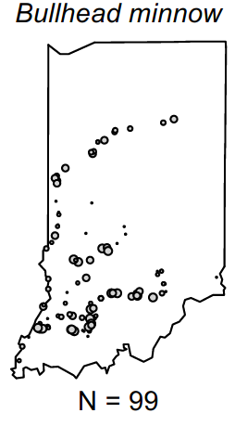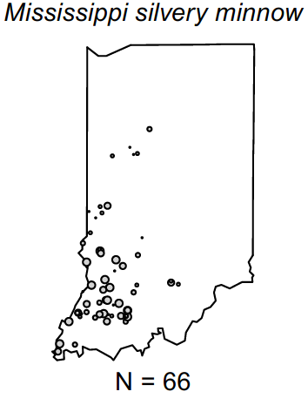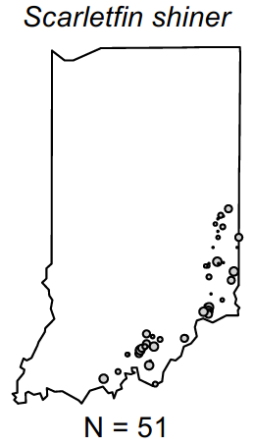

**Expert Review of Site Classes**

For the BCG exercise, experts familiar with the fish assemblage in Indiana reviewed the classification information presented above and decided to use catchment size and level 3 ecoregions to define site classes for wadeable streams. To account for differences attributed to stream size, a site class was defined to separate out large streams and rivers, regardless of ecoregion. Large streams and rivers with catchments greater than 1000 mi2 were assigned to one class for the BCG. For smaller streams, the classes were based on level 3 ecoregions. The Eastern Corn Belt Plains (ECBP) (ecoregion 55) and the Interior Plateau (IP) (ecoregion 71) were combined as a single site class.

* Eastern Corn Belt Plains (ECBP) (ecoregion 55) + Interior Plateau (IP) (ecoregion 71) (combined)
* Interior River Lowlands (IRL) (ecoregion 72)
* Central Corn Belt Plains (CCBP) (ecoregion 54)
* Southern Michigan/Northern Indiana Drift Plains (SMNIDP) (ecoregion 56)

The Huron/Erie Lake Plains ecoregion was included in the ECBP and IP regions, which surround it and are assumed to have similar expectations for a natural fish community. There were not enough sampled sites to calibrate an index specific to this area or even to confidently assign it to another region.

The wadeable stream classification system used for the BCG exercise was adopted for the IBI development process because it was based on the preceding analysis and was endorsed by regional fish experts. The combination of the Eastern Corn Belt Plains and Interior Plateau is supported in the NMS diagram of presence/absence (Figure 30 earlier in the document). Distinctions of the other ecoregions might not be evident in the analysis due to low reference sample sizes.

However, once the index combinations were formulated and tested, it was determined that the metric responses within the site classes were highly variable among site classes, including some responses that were opposite expectations of IDEM and regional biologists. Therefore, the ecoregions were all combined and metric selection and index formulation proceeded in two classes based on stream size, less than and greater than 20 mi2.

Stream size, which is closely related to collection method, exerts a major influence on the number of taxa captured during sampling (Figure 40). For the IBI development, samples collected from a boat were separated from those collected using wadeable methods. Because of the strong effect of catchment size on taxa richness, fish metrics were compared along the catchment size gradient for both boatable and wadeable samples. Appropriate adjustments were implemented so that samples from different stream sizes could be compared (see Section 4.4.3). For the BCG calibration, streams that had drainage areas < 20 mi2 (51.8 km2) were considered as a subclass within the ecoregional classes. The smaller streams are generally more prone to intermittency, particularly in the southern part of the state, where streams generally have low base flow (please refer to Figure 7 earlier in the document).

The final classification scheme for the wadeable fish index included small and large streams, using 20 mi2 as the breakpoint between the classes. A 10 mi2 breakpoint was also tested, but the 20 mi2 breakpoint was selected because metric responses in the 10-20 mi2 streams were more similar to responses in smaller streams (<10 mi2) than in larger streams (> 20 mi2). In addition, the 20 mi2 breakpoint is consistent with definitions of headwater streams in the BCG analysis (Stamp et al. 2016). The ecoregional site classes were retained for evaluation and application, but were not used to select metrics for the final index.

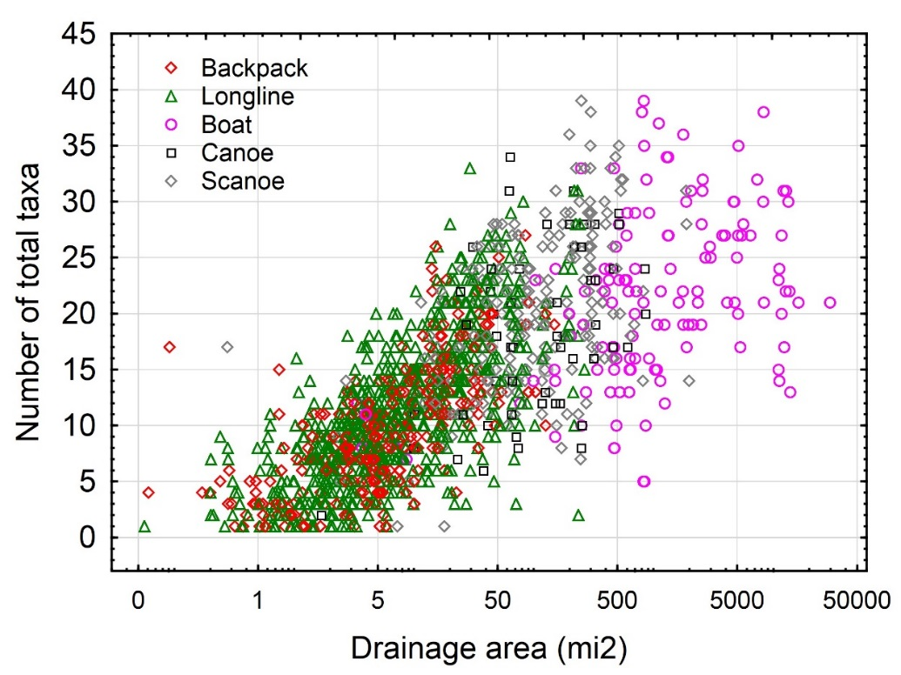

Figure . Scatterplots of total taxa richness vs drainage area (mi2). Samples are coded by collection gear. The x-axis is log-transformed.

For boatable sites, fish experts determined that the gradient measure was more dependable than ecoregion or riffle presence/absence for parsing natural variability. Three feet per mile was considered as a breakpoint between high and low gradients for rivers. Only 17 boatable streams and rivers had gradients greater than three feet per mile. Using 1.5 feet per mile as a distinction between low and high gradient systems was based on PCA ordinations and metric distributions.

The IBI development process proceeded with the following four stream classes:

* Small wadeable stream fish index for samples collected with non-boat methods in streams with drainage areas < 20 mi2
* Large wadeable stream fish index for samples collected with non-boat methods in streams with drainage areas > 20 mi2
* Low gradient boatable stream fish index for samples collected with boat methods in streams and rivers with gradients < 1.5 feet per mile
* High gradient boatable stream fish index for samples collected with boat methods in streams and rivers with gradients > 1.5 feet per mile

### 4.4.2 Tolerance Values and Other Traits

Fish traits related to pollution tolerance, native status, trophic guild, reproductive strategy, and habitat preference (large rivers, headwaters, pioneers, and thermal guild) were provided by IDEM and revised by a workgroup of scientists from IDEM, MBI, and Tetra Tech. The workgroup primarily focused on pollution tolerance. The trophic class and reproductive guild traits were also revised by IDEM using a literature review (Simon 1998; Simon 2011).

For the pollution tolerance traits, the workgroup reviewed traits used in existing Indiana fish indices as well as tolerance values from Illinois, Ohio, and other Indiana sources. These values were also compared to plots describing fish capture probability modeled against percent imperviousness and the QHEI (see Appendix C in Stamp et al. 2016). The GAM plots were generated as described for macroinvertebrates (Section 4.3.2) using Indiana data. Workgroup members focused on those taxa with contrasting tolerance indications from the state sources and then used the plots to inform the sensitivity of the taxon to the stressors in Indiana. Final trait assignments (Appendix M) were established through multiple workgroup discussions and consensus.

### 4.4.3 Metric Adjustments and Sensitivity

Adjustments were made to metrics from wadeable sites using quantile regressions based on wadeable samples from sites >0.5 mi2. Metric values were plotted against the log of catchment size. The plots included the 95th quantile regression and LOWESS regression lines. To account for the effects of catchment size, adjustments to metric values were implemented for metrics that had a substantial slope to the quantile regression line and a LOWESS regression line that agreed with the quantile regression line (Figure 41). Adjustments were not made if there was a shallow slope to the quantile regression line or if the slopes of the quantile regression line and the LOWESS did not agree (Figure 42).

For metrics with an evident plateau based on peak metric values and LOWESS regressions, the quantile regression value at the perceived plateau point (typically 500 mi2) was used for scoring metrics in larger sites. The LOWESS regression line was used to determine whether a plateau in metric values occurred at either end of the catchment size gradient. If a plateau was detected where the LOWESS line leveled out, then the catchment size adjustment was only applied within a limited range. At the plateau, which was typically 500 mi2 for wadeable streams, metric expectations were based on the metric value indicated by the quantile regression line at the point of plateau.

When composing and evaluating index compositions, the adjusted metric scores were always used in place of unadjusted scores.



Figure . Examples of metrics that were adjusted for catchment size based on the 95th quantile regression line (dashed slope) and the LOWESS regression (blue curve).



Figure . Examples of metrics that were not adjusted for catchment size because the 95th quantile regression line (dashed slope) does not agree with the LOWESS regression (blue curve).

A review of the relationships between metrics and drainage areas resulted in adjustments for 57 of 77 wadeable stream metrics (Appendix N). The relationships were not always consistent within the small or large wadeable stream ranges, and some metrics were not adjusted to the 95th quantile regression line of the entire wadeable stream data set. Instead, they were adjusted to regression lines resulting from an appropriate range of drainage areas or were not adjusted at all.

For boat sites, 7 samples from the Grand Calumet River were removed during metric adjustment because the drainage area was very small and the site resembles a canal that might have backflow from downstream sources. Otherwise, the range of drainage areas was from 50 to 30,000 square miles. The Wabash and White rivers had the largest drainage areas. Of the 74 boatable metrics, 25 warranted adjustment (Appendix O).

The percent of DELT anomalies (pi\_delt) was modified to address singular and perhaps unrepresentative individuals with DELT anomalies. For samples with only a single individual with DELT anomalies, the anomaly was discounted as unrepresentative without confirmation by a second individual in the sample. The metric for those samples would be re-set to a value of 0%. For all other samples, the pi\_delt metric was calculated as the percentage of individuals with DELT anomalies compared to all individuals in the sample. The expectation for the modified pi\_delt metric was that values should be zero (scoring 100 points), all values greater than 2% would score 0 points, and values between 0-2 would be scored on a linear scale.

### 4.4.4 Index alternatives

Initial index alternatives for wadeable sites included metrics selected separately for each preliminary ecoregional class based on good performance and representation of metric categories. Using this approach, the best index alternatives in each site class had DE ranging from 68 in the combined Eastern Corn Belt Plains and Interior Plateau to 92 in the Interior River Lowlands (Appendix P). However, the large variety of metrics included some that were ecologically ambiguous, such as the percent of schooling individuals that decreased with increasing stress and the percentage of carnivore-piscivore individuals that increased with increasing stress. The inconsistency of responses among site classes suggested that some responses were not strongly related to ecologic response mechanisms and might be less robust with larger data sets, considering that some of the reference and stressed data sets were small within some site classes. A combination of all classes except the Interior River Lowlands also resulted in unsatisfactory results. Therefore, statewide indices were developed for all wadeable sites, using reference and stressed sites from all site classes for metric and index evaluation. A separate index was developed for samples collected using boat equipment.

While alternative metric compositions for indices were assembled and tested for all the wadeable sites, the stream size appeared to affect the types of metrics that were responsive. In addition, the ecological significance of some metrics were known to only apply in certain size streams. These metrics included those that measure headwater, pioneer, and sunfish species as well as others.

The small wadeable stream fish index that performed best and included metrics that were from diverse metric categories and were meaningful to IDEM contained 10 metrics from seven metric categories (Table 31). All metrics showed individual DE greater than 50%, except for two that were included because of their ecological importance. Even though the percent pioneer individuals (pi\_pioneer) and percent DELT individuals (pi\_delt) metrics have low DE on their own, the index without them performs with very little reduction in DE compared to the index with them (75.1% compared to 75.3%). Six of the metrics were adjusted to drainage area.

Table . Metrics in the small wadeable stream fish index. All values that calculate to < 0 or >100 are re-set to the 0-100 scale before averaging in the index.

|  |  |  |  |
| --- | --- | --- | --- |
| **Metric Code** | **Category** | **DEa** | **Scoring Equationb** |
| jnt\_native | Richness | 52.5 | DA<1: 100\* MetVal / 9.75  DA>1: 100\*MetVal/(9.71 \* logDA + 9.75) |
| jnt\_dartmadsculp | Richness | 64.8 | 100\*MetVal/(2.42 \* logDA + 2.57) |
| jni\_total | Density | 57.4 | 100\*MetVal/(195 \* logDA + 459) |
| pi\_CyprinNoCarp | Composition | 53.1 | 100\*(MetVal)/94 |
| pi\_osbh\_lithophil | Habitat | 63.0 | 100\*(MetVal)/94 |
| jpi\_headwater | Habitat | 77.8 | DA<1: 100\* MetVal / 59  DA>1: 100\* MetVal / (-23.4\*logDA+59) |
| pi\_pioneer | Habitat | 28.4+ | 100\*(98-MetVal)/96 |
| jnt\_natinvert | Trophic | 50.6 | DA<1: 100\* MetVal / 5.53  DA>1: 100\* MetVal / 7.48\*logDA+5.53) |
| jpt\_toler | Tolerance | 58.0+ | DA > 500: 100-(100\*MetVal/24.7)  DA < 500: 100-(100\*MetVal/(-29.4\*logDA + 104)) |
| pi\_delt | Condition | 0.6+ | 100\*(2-MetVal)/2 |

a: DE = discrimination efficiency, + = metric increases with increasing stress

b: MetVal = metric value, DA = drainage area in mi2, logDA = log10(DA)

Metrics within the small wadeable stream fish index were not highly correlated, indicating unique information from each metric in the index except for the nt\_native and nt\_natinvert metrics (Table 32). It appears that native invertivores comprise a consistent proportion of the native taxa in the small streams (about 60% of the taxa). These two metrics were retained in the index because they represent different metric categories (Richness and Trophic). An alternative index without nt\_natinvert was tested and had the same DE and Z-score as the index with the metric for the calibration data.

Table . Correlation (Spearman rho) among metrics of the small wadeable stream fish index.

|  |  |  |  |  |  |  |  |  |  |
| --- | --- | --- | --- | --- | --- | --- | --- | --- | --- |
|  | ni\_total | nt\_native | nt\_dartmadsculp | pi\_CyprinNoCarp | pi\_osbh\_lithophil | pi\_headwater | pi\_pioneer | nt\_natinvert | pi\_delt |
| ni\_total |  |  |  |  |  |  |  |  |  |
| nt\_native | 0.68 |  |  |  |  |  |  |  |  |
| nt\_dartmadsculp | 0.60 | 0.70 |  |  |  |  |  |  |  |
| pi\_CyprinNoCarp | 0.43 | 0.22 | 0.24 |  |  |  |  |  |  |
| pi\_osbh\_lithophil | 0.41 | 0.15 | 0.32 | 0.63 |  |  |  |  |  |
| pi\_headwater | 0.32 | 0.19 | 0.47 | 0.29 | 0.50 |  |  |  |  |
| pi\_pioneer | 0.16 | -0.04 | 0.07 | 0.44 | 0.32 | -0.10 |  |  |  |
| nt\_natinvert | 0.63 | **0.95** | 0.73 | 0.18 | 0.11 | 0.21 | -0.08 |  |  |
| pi\_delt | 0.11 | 0.19 | 0.10 | -0.02 | -0.03 | 0.04 | -0.06 | 0.17 |  |
| pt\_toler | -0.36 | -0.56 | -0.51 | -0.06 | -0.04 | -0.05 | 0.23 | -0.63 | -0.09 |

The large wadeable stream fish index included eight metrics from six metric categories (Table 33). Metrics from the habit category degraded index performance except the % headwater individuals, which would not be appropriate for application in large streams. All metrics in the index had DE greater than 65%, except for the percent DELT individuals (pi\_delt) metric that was retained for its important ecological meaning. The index without pi\_delt performs with no reduction in DE compared to the index with it (76.4 %). Two of the metrics were adjusted to drainage area.

Table . Metrics in the large wadeable stream fish index. All values that calculate to < 0 or >100 are re-set to the 0-100 scale before averaging in the index.

|  |  |  |  |
| --- | --- | --- | --- |
| **Metric Code** | **Category** | **DEa** | **Scoring Equationb** |
| jnt\_darter | Richness | 81.8 | 100\*MetVal/(1.88 \* logDA + 2.47) |
| nt\_Cyprin | Richness | 47.3 | 100\*MetVal/10 |
| ni\_Total\_perdist | Density | 65.5 | 100\*(MetVal-0.2)/7.6 |
| pi\_CyprinNoCarp | Composition | 65.5 | 100\*(MetVal-4)/74 |
| pi\_sunfish | Composition | 54.5+ | 100\*(66.6-MetVal)/66.6 |
| pi\_omni | Trophic | 58.2+ | 100\*(21.0-MetVal)/21.0 |
| jpi\_toler | Tolerance | 60.0+ | DA<500: 100-(100\*MetVal/(-21.2 \* logDA + 106))  DA>500: 100\*(48.8-MetVal)/48.8 |
| pi\_delt | Condition | 7.3+ | 100\*(2.0-MetVal)/2.0 |

a: DE = discrimination efficiency, + = metric increases with increasing stress

b: MetVal = metric value, DA = drainage area in mi2, logDA = log10(DA)

The metrics in the large wadeable stream fish index are not redundant, with all Spearman correlation coefficients having magnitudes less than 0.65 (Table 34). The metrics that have the highest correlation are pi\_omni and pi\_toler (0.64). These metrics represent different aspects of the assemblage: trophic guild and pollution tolerance.

Table . Correlations (Spearman rho) among metrics of the large wadeable stream fish index.

|  |  |  |  |  |  |  |  |
| --- | --- | --- | --- | --- | --- | --- | --- |
|  | nt\_Cyprin | nt\_darter | ni\_Total\_perdist | pi\_CyprinNoCarp | pi\_sunfish | pi\_omni | pi\_toler |
| nt\_Cyprin |  |  |  |  |  |  |  |
| nt\_darter | 0.49 |  |  |  |  |  |  |
| ni\_Total\_perdist | 0.59 | 0.42 |  |  |  |  |  |
| pi\_CyprinNoCarp | 0.62 | 0.21 | 0.55 |  |  |  |  |
| pi\_sunfish | -0.49 | -0.23 | -0.41 | -0.61 |  |  |  |
| pi\_omni | -0.10 | -0.28 | -0.05 | 0.10 | -0.11 |  |  |
| pi\_toler | -0.06 | -0.26 | 0.03 | 0.11 | 0.01 | 0.64 |  |
| pi\_delt | 0.00 | 0.08 | -0.07 | -0.11 | 0.07 | 0.04 | -0.02 |

For fish samples collected with boat gear, indices were formulated from the best performing metrics in each site class. Metrics were substituted in alternative index formulations to find the best performing indices. IDEM reviewed preliminary indices and requested that metrics were included that are familiar and theoretically responsive. These were added to the best index options derived through analysis of performance. In the low gradient, the metric added was total native species, which replaced the total species metric. In the high gradient, total native species and darter species were added, although both had DE less than 25%.

The low gradient boatable stream fish index included 9 metrics from eight metric categories (Table 35). The two tolerance metrics were excellent indicators of stress in this data set, both having DE of 100%. The pi\_delt metric did not respond strongly to stress, but was retained because of its importance as an indicator of severely degraded systems.

Table . Metrics in the low gradient boatable stream fish index. All values that calculate to < 0 or >100 are re-set to the 0-100 scale before averaging in the index.

|  |  |  |  |
| --- | --- | --- | --- |
| **Metric Codea** | **Category** | **DEb** | **Formulac** |
| jnt\_native | Richness | 80 | DA<500: 100\*MetVal/(10.7 \*logDA + 4.44)  DA>500: 100\*MetVal/33.3 |
| pi\_rbs | Composition | 50 | 100\*MetVal/29.8 |
| pi\_dom01 | Richness | 70+ | 100\*(61.2-MetVal)/45.3 |
| BioNatNonTolnGS\_perdist | Density | 80 | 100\*(MetVal-6.8)/171.1 |
| nt\_natCypinvert | Trophic | 80 | 100\*MetVal/6 |
| pi\_intolerant | Tolerance | 100 | 100\*(MetVal-1.6)/61.7 |
| pb\_toler | Tolerance | 100+ | 100\*(87.3-MetVal)/87.3 |
| pi\_os\_lithophil | Reproduction | 90 | 100\*(MetVal-3.9)/48.5 |
| pi\_delt | Condition | 30+ | 100\*(2-MetVal)/2 |

a: Refer to Table 5 for metric descriptions, for example BioNatNonTolnGS\_perdist = Biomass of Native Nontolerant minus Gizzard Shad per distance

b: DE = discrimination efficiency, + = metric increases with increasing stress

c: MetVal = metric value, DA = drainage area in mi2, logDA = log10(DA)

The metrics in the low gradient boatable fish index are not redundant, with all Spearman correlation coefficients with magnitudes less than 0.70 (Table 36). The metrics that have the highest correlation are nt\_native and nt\_natCypinvert (0.68). These metrics represent different aspects of the assemblage: richness and trophic guild composition.

Table . Correlations (Spearman rho) among metrics of the low gradient boatable fish index.

|  |  |  |  |  |  |  |  |  |
| --- | --- | --- | --- | --- | --- | --- | --- | --- |
| Metric | nt\_native | pi\_rbs | pi\_dom01 | BioNatNonTolnGS \_perdist | nt\_natCypinvert | pi\_intolerant | pb\_toler | pi\_os\_lithophil |
| nt\_native |  |  |  |  |  |  |  |  |
| pi\_rbs | 0.22 |  |  |  |  |  |  |  |
| pi\_dom01 | -0.36 | -0.29 |  |  |  |  |  |  |
| BioNatNonTolnGS\_perdist | 0.63 | 0.25 | -0.29 |  |  |  |  |  |
| nt\_natCypinvert | 0.68 | -0.01 | -0.20 | 0.31 |  |  |  |  |
| pi\_intolerant | 0.14 | 0.63 | -0.33 | 0.02 | 0.03 |  |  |  |
| pb\_toler | -0.24 | 0.14 | -0.01 | -0.20 | -0.27 | -0.25 |  |  |
| pi\_os\_lithophil | 0.13 | 0.26 | -0.30 | 0.31 | -0.07 | 0.01 | 0.00 |  |
| pi\_delt | -0.08 | -0.25 | 0.03 | -0.30 | -0.04 | -0.14 | 0.10 | -0.16 |

The high gradient boatable stream fish index included 10 metrics from six metric categories (Table 37). Two richness metrics were included in the index despite poor DE performance on their own. Native taxa richness and darter richness did not show strong responses to stress in the calibration data set. They were included in the index to represent overall diversity and darter diversity, both of which are expected to decrease with additional stress at the site. These conceptual and theoretical responses are reliable indicators for IDEM and regional biologists, who selected them as components of the BCG rules for the large river fish model (Stamp et al. 2016). The pi\_delt metric performed better in this data set than in any others.

The metrics in the high gradient boatable fish index are not redundant, as can be seen in Spearman correlation coefficients with magnitudes generally less than 0.80 (Table 38). The metric that has the highest correlations is pi\_intolerant, which is correlated with pb\_rbs (0.85) and pi\_insinv (0.77). These three metrics are from different metric categories: pollution tolerance, and composition, trophic guilds. They were retained in the index to represent different aspects of the assemblage.

Table . Metrics in the high gradient boatable stream fish index. All values that calculate to < 0 or >100 are re-set to the 0-100 scale before averaging in the index.

|  |  |  |  |
| --- | --- | --- | --- |
| **Metric Codea** | **Category** | **DEb** | **Formulac** |
| jnt\_native | Richness | 22.2 | DA<500: 100\*MetVal/(10.7 \*logDA + 4.44)  DA>500: 100\*MetVal/33.3 |
| nt\_darter | Richness | 16.7 | 100\*MetVal/8 |
| nt\_Cent | Richness | 72.2 | 100\*(MetVal-2.9)/5.2 |
| pb\_rbs | Composition | 100 | 100\*MetVal/77.1 |
| pi\_insinv | Trophic | 83.3 | 100\*(MetVal-22.5)/64.3 |
| pi\_omni | Trophic | 100+ | 100\*(28.2-MetVal)/28.2 |
| pi\_intolerant | Tolerance | 77.8 | 100\*(MetVal-0.2)/70.1 |
| pb\_toler | Tolerance | 100+ | 100\*(96.1-MetVal)/96.1 |
| pi\_os\_lithophil | Reproduction | 44.4 | 100\*(MetVal-6.1)/56.7 |
| pi\_delt | Condition | 77.8+ | 100\*(2-MetVal)/2 |

a: Refer to Table 5 for metric descriptions

b: DE = discrimination efficiency, + = metric increases with increasing stress

c: MetVal = metric value, DA = drainage area in mi2, logDA = log10(DA)

Table . Correlations (Spearman rho) among metrics of the high gradient boatable fish index.

|  |  |  |  |  |  |  |  |  |  |
| --- | --- | --- | --- | --- | --- | --- | --- | --- | --- |
| Metric | nt\_native | nt\_darter | nt\_Cent | pb\_rbs | pi\_omni | pi\_insinv | pi\_intolerant | pb\_toler | pi\_os\_lithophil |
| nt\_native |  |  |  |  |  |  |  |  |  |
| nt\_darter | 0.59 |  |  |  |  |  |  |  |  |
| nt\_Cent | 0.26 | 0.10 |  |  |  |  |  |  |  |
| pb\_rbs | 0.51 | 0.33 | 0.25 |  |  |  |  |  |  |
| pi\_omni | -0.16 | -0.11 | -0.35 | -0.60 |  |  |  |  |  |
| pi\_insinv | 0.35 | 0.17 | 0.18 | 0.78 | -0.49 |  |  |  |  |
| pi\_intolerant | 0.50 | 0.47 | 0.19 | 0.85 | -0.61 | 0.77 |  |  |  |
| pb\_toler | -0.39 | -0.09 | -0.21 | -0.67 | 0.63 | -0.55 | -0.67 |  |  |
| pi\_os\_lithophil | 0.33 | -0.04 | -0.12 | 0.49 | -0.24 | 0.31 | 0.43 | -0.56 |  |
| pi\_delt | -0.33 | -0.05 | -0.02 | -0.41 | 0.30 | -0.40 | -0.44 | 0.51 | -0.45 |

### 4.4.5 Performance and thresholds

Index performance in responding to disturbance is evaluated by comparing index value distributions among disturbance categories, especially between reference and stressed sites. The discrimination efficiency (DE) is a direct measure of index sensitivity based on the stressed sites in comparison to the lower reference quartile. Performance is also measured using the Z-score, which is a measure of the difference between reference and stressed mean values divided by the reference standard deviation.

Thresholds for assessment can be based on index statistics of the reference distribution or from BCG Levels. The BCG Levels are associated with narrative conditions that are ecologically meaningful. BCG Levels 2 and 3 are generally associated with Exceptional and Good conditions. At BCG Level 4, there are moderate changes in the structure of the fish assemblage and minimal changes in ecosystem function relative to natural conditions (USEPA 2016). BCG Levels 5 and 6 are characterized by moderate to severe changes in community structure and function. When modified uses are recognized, such as in channelized streams, biological expectations might be derived from Level 5.

BCG Level 4 is a critical level for deriving thresholds for general use (Bouchard et al. 2016). There are usually more samples in Level 4 than in other Levels, allowing calculation of statistics in smaller data sets, such as site classes with few members. The moderate changes in structure at level 4 are due to replacement of some intermediate sensitive taxa by more tolerant taxa, but reproducing populations of some sensitive taxa are maintained. Overall, there is a balanced distribution of all expected major taxonomic groups.

The expert panel that reviewed fish samples for the Indiana BCG described Level 4 conditions as follows (Stamp et al. 2016). Sensitive species and individuals are still present but in reduced numbers (e.g., approximately 10 – 30% of the community rather than 50% found in Level 3 streams). The persistence of some sensitive species indicates that the original ecosystem function is still maintained albeit at a reduced level. Densities and richness of intermediate tolerance taxa have increased compared to BCG Level 3 samples. Two or three intermediate sensitive taxa may be present but occur in very low numbers (e.g., Redhorse species, Sculpin species, Mimic Shiner, or River Chub). Taxa of intermediate tolerance such as Rainbow Darter, Sand Shiner, Longear Sunfish, and Central Stoneroller are common, as well as tolerant taxa like Largemouth Bass, Blacknose Dace, and Bluntnose Minnow.

When adequate samples are available in BCG Level 3, index value statistics can be derived that might be appropriate for evaluating streams for exceptional use. Likewise, at Level 5, statistics for evaluating modified uses might be derived. The statistics from the reference distributions and from BCG Levels 3, 4, and 5 have been used to establish index thresholds in other states (e.g. Minnesota; Bouchard et al. 2016). The statistics are presented below for distributions with adequate sample sizes. Statistics from small sample sizes are noted as being uncertain.

The statistics from BCG levels are compared to reference distribution statistics. While these might be appropriate for evaluating exceptional, general, or modified uses, the establishment of uses and thresholds are not in the scope of this report. IDEM might establish thresholds based on the statistics presented after consideration of other analyses and factors.

**Small Wadeable Stream Fish Index**

For the small wadeable stream fish index, there was good performance in all site classes as measured by the discrimination efficiency (DE) (Table 39). The statewide DE was about 76%. The site class with the best DE was the IRL, with a DE of 87.5%. The SMNIDP had the lowest DE of 50%. Z-scores show a large effect (>0.80) between reference and stressed scores in all site classes except the SMNIDP. There are several cool-water streams in the SMNIDP region that might not be as responsive to the index than warm-water streams in other regions. However, index scores decreased incrementally for each successive level of disturbance in each site class (Figure 43). Index scores in the ECBP+IP are somewhat higher than in the other regions for each disturbance category.

Table . Performance measures and threshold statistics for the small wadeable stream fish index statewide and in site classes. Values in bold-type are displayed in Figure 45.

|  |  |  |  |  |  |  |
| --- | --- | --- | --- | --- | --- | --- |
| Data Set | Statistic | Statewide | CCBP | SMNIDP | ECBP+IP | IRL |
| Ref + BestRef | 75th | 66.3 | 54.5 | 53.1 | 66.8 | 54.3 |
| Median | 59.0 | 50.4 | 44.9 | 61.1 | 48.1 |
| 25th | 51.2 | **46.3** | **41.0** | **56.3** | **47.8** |
| Strs + HighStrs | DE | 75.9 | 77.2 | 50.0 | 79.5 | 87.5 |
| Ref v. Strs | Z-score | 1.5 | 1.1 | 0.4 | 1.8 | 1.3 |

|  |  |  |  |  |  |  |
| --- | --- | --- | --- | --- | --- | --- |
| BCG 3 | 75th | 75.3 | 69.5 |  | 75.9 |  |
| Median | 68.8 | **63.5** | NA | **69.2** | NA |
| 25th | 66.5 | 56.6 |  | 66.5 |  |
| Interpolation | 70.5 | 62.6 | 61.2 | 75.1 | 61.2 |
| BCG 4 | 75th | 64.0 | 57.0 | 59.8 | 66.8 | 53.7 |
| Median | 57.0 | **50.7** | **52.5** | **60.7** | **49.4** |
| 25th | 49.0 | 43.1 | 45.5 | 55.8 | 43.2 |
| Interpolation | 56.9 | 50.3 | 51.7 | 60.9 | 49.7 |
| BCG 5 | 75th | 49.7 | 38.9 | 46.3 | 53.4 | 42.5 |
| Median | 42.7 | **34.4** | **41.0** | **47.6** | **38.6** |
| 25th | 36.2 | 28.4 | 35.4 | 40.4 | 32.3 |
| Interpolation | 43.4 | 37.9 | 42.1 | 46.6 | 38.2 |



Figure . Comparison of the small wadeable stream fish index distributions among site classes and disturbance categories.

For assessment, thresholds could be specific to the class because the small wadeable stream fish index shows differences among site classes within BCG Levels (Figure 44). The incremental changes in index scores among BCG levels is generally stronger than the changes with disturbance category (compare Figure 43). Figure 45 demonstrates that the best conditions observed are BCG level 3 in the CCBP and the ECBP + IP classes. These do not always coincide with reference sites, suggesting that the reference conditions are at level 4 in most cases. The median index values of BCG Levels 3, 4, and 5 samples (Table 39) are potential assessment thresholds statewide or in the site classes. In other studies, Level 3 statistics have been associated with Exceptional Uses, Level 4 statistics with General Uses, and Level 5 with Modified Uses (Bouchard et al. 2016). The statewide median index value of Level 4 (57.0) is higher than the statewide 25th percentile of reference sites (51.2). Similar index comparisons can be made in each site class.

Because of the linear relationship between the BCG Levels and the fish index, regressions can be derived from the relationships and interpolation at each level gives another potential threshold – one that is less sensitive to sample size in each level. Regression equations for index values at BCG Levels 3, 4, and 5 are shown in Table 40 and interpolated values are in Table 39. The interpolated index values at BCG Level 4 are consistently close to the BCG Level 4 median index values. The interpolated index values for BCG Levels 3 and 5 do not always agree with the median index values in those levels and in some cases provide an estimate of the median value when the data points are lacking for deriving a median value. Use of the interpolated values has merit if we expect the index to have a linear relationship with the BCG levels, which appears to be the case.

Table . Regression equations for predicting small wadeable stream fish index values from BCG Levels.

|  |  |
| --- | --- |
| Site Class | Regression Equation |
| Statewide | Index = 117.83-13.53\*x |
| ECBP\_IP | Index = 125.04-14.26\*x |
| SMNIDP | Index = 94.62-9.54\*x |
| CCBP | Index = 105.93-12.37\*x |
| IRL | Index = 101.37-11.48\*x |



Figure . Comparison of the small wadeable stream fish index distributions among site classes and BCG model predictions. Half BCG Levels indicate ties.



Figure . The small wadeable stream fish index in BCG Levels, showing site disturbance status and thresholds suggested by distribution statistics.

**Large Wadeable Stream Fish Index**

For the large wadeable stream fish index, there was good performance statewide as measured by the discrimination efficiency (DE = 76.4%) (Table 41). The Z-score showed a large effect (>0.80) between reference and stressed scores. Only the ECBP+IP site class was well-represented in reference and subreference sites (Figure 46), so DE was not calculated by site class. In general, index scores decreased incrementally for each successive level of disturbance in each site class. Index scores in the ECBP+IP were higher than in other classes within disturbance categories, so the statewide DE might reflect differences among site classes as well as between reference and stressed sites.

Table . Performance measures and threshold statistics for the large wadeable stream fish index statewide and in site classes. Values in bold-type are displayed in Figure 49.

|  |  |  |  |  |  |  |
| --- | --- | --- | --- | --- | --- | --- |
| Data Set | Statistic | Statewide | CCBP | SMNIDP | ECBP+IP | IRL |
| Ref + BestRef | 75th | 74.9 |  |  |  |  |
| Median | 69.1 |  |  |  |  |
| 25th | **58.7** |  |  |  |  |
| Strs + HighStrs | DE | 76.4 |  |  |  |  |
| Ref v. Strs | Z-score | 1.4 |  |  |  |  |

|  |  |  |  |  |  |  |
| --- | --- | --- | --- | --- | --- | --- |
| BCG 3 | 75th | 76.2 | 67.9 | 63.8 | 77.5 | 76.1 |
| Median | 69.3 | **62.7** | **60.7** | **71.4** | **70.0** |
| 25th | 61.4 | 57.3 | 54.6 | 63.6 | 64.6 |
|  | Interpolation | 68.7 | 60.7 | 61.0 | 69.6 | 67.8 |
| BCG 4 | 75th | 64.7 | 52.8 | 56.3 | 67.4 | 62.8 |
| Median | 55.7 | **46.5** | **47.9** | **59.8** | **58.2** |
| 25th | 45.9 | 37.6 | 36.6 | 50.2 | 49.6 |
|  | Interpolation | 55.6 | 47.0 | 48.1 | 60.5 | 57.0 |
| BCG 5 | 75th | 52.2 | 35.0 | 38.9 | 63.8 | 60.6 |
| Median | 36.2 | **31.2** | **32.3** | **57.0** | **41.7** |
| 25th | 30.0 | 24.8 | 29.0 | 50.1 | 32.3 |
|  | Interpolation | 42.5 | 33.3 | 35.2 | 51.4 | 46.2 |



Figure . Comparison of the large wadeable stream fish index distributions among disturbance categories.

Assessment thresholds could be specific to the classes because BCG Level 4, on which thresholds might be based, is well represented. At Level 4, index distributions are similar for the ECBP + IP and the IRL classes. Index distributions are also similar for the CCBP and SMNIDP classes, though they are generally lower than the others. The incremental changes in index scores among BCG levels is generally stronger than the changes with disturbance category (compare Figures 47 and 48). The BCG figure shows that BCG Level 3 conditions exist in each site class. The median, upper and lower quartiles of Level 4 index values are potential assessment thresholds statewide or in the site classes (Table 41). Expert descriptions of Level 4 for large wadeable streams are similar to descriptions for small wadeable streams. The statewide median index value of Level 4 (55.7) is lower than but similar to the statewide 25th percentile of reference sites (58.7).

Regressions between the BCG Levels and the fish index can help refine index threshold establishment. The interpolated index values at BCG Levels 3 and 4 are consistently close to the BCG Levels 3 and 4 median index values. Some differences are apparent Level 5 interpolated and median index values. Regression equations for index values at BCG Levels 3, 4, and 5 are shown in Table 42 and interpolated values are in Table 41.

Table . Regression equations for predicting large wadeable stream fish index values from BCG Levels.

|  |  |
| --- | --- |
| Site Class | Regression Equation |
| Statewide | Index = 114.64-13.12\*x |
| ECBP\_IP | Index = 101.37-9.09\*x |
| SMNIDP | Index = 106.09-12.89\*x |
| CCBP | Index = 108.60-13.68\*x |
| IRL | Index = 105.48-10.78\*x |



Figure . Comparison of the large wadeable stream fish index distributions among site classes and disturbance categories.



Figure . Comparison of the large wadeable stream fish index distributions among site classes and BCG model predictions. Half BCG Levels indicate ties.



Figure . The large wadeable stream fish index in BCG Levels, showing site disturbance status and thresholds suggested by distribution statistics.

**Low Gradient Boatable Fish Index**

The low gradient boatable fish index had a DE of 80% when stressed sites were compared to the 25th percentile of SubReference and ‘Other’ samples that had reference scores more than 5 (61.0 index points; Table 43). There were only two SubReference sites and a single high scoring ‘Other’ site. The Ottawa River sites that were included as examples of extremely stressed conditions had the lowest index scores (Figure 50).

Table . Performance measures and threshold statistics for the low gradient boatable fish index statewide and in site classes. Values in bold-type are displayed in Figure 52.

|  |  |  |  |  |  |  |
| --- | --- | --- | --- | --- | --- | --- |
| Data Set | Statistic | Statewide | CCBP | SMNIDP | ECBP+IP | IRL |
| SubRef + Other | 75th | 67.4 |  |  |  |  |
| Median | 63.5 |  |  |  |  |
| 25th | **61.0** |  |  |  |  |
| Strs + HighStrs | DE | 80.0 |  |  |  |  |
| Ref v. Strs | Z-score | 3.8 |  |  |  |  |

|  |  |  |  |  |  |  |  |  |  |
| --- | --- | --- | --- | --- | --- | --- | --- | --- | --- |
| BCG 3 | 75th | 72.0 | 71.3 | | 90.7 | | 72.6 | 66.4 | |
| Median | 65.0 | **57.8** | | **83.8** | | **67.6** | **61.7** | |
| 25th | 57.0 | 47.9 | | 76.8 | | 55.1 | 58.5 | |
|  | Interpolation | 69.4 | 64.9 | | 79.9 | | 70.5 | 65.5 | |
| BCG 4 | 75th | 60.8 | 44.0 | | 67.8 | | 67.5 | 60.4 | |
| Median | 52.6 | **31.9** | | **60.8** | | **56.4** | **54.3** | |
| 25th | 42.6 | 28.1 | | 55.6 | | 44.4 | 50.8 | |
|  | Interpolation | 50.9 | 40.2 | | 61.5 | | 54.4 | 54.9 | |
| BCG 5 | 75th | 47.4 | NA | | | | | | |
| Median | 46.6 |
| 25th | 40.1 |
|  | Interpolation | 32.4 | 15.4 | 43.1 | | 38.4 | | | 44.3 |



Figure . Comparison of the low gradient boatable fish index distributions among disturbance categories.

Assessment thresholds could be specific to the classes because BCG Level 4, on which thresholds might be based, is well represented. At Level 4, index distributions are similar for the ECBP + IP and the IRL classes. Index distributions for the CCBP and SMNIDP classes differ. The incremental changes in index scores among BCG levels are as strong as changes with disturbance category (compare Figures 51 and 50). The BCG figure shows that BCG Level 3 conditions exist in each site class. The median, upper and lower quartiles of Level 4 index values are potential assessment thresholds statewide or in the site classes (Table 43). Distribution statistics for Level 4 in the SMNIDP are based on only three samples. Expert descriptions of Level 4 for low gradient boatable streams are similar to descriptions for small wadeable streams. The statewide median index value of Level 4 (52.6) is lower than the statewide 25th percentile of SubReference and Other sites (61.0).

Regressions between the BCG Levels and the fish index appear to confirm median index values in the BCG levels in general, except in the CCBP where the regression equation appears to be steeper than the median values, giving a high index interpolated value in Level 3 and a low value in Level 5. Even the interpolated value in Level 4 is somewhat higher than the median value. Due to the paucity of Level 5 samples, median values were not derived in any of the site classes. The interpolated values assume a linear relationship and should only be used as preliminary suggestions of thresholds for modified uses. Regression equations for index values at BCG Levels 3, 4, and 5 are shown in Table 44 and interpolated values are in Table 43.

Table . Regression equations for predicting low gradient boatable stream fish index values from BCG Levels.

|  |  |
| --- | --- |
| Site Class | Regression Equation |
| Statewide | Index = 134.07-18.48\*x |
| ECBP\_IP | Index = 126.47-16.01\*x |
| SMNIDP | Index = 144.23-18.38\*x |
| CCBP | Index = 151.50-24.74\*x |
| IRL | Index = 102.61-10.60\*x |



Figure . Comparison of the low gradient boatable fish index distributions among site classes and predicted BCG Levels. Half BCG Levels indicate ties.



Figure . The low gradient boatable fish index in BCG Levels, showing site disturbance status and thresholds suggested by distribution statistics.

**High Gradient Boatable Fish Index**

The high gradient boatable fish index had a DE of 100% when stressed sites were compared to the 25th percentile of SubReference and ‘Other’ samples that had reference scores more than 5 (59.8 index points) (Table 45). There were four sites from which the 25th percentile was derived. As disturbance intensity increases through stressed categories, the index value declines (Figure 53). Index values are lowest in the samples from the Ottawa River.

Table . Distribution statistics for BCG Level 4 index values for the high gradient boatable stream fish index. Values in bold are shown in Figure 55.

|  |  |  |  |  |  |  |
| --- | --- | --- | --- | --- | --- | --- |
| Data Set | Statistic | Statewide | CCBP | SMNIDP | ECBP+IP | IRL |
| SubRef + Other | 75th | 80.3 |  |  |  |  |
| Median | 71.0 |  |  |  |  |
| 25th | **59.8** |  |  |  |  |
| Strs + HighStrs | DE | 100 |  |  |  |  |
| Ref v. Strs | Z-score | 1.6 |  |  |  |  |

|  |  |  |  |  |  |  |
| --- | --- | --- | --- | --- | --- | --- |
| BCG 3 | 75th | 76.9 | NA | | | |
| Median | **70.9** |
| 25th | 60.7 |
|  | Interpolation | 68.7 |  | | | |
| BCG 4 | 75th | 67.7 | 68.2 | 67.7 | 68.2 | 67.7 |
| Median | **54.4** | 53.0 | 54.4 | 53.0 | 54.4 |
| 25th | 49.1 | 37.8 | 49.1 | 37.8 | 49.1 |
|  | Interpolation | 55.8 |  |  |  |  |
| BCG 5 | Interpolation | 42.9 |  |  |  |  |



Figure . Comparison of the high gradient boatable fish index distributions among disturbance categories. The red markers are Whitewater River sites that were displayed as verification of reference conditions.

Most samples in the high gradient boatable site class were in BCG Level 4, including the single sample in the IRL. The statistics were calculated though numbers of samples were small. Assessment thresholds might be derived from the Level 4 statistics, assuming that the index is responsive to disturbance as indicated in Figure 54. The statewide median index value of Level 4 (54.4) is lower than and similar to the statewide 25th percentile of SubReference and Other sites (59.8).

Sites that had high scores (>75) for the high gradient boatable index included the Eel River and Tippecanoe River in the Upper Wabash basin; Sugar Creek, Flatrock River, and Driftwood River in the East Fork White River basin; and the Whitewater River and East Fork of the Whitewater River in the Great Miami basin.

Because of the linear relationship between the BCG Levels and the fish index in all sites, a regression was derived from the relationship and interpolation at each level gives another potential threshold for the statewide index application. The regression equation for index values in BCG Levels is shown in Table 46 and interpolated values are in Table 45. The interpolated index values at BCG Levels 3 and 4 are consistently close to the BCG Levels 3 and 4 median index values. An interpolated value for Level 5 has no comparison to a median because of the lack of level 5 samples.

Table . Regression equations for predicting high gradient boatable stream fish index values from BCG Levels.

|  |  |
| --- | --- |
| Site Class | Regression Equation |
| Statewide | Index = 113.82-12.89\*x |



Figure . Comparison of the high gradient boatable fish index distributions among site classes and predicted BCG Levels.



Figure . The high gradient boatable fish index in BCG Levels, showing site disturbance status and thresholds suggested by distribution statistics.

# 5.0 Discussion

The multimetric indices of biotic integrity (IBI) for macroinvertebrate and fish assemblages in Indiana streams were developed using high quality sampling data, current and valid analytical methods, and validation against the biological condition gradient (BCG). The IBI perform well to discern conditions that are different from reference conditions within the regions and stream types of Indiana. Application of the IBI will lead to biological assessments with known uncertainties that can be quantified using the DE as the primary performance statistic.

IDEM has options for selecting assessment thresholds for each IBI. The 25th percentile of the reference site index distribution is a standard that accepts the possibility that 25% of the reference samples can fail the threshold due to errors in reference site identification, misclassification, sampling error, and natural variability. Because the reference sites were selected as the least disturbed sites in a landscape of widespread agricultural and urban land use disturbance, it is reasonable to expect that some portion of the reference sites have moderate levels of disturbance and that they might fail the biological threshold. Therefore, the 25th percentile is a reasonable threshold, though it is an arbitrary point of the scale. The 10th percentile could be selected if there is greater confidence the reference condition is derived from more natural sites and the 50th percentile could be selected if substantial disturbance is suspected in the reference sites.

By calibrating the index to the biological condition gradient (BCG), IDEM can select IBI thresholds that represent the known condition descriptions associated with each BCG Level. Levels 1 and 2 represent natural conditions that persist in undisturbed or recovered landscapes. These conditions are recognized by the regional experts of Indiana to be as expected, though they are not represented by many samples in the data set. At Level 3, some structural and functional changes in the biological condition are recognized, but the disturbance is probably minor and the community still has much of the integrity of a natural system. In Level 4, structural and functional changes are more evident, to the point where impairment of the biological condition begins to occur. At levels 5 and 6, biological changes are obvious and impairment is likely. Based on these descriptions, the mid-point of BCG Level 4 is a reasonable alternative for a general use index threshold.

As IDEM applies the indices and selects threshold, the refinement of expectations might result in selection of multiple assessment thresholds, derived from the BCG calibration and distribution statistics, to accommodate protection of high quality waters or modified systems. Examination of index values relative to BCG Level 3 can provide a basis for protecting high quality waters. At this level, the biological community is highly functional with minimal changes in taxa composition, relative to natural expectations. At BCG Level 5, changes have obviously occurred and impairment is probable. However, modified stream systems (such as channels altered for agricultural use or urban planning) might have this minimal expectation. The selection of multiple assessment thresholds based on the BCG calibration is a possibility that IDEM can explore using the analyses in this report as a framework.

The indices are robust and applicable throughout Indiana, though some limitations are known. For example, there was no IBI developed for the smaller streams in the South-Central site class. The metric responses along the reference-stressed scale were not as generally expected. There might be site-specific reasons for the unusual metric responses, such as unrecognized site classification issues, uneven reference and stressed site locations, or different sampling conditions for reference versus stressed sites. The South-Central region should most closely resemble the Southeastern region and the Southeastern IBI could be applied to both regions until additional data can be collected and analyzed for a recalibration.

Another factor that might not be adequately recognized in the macroinvertebrate IBI is the natural effect of bedrock substrate in the Southeast. Several reference sites in the Southeast were dominated by bedrock substrates. The bedrock sites have the lowest index scores and the worst BCG Levels. In application of the index, bedrock sites should be scrutinized and index results might be qualified to describe the uncertainty associated with the substrate type.

For the fish IBI, possible differences between cool – cold stream types might not be adequately recognized. The base-flow index (BFI), which is related to temperature-moderating groundwater, has regional variability that is related to the fish site classes. However, the existing designations of cool- and cold-water stream types might need refinement before natural expectations for fish communities can be associated with them. There are several cool-water streams in the SMNIDP region that might not be as responsive to the index as warm-water streams in other regions. IDEM should explore temperature regimes in the landscape and stream channels to better understand possible temperature effects on expected fish communities.

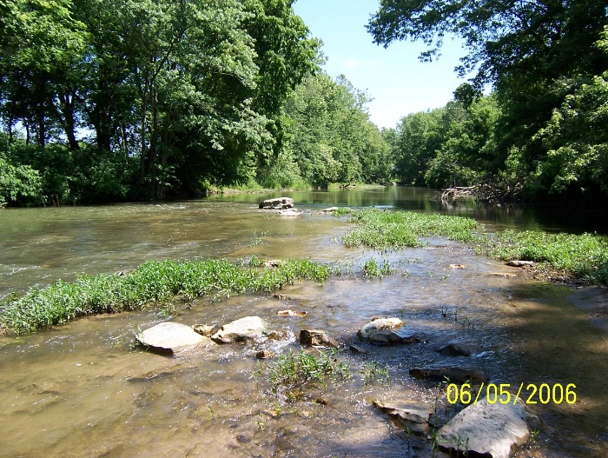 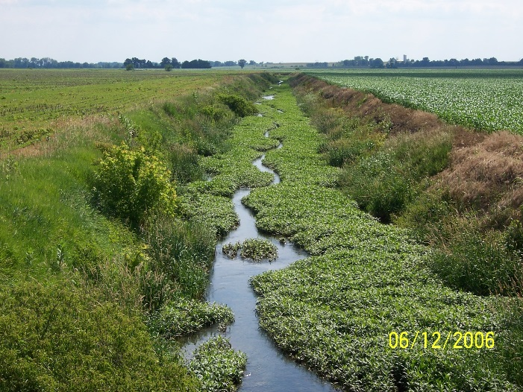

Big Walnut Creek at CR 200 West in Putnam County Indiana (2006) and Timmons Ditch at CR 600 West in Greene County Indiana (2006).

# 6.0 References Cited

Barbour, M. T., J. Gerritsen, G. E. Griffith, R. Frydenborg, E. McCarron, J. S. White, and M. L. Bastian. 1996. A framework for biological criteria for Florida streams using benthic macroinvertebrates. *Journal of the North American Benthological Society*, 15(2):185-211.

Barbour, M.T., J. Gerritsen, B.D. Snyder, and J.B. Stribling. 1999. *Rapid Bioassessment Protocols for Use in Streams and Wadeable Rivers: Periphyton, Benthic Macroinvertebrates and Fish, Second Edition*. EPA 841-B-99-002. U.S. Environmental Protection Agency; Office of Water; Washington, D.C.

Blocksom, K. 2003. A performance comparison of metric scoring methods for a multimetric index for mid-Atlantic highlands streams. *Environmental Management* 31(5):670 –682.

Bouchard Jr, R.W., S. Niemela, J.A. Genet, C.O. Yoder, J., Sandberg, J.W. Chirhart, M. Feist, B. Lundeen, and D. Helwig. 2016. A novel approach for the development of tiered use biological criteria for rivers and streams in an ecologically diverse landscape. *Environmental monitoring and assessment*, 188(3), 1-26.

Brown, M. T. and M. B. Vivas. 2005. Landscape Development Intensity Index. *Environmental Monitoring and Assessment* 101:289-309.

Bryce, S.A., and S.E. Clarke. 1996. Landscape-level ecological regions: linking state-level ecoregion frameworks with stream habitat classifications. *Environmental Management*, 20(3):297-311.

Cohen, J. 1992. A power primer. *Psychological Bulletin*, 112(1):155.

Davies, S.P., and S.K. Jackson. 2006. The biological condition gradient: a descriptive model for interpreting change in aquatic ecosystems. *Ecological Applications*, *16*(4):1251-1266.

Flotemersch, J.E., J.B. Stribling, and M.J. Paul. 2006. *Concepts and Approaches for the Bioassessment of Non-wadeable Streams and Rivers*. US Environmental Protection Agency, Office of Research and Development.

Fore, L.S., R. Frydenborg, D. Miller, T. Frick, D. Whiting, J. Espy, and L. Wolfe 2007. *Development and testing of biomonitoring tools for macroinvertebrates in Florida streams (Stream Condition Index and Biorecon).* Final Report, Prepared for: Florida Department of Environmental Protection, Tallahassee, FL.

Frey, D.G. 1977. *Biological integrity of water: An historical approach*. The Integrity of Water. Proceedings of a Symposium, March 10-12 1975. U.S. Environmental Protection Agency, Washington DC.

Gerritsen, J. 1995. Additive biological indices for resource management. *Journal of the North American Benthological Society*, 14(3):451-457.

Gerritsen, J., M.T. Barbour, and K. King. 2000. Apples, oranges, and ecoregions: on determining pattern in aquatic assemblages. *Journal of the North American Benthological Society*, 19(3):487-496.

Homoya, M.A., D. B. Abrell, J.R. Aldrich and T.W. Post. 1985. The Natural Regions of Indiana. Proc. Ind. Acad. Sci. 94:245-268.

Hughes, R. M., P. R. Kaufmann, A. T. Herlihy, T. M. Kincaid, L. Reynolds, and D. P. Larsen, 1998. A process for developing and evaluating indices of fish assemblage integrity. *Canadian Journal of Fisheries and Aquatic Sciences*, *55*(7):1618-1631.

Indiana Department of Environmental Management (IDEM). 2005. Summary of Protocols: Probability Based Site Assessment. IDEM 32/03/002/1999, Revision: # 7. Indianapolis, IN.

Indiana Department of Environmental Management (IDEM). 2010. Multi-habitat (MHAB) Macroinvertebrate Collection Procedure. IDEM S-001-OWQ-W-BS-10-T-R0. Technical Standard Operating Procedure. Indianapolis, IN.

Jessup, B.K., and J. Stamp 2017. Calibration of the Biological Condition Gradient (BCG) for Benthic Macroinvertebrate Assemblages in Indiana Streams. Prepared for US EPA Region 5 and the Indiana Department of Environmental Management.

Karr, J.R. 1981. Assessment of biotic integrity using fish communities. *Fisheries* 6(6): 21-27.

Karr, J.R., and D.R. Dudley. 1981. Ecological perspectives on water quality goals. *Environ. Manage.* 5:55-68.

Karr, J.R., K.D. Fausch, P.L. Angermeier, P.R. Yant, and I.J. Schlosser. 1986. *Assessment of biological integrity in running waters: A method and its rationale*. Illinois Natural History Survey, Champaign, Illinois. Special Publication 5.

King, R.S., M.E. Baker, D.F. Whigham, D.E. Weller, T.E. Jordan, P.F. Kazyak, and M.K. Hurd. 2005. Spatial considerations for linking watershed land cover to ecological indicators in streams. *Ecological applications*, 15(1):137-153.

Maxted, J. R., M. T. Barbour, J. Gerritsen, V. Poretti, N. Primrose, A. Silvia, D. Penrose, and R. Renfrow. 2000. Assessment framework for mid-Atlantic coastal plain streams using benthic macroinvertebrates. *Journal of the North American Benthological Society* 19(1):128-144.

Ofenböck, T., O. Moog, J. Gerritsen, and M. Barbour. 2004. A stressor specific multimetric approach for monitoring running waters in Austria using benthic macro-invertebrates. In *Integrated Assessment of Running Waters in Europe* (pp. 251-268). Springer Netherlands.

Ohio Environmental Protection Agency (OHEPA). 2006. Methods for Assessing Habitat in Flowing Waters: Using the Qualitative Habitat Evaluation Index (QHEI). OHIO EPA Technical Bulletin EAS/2006-06-1. Revised by the Midwest Biodiversity Institute for State of Ohio Environmental Protection Agency, Division of Surface Water, Ecological Assessment Section, Groveport, Ohio.

Pond G.J., J. E. Bailey, B. M. Lowman and M. J. Whitman. 2012. Calibration and validation of a regionally and seasonally stratified macroinvertebrate index for West Virginia wadeable streams. *Environ Monit Assess*. DOI 10.1007/s10661-012-2648-3.

Rohm, C. M., John W. Giese, and Charles C. Bennett. 1987. Evaluation of an aquatic ecoregion classification of streams in Arkansas. *Journal of Freshwater Ecology*, *4*(1):127-140.

Stamp, J., J. Gerritsen, and B. Jessup. 2016. Calibration of the Biological Condition Gradient (BCG) for Fish Assemblages in Indiana Streams & Large Rivers. Prepared for U.S. EPA Region 5 and IDEM.

Simon, T.P. DRAFT. Development of Index of Biotic Integrity Expectations for the Ecoregions of Indiana. Interior River Lowland.

Simon, T.P. 1991. Development of Index of Biotic Integrity Expectations for the Ecoregions of Indiana I. Central Corn Belt Plain. U.S. Environmental Protection Agency, Region V, Environmental Sciences Division, Monitoring and Quality Assurance Branch: Ambient Monitoring Section, Chicago. IL. EPA 905/9-91/025. 335p.

Simon, T.P. 1992. Biological Criteria Development for Large Rivers with an emphasis on an assessment of the White River Drainage, Indiana. U.S. Environmental Protection Agency, Region V, Water Division, Water Quality Standards, Chicago, IL. EPA 905/R-92/006.

Simon, T.P. 1994. Development of Index of Biotic Integrity Expectations for the Ecoregions of Indiana II. Huron-Erie Lake Plain. U.S. Environmental Protection Agency, Region V, Water Division, Watershed and Non-Point Branch, Chicago. IL. EPA 905/R-92/007.

Simon, T.P. 1997a. Biological Characterization of the Middle Fork Anderson River, Perry County, Indiana. U.S. Environmental Protection Agency, Region V, Water Division, Watershed and Non-Point Branch, Chicago. IL. EPA 905/R-96/007.

Simon, T.P. 1997b. Development of Index of Biotic Integrity Expectations for the Ecoregions of Indiana III. Northern Indiana Till Plain. U.S. Environmental Protection Agency, Region V, Water Division, Watershed and Non-Point Branch, Chicago. IL. EPA 905/R-96/002. 186p.

Simon, T.P.  1998. Assessing biological integrity using fish communities.

Simon, T.P.  2006.  Development, Calibration, and Validation of an Index of Biotic Integrity for the Wabash River.  Proceedings of the Indiana Academy of Science 115(2):170-186.

Simon, T.P.  2011. Fishes of Indiana. Indiana University Press, Bloomington, Indiana.

Simon, T.P. and R.L. Dufour. 1998. Development of Index of Biotic Integrity Expectations for the Ecoregions of Indiana V. Eastern Cornbelt Plain. U.S. Environmental Protection Agency, Region V, Water Division, Watershed and Non-Point Branch, Chicago. IL. EPA 905/R-96/004.

Simon, T.P. and R.L. Dufour. 2005. Guide to appropriate metric selection for calculating the Index of Biotic Integrity (IBI) for Indiana Large and Great Rivers, Inland Lakes, and Great Lakes nearshore. U.S. Department of the Interior, Fish and Wildlife Service, Bloomington Field Office, Bloomington, Indiana.

Simon, T.P. and J.R. Stahl. 1998. Development of Index of Biotic Integrity Expectations for the Wabash River. U.S. Environmental Protection Agency, Region V, Water Division, Watershed and Non-Point Branch, Chicago. IL. EPA 905/R-96/005.

Stoddard, J.L., D. P. Larsen, C.P. Hawkins, R.K. Johnson, and R.H. Norris. 2006. Setting expectations for the ecological condition of streams: the concept of reference condition. *Ecological Applications*, 16(4), pp. 1267–1276.

Stoddard, J.L., A. T. Herlihy, D. V. Peck, R. M. Hughes, T. R. Whittier, and E. Tarquinio. 2008. A process for creating multimetric indices for large-scale aquatic surveys. *J. N. Am. Benthol. Soc*., 2008, 27(4):878–891

USEPA (US Environmental Protection Agency). 2013. Biological Assessment Program Review: Assessing Level of Technical Rigor to Support Water Quality Management. Office of Science and Technology, Washington, DC; EPA 820-R-13-001.

USEPA (US Environmental Protection Agency). 2016. [A Practitioner’s Guide to the Biological Condition Gradient: A Framework to Describe Incremental Change in Aquatic Ecosystems. Office of Water, Washington DC.](http://www.epa.gov/wqc/practitioners-guide-biological-condition-gradient-framework-describe-incremental-change-aquatic) EPA 842-R-16-001.

Van Sickle, J., and R. M. Hughes. 2000. Classification strengths of ecoregions, catchments, and geographic clusters for aquatic vertebrates in Oregon. *Journal of the North American Benthological Society*, 19(3):370-384.

Van Sickle, J., and C.B. Johnson. 2008. Parametric distance weighting of landscape influence on streams. *Landscape Ecology*, *23*(4):427-438.

Weigel, B. M. 2003. Development of stream macroinvertebrate models that predict watershed and local stressors in Wisconsin. *Journal of the North American Benthological Society*, 22(1):123-142.

Whittier, T. R., R. M. Hughes, J. L. Stoddard, G. A. Lomnicky, D. V. Peck, And A. T. Herlihy. 2007. A structured approach for developing indices of biotic integrity: three examples from streams and rivers in the western USA. *Trans. Am. Fish. Soc*. 136:718– 735.

Woods, A.J., J.M. Omernik, C.S. Brockman, T.D. Gerber, W.D. Hosteter, and S.H. Azevedo. 1998. Ecoregions of Indiana and Ohio (Map) and Supplementary Text.

Yuan, L.L., 2006. *Estimation and application of macroinvertebrate tolerance values*. US EPA, ORD, National Center for Environmental Assessment.